Lorch Schweißtechnik expands its successful Speed process technology
Welding aluminium and stainless steels even better and more efficiently with Lorch SpeedWave XT and the “Twin” function

The Speed processes of Lorch Schweißtechnik are setting standards in MIG-MAG welding. The tried and tested TwinPulse is made available as a Twin function that can be activated on all non-cyclic MIG/MAG process types. SpeedWave XT now provides customers with another cyclic high-end welding process for medium- to thick-walled aluminium applications and chromium-nickel steels. Lorch is also expanding its portfolio of characteristic synergic curves for the difficult-to-weld high-strength steels.
Welding of aluminium and chrome-nickel steels poses particularly high demands to welders. For its new flagship, the iQS, Lorch Schweißtechnik is now expanding the application options for its tried and tested TwinPulse to all non-cyclic Lorch Speed processes with its new Twin function. On top of this, the new cyclic SpeedWave XT welding process is introduced on the iQS, reducing pore formation and susceptibility to cracking of the weld seam. This welding process is a modified pulsed arc that influences the weld pool with additional cyclically changing energy and an adjustable frequency (“Wave”) while keeping the wire feed constant. SpeedWave XT thus expands the offering of welding processes such as SpeedPulse XT and TwinPulse, which are already successfully in use. SpeedWave XT is now available for increased requirements or more difficult material situations.
The advantages of SpeedWave XT result from the “Wave” frequency that excites the middle natural frequencies in the weld pool, thereby increasing gas expulsion from the weld pool and reducing porousness. The grain in the freezing material can also be refined, which reduces susceptibility to cracks. The welding process further ensures a fine seam scaling, as customers demand frequently in particular in the areas of aluminium and chrome-nickel steels. The adjustable range of the Wave frequency starts as low as at 4 Hz, overlapping the upper 5 Hz of the Twin(Pulse) function and then going all the way to 40 Hz. The SpeedWave XT’s constant wire feed is more gentle on units and accessories than the Twin(Pulse) function.
Jonas Kappel, Head of Product Management and Marketing at Lorch Schweißtechnik, says: “When introducing the iQS, we announced that we would quickly implement new application areas and process innovations. Our cutting-edge Smart Process Control Engine enables us to put this into practice speedily as well. The iQS has a fast-adjusting inverter that makes it possible to reach even higher and stable frequencies now – laying the basis for a new welding process. We are going to continue to develop the Speed technology in this direction in order to make applications ever simpler and more effective for our customers.”
Lorch Schweißtechnik is presenting yet another addition at “Schweißen und Schneiden” in Essen, the global leading trade fair, with a package of new characteristic synergic curves for high-strength steels. High-strength fine-grained steel is seeing more and more use today since it has a much higher tensile resistance and maximum elongation than conventional steel. The material is ideal for structures from the areas of crane, heavy load, or vehicle construction since it warrants a particularly low weight at greatest stability. Fine-grained steels, however, need to be processed with precise heat input.
The new characteristic synergic curves enable customers to call up characteristic synergic curves that are specifically aligned with the material at hand and the wire brand – immediately ready for use in everyday production. This facilitates the welder's work considerably, increases weld seam quality, and reduces any rework required by spatter. Lorch Schweißtechnik has characteristic synergic curves available for all market-leading high-strength steel brands. Some of them include the MAG wire electrodes by Fliess and Böhler.
Visit Lorch’s stand (hall 5, stand H18) at the world’s leading trade fair “Schweißen und Schneiden” in Essen from 15 to 19 September 2025 and experience the new welding processes live.

Lorch Schweißtechnik GmbH is a leading manufacturer of arc welding systems for industrial applications, the demanding metal craft, as well as for use in automation with robots and collaborative robot systems. Lorch high-quality systems have been produced in one of the world’s most state-of-the-art welding system productions in Germany and exported into more than 60 countries for more than 65 years. Welding technology by Lorch combines great practical benefits, very simple operation, and high economic efficiency, setting new technology standards on the market.
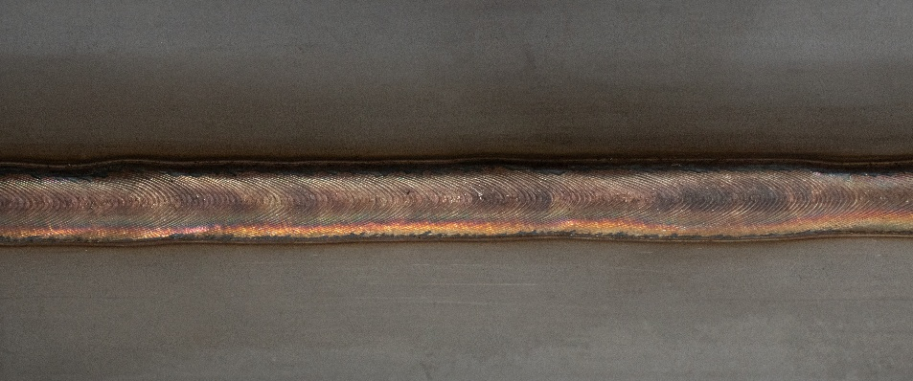
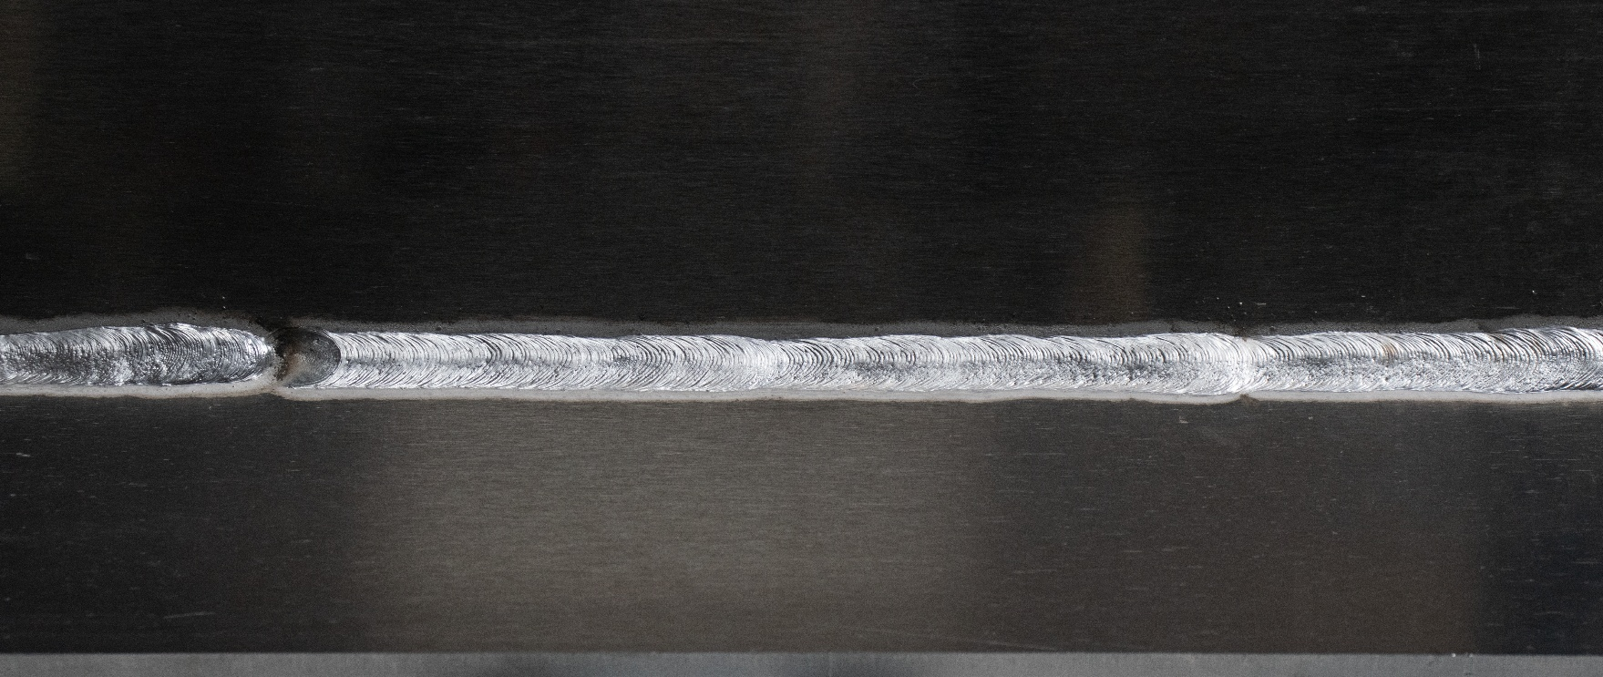
Figure 01: Aluminium fillet weld, welded with the SpeedWave XT process
Figure 01: Stainless steel fillet weld, welded with the SpeedWave XT process

Press contact:
Lorch Schweißtechnik GmbH
Michaela Schreiter
P +49 7191 503-0
F +49 7191 503-199
Im Anwänder 24–26
D-71549 Auenwald
Germany
Print free of charge. Voucher copy requested.

