DAIHEN establishes synergy network in Europe for welding units
Focused know-how for the growth market of the future
Six subsidiaries of DAIHEN group are bundling their solution competences in the areas of integrated robot and welding technology under the DAIHEN Smart Solutions Europe brand. This combination is targeted at providing turn-key automation solutions for all industrial dimensions on the overall European market. The network also includes Lorch Schweißtechnik and OTC DAIHEN.

Listed Japanese DAIHEN Corporation has become established in Europe with industrial solutions and strives to further develop its European market shares in integrated welding technology automation in the scope of its growth strategy. A competence network comprising its six European subsidiaries – industrial solution providers Lorch Schweißtechnik, OTC DAIHEN, and DAIHEN Varstroj as well as the robot system providers Rolan Robotics, LASOtech Systems, and Femitec – was formed to this end under the umbrella brand of DAIHEN Smart Solutions Europe.

Metal processors in industry and trade are acting on complex and increasingly volatile markets. Speed, best quality, and economic efficiency are vital for welding processes there. DAIHEN Smart Solution Europe knows that automation plays a central role for the future of welding: In light of limited personnel resources, automation, integration, and digitalisation offer a unique opportunity for industrial operations to become more competitive while accessing new growth areas.

Companies of all sizes in the European area, from SMEs to large groups, will find the right solutions in the competence network for turn-key automated welding technology challenges. The solution range comprises everything from standardised welding solutions to custom welding, cutting and grinding systems. Up- and downstream handling processes can be seamlessly integrated as well. The great advantage for the customers is having a single contact even for the most complex of solutions, bundled know-how across all production areas, and thus simple access to custom automated solutions. These solutions can be used world-wide beyond Europe as well. The cooperating DAIHEN companies are known as leaders in their respective disciplines. They continue to act independently on their markets with foreign companies and dedicated dealer networks. DAIHEN group is establishing its network to develop a unique competitive position in Europe, taking the evolutionary step into the future of the solution business.

The management body of DAIHEN Smart Solutions Europe is a board led by DAIHEN Corporation, filled with the managing directors of the six companies active in Europe. The board controls inter-company cooperation considering growth and technology competences.

Jens Gauder, managing director of Lorch Schweißtechnik GmbH, explains: “Lorch has been successful in manual welding of industrial and commercial metal processors for years. We have also been able to enter the area of automation solutions with collaborative robot welding. We will now tackle the next step towards more complex solutions on the overall market of Europe together in the scope of DAIHEN Smart Solutions Europe, while enormously expanding our automated solution portfolio for our customers.”

René Lohmann, managing director of OTC DAIHEN Europe, adds: “The industrial solutions of OTC are based on combining our competences in arc welding technology and system integration. This has enabled us to achieve a strong position on the market. We consider the increased cooperation with the European affiliates of DAIHEN group to be a valuable opportunity for using synergies together. In the scope of DAIHEN Smart Solutions Europe, we aim for sustainable expansion of our European market presence.”

Matjaž Vnuk, managing director of DAIHEN Varstroj and Vice Chairman of DAIHEN Smart Solutions Europe: “The group is the natural next step of DAIHEN’s acquisition process in Europe over the recent 10 years. We are now one of the top providers of solutions for customers in the metal industry also in Europe. Our task is to combine Japanese perfection with European development strength and flexibility to give the best technology to our customers – all in one group: at DAIHEN we call this single source !”

About DAIHEN Smart Solutions Europe
DAIHEN Smart Solutions Europe is the European competence network of listed Japanese DAIHEN Corporation. The brand serves as the umbrella under which six subsidiaries – OTC DAIHEN Europe, Lorch Schweißtechnik, DAIHEN Varstroj (Slovenia), Femitec, Rolan Robotics (The Netherlands), and LASOtech Systems – are bundling their expertise in welding technology and robotization. They pursue the objective of supporting industrial customers across Europe and beyond with integrated, turn-key automation solutions. The network represents quality, innovation power, and customer-specific solutions in the areas of industrial welding and cutting technology – for companies of all sizes.

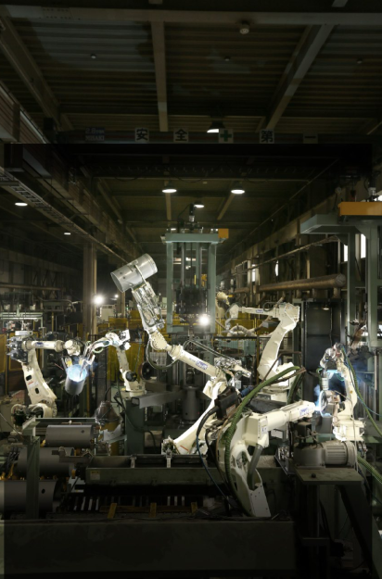
Figure 01: Innovative synergy network – DAIHEN group bundles the know-how in welding automation for SME and large companies alike with DAIHEN Smart Solutions Europe.

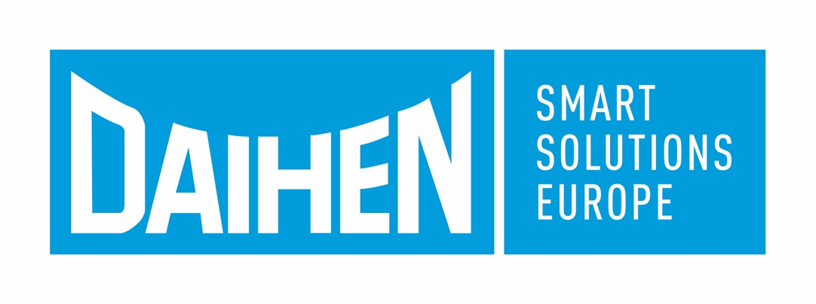
Figure 02: Six subsidiaries of DAIHEN group are going to offer turn-key automation solutions in a competence network under the DAIHEN Smart Solutions Europe brand in future.

Figure 03: Robots are decisive in automation. DAIHEN is a global leader in robotics with its highly precise and fast robots.

Press contact:
DAIHEN Smart Solutions Europe
c/o Lisa Michler
info@daihen-smartsolutions.com

Print free of charge.
Voucher copy requested.

