Compact, flexible, highly efficient, and easy to install

**CUBE robot welding cells by Lorch – the perfect introduction to welding automation**

*Companies can now start automated welding even more easily: Lorch Schweißtechnik offers a portfolio of five new robot welding cells that are designed extremely space-savingly and carry Lorch’s high-performance equipment. They can be quickly integrated into any production environment. These high-end compact cells designed in cooperation with the affiliate OTC DAIHEN EUROPE GmbH contain state-of-the art robot systems from DAIHEN Corporation that have been developed specifically for welding. Globally active DAIHEN Corporation counts amongst the market leaders in robotics.*

The new systems correspond to the highest industrial standards and are characterised by extraordinary performance, precision, and reliability. The individual components – industrial robots, welding current source, welding equipment, positioning technology, control cabinet, and the CE-certified safety technology – are optimally coordinated with each other. This allows a quick and easy start into automated robot welding. Their compact design makes it easy to transport the welding cells by lorry and permits quick commissioning without any additional installation work.

The CUBE robot welding cells are available in five different versions. They are equipped by default with the versatile FD19 generation six-axis robot by OTC, which is known for its high speed and accuracy. CUBE 01 has two fixed tables (1000 x 800 millimetres), permitting highly efficient serial production in cyclic operation with optimally coordinated cycle times. CUBE 02 works with a 180-degree cycling table that can be turned via a motor, while CUBE 03 has two horizontal rotating positioners in different carrying load classes available. CUBE 04 comprises two stations with horizontal turning positioners and CUBE 05 has 2x2-axis-tilt-turn positioners. All cells come in an encapsulated design, with roof extraction sockets, compressed-air connection, LED-lighting, and status lamps for the corresponding production status.

The powerful S-RoboMIG XT series from Lorch is available as a welding power source for MIG-MAG applications. State-of-the art processor technology and lightning-fast control technology maximise arc performance and optimise results in all welding processes. Every CUBE robot cell is delivered with the pre-installed Lorch “SpeedPulse” process package that comprises the MIG-MAG synergy and MIG-MAG pulse processes, TwinPulse, TwinPulse XT, SpeedPulse, SpeedPulse XT, and SpeedArc XT. TIG welding is possible with the tried and tested Lorch V-RoboTIG. Its contact-free HF ignition warrants increased arc stability and optimises material transition. The V-RoboTIG combines best arc properties with a high duty cycle and outstanding performance. The TIG robot cells are delivered with the corresponding TIG cold-wire equipment (TIG control unit, feed, torch, and holder).

“With its CUBE robot welding cells, Lorch offers an ideal solution for all companies aiming to start automation of their welding tasks. The cells take up little space. They are quick to set up and very easy to integrate into any production environment. Since the individual components are optimally coordinated, installation is very fast,” Heiko Hedderoth, Senior product manager for automation and in charge of the robot welding area at Lorch Schweißtechnik, summarises the advantages. “By joining forces with OTC, we can quickly access their entire know-how and are able to implement customer-specific adjustments on short notice as well.”

*Lorch Schweißtechnik GmbH is a leading manufacturer of arc welding systems for industrial applications, the demanding metal craft, as well as for use in automation with robots and collaborative robot systems. Lorch high-quality systems have been produced in one of the world’s most state-of-the-art welding system productions in Germany and exported into more than 60 countries for more than 65 years. Welding technology by Lorch combines great practical benefits, very simple operation, and high economic efficiency, setting new technology standards on the market.*

Ein Bild, das Maschine, Roboter, Im Haus enthält.
Figure 01: All CUBE robot welding cells come with the robust and diverse six-axis robots of the FD19 generation of OTC Daihen, warranting high speed and accuracy.

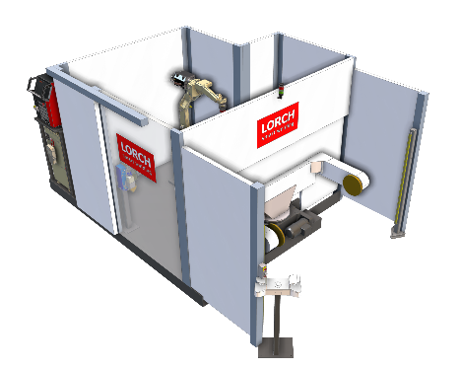

Figure 02: Compact and easy to install: The high-end compact CUBE cells are available in five versions with optimally coordinated components.

**Ein Bild, das Maschine, Motor enthält.
**

Figure 03: The high-performance S-RobotMIG series by Lorch with the pre-installed “SpeedPulse” package is the optimal MIG-MAG welding current source.The TIG area uses the tried and tested V-RoboTIG.

**Ein Bild, das Maschine, Roboter, Spielzeug, Werkzeug enthält.
**

Figure 04: In addition to the power source, all other components, such as wire feed, torch, and holder, are precisely aligned with the high-performance robot.

**Press contact:**

Lorch Schweißtechnik GmbH  
Michaela Schreiter  
P +49 7191 503-0  
F +49 7191 503-199  
Im Anwänder 24–26  
D-71549 Auenwald

Germany

*Print free of charge. Voucher copy requested.*