Larger field of vision and many new functions
Even greater safety and comfort with the new APR 900 PLUS welding helmet by Lorch Schweißtechnik
Lorch Schweißtechnik has been successful on the market with its dedicated, in-house-developed welding helmets for three years already. The current new edition of the APR 900 PLUS helmet is characterised by an even larger field of vision and features such as soft-delay, spot-delay, and auto shade that make welding even less fatiguing.
Improvement of the working environment is growing more and more important in welding, and the demand in the corresponding technology and equipment is rising. Lorch Schweißtechnik also develops and produces its products with a focus on ongoing improvement of the working conditions of welders. Where the helmets developed by Lorch even back in 2022 were characterised by a sophisticated design, perfect view, and greatest possible safety standards for the welder, the subsequent generation is offering even greater comfort for harsh everyday work as a welder, meeting even the very latest safety standards easily.
One essential advantage of the new generation of APR 900 PLUS helmets is its new glare protection cassette, characterised, amongst other things, by a particularly large field of vision. Enlarged to 82 x 100 millimetres, this field of vision now grants the welder an even better view of their workpiece and environment. This is particularly supported by the field of vision of the cassette being extended downwards, so that the welder will find it easier to keep their head upright during the welding process. This further improves body posture and prevents neck issues.
The new glare protection cassette on the highest quality level is also certified to the new ISO standard 16321-2 that has been mandatory for certification of new products in the area of eye and facial protection since November of 2024. Innovative filter technology clearly limits the blue-light share, thereby reducing the risk of fatigue, headache, and long-term retinal damage.
Further functions have been added to the practical control panel in the lower area of the cassette, where operating modes and protection levels, sensitivity, and delay control can be set easily to match the application at hand. The new soft-delay option opens the cassette gradually, thereby ensuring that the eye can adjust slowly to the brightness of the open cassette. This makes unpleasant glare – e.g., due to afterglow of the weld seam – a thing of the past. Spot delay – developed specifically for tack welding – reduces the change between light and dark, rendering work much more pleasant for the welder and reducing eye fatigue. The new auto-shade function steplessly and automatically adjusts the protection level between light and dark to match the light intensity of the arc. This adjustment continues while welding to ensure an optimal view at all times even during long and complex weld seams and in large parts, reducing welding errors that necessitate expensive and annoying rework.
The welding helmet is fitted securely with a ratchet fastening knob that makes it easy to adjust the circumference of the head. Lateral sliders and two overhead straps further customise the helmet to the user’s head shape. Wearing comfort is even further improved by extended and even more comfortable premium welding bands at the forehead and at the back of the head. The helmet can be put down securely thanks to a sophisticated four-point support on the visor side. It keeps the helmet from rolling away, while the slightly recessed front cover remains perfectly protected from scratches.
The new welding helmets are available in four different versions: On the one hand, there is the standard helmet APR 900 PLUS and the flip helmet APR 900 XF PLUS. Its divided visor with glare protection cassette can be simply folded up. The flip version offers the advantage that work such as grinding can be done even better protected by a protective pane while improving view. The two models can also be combined with a fresh-air system that protects the welder from inhaling of welding fumes and toxic welding gases. The battery-powered filter and blower unit (PAPR) – connected by a flexible ventilation hose – ensures fresh-air supply right into the welding helmet. The helmets are equipped with a reworked face seal and collar of soft fleece material to prevent ingression of unfiltered ambient air via the throat and neck areas. This seals the helmet from below and can be replaced quickly and without needing any tools thanks to the industrial-grade Velcro attachment.
“Our new welding helmet makes welding a lot more pleasant and safe. The larger field of vision, certification to the latest protection standards, and the many additional functions offer our customers a harmonious overall concept without any compromises at a very attractive and affordable price,” says Maximilian Hipp, the competent product manager at Lorch Schweißtechnik.
Lorch Schweißtechnik GmbH is a leading manufacturer of arc welding systems for industrial applications, the demanding metal craft, as well as for use in automation with robots and collaborative robot systems. Lorch high-quality systems have been produced in one of the world’s most state-of-the-art welding system productions in Germany and exported into more than 60 countries for more than 65 years. Welding technology by Lorch combines great practical benefits, very simple operation, and high economic efficiency, setting new technology standards on the market.

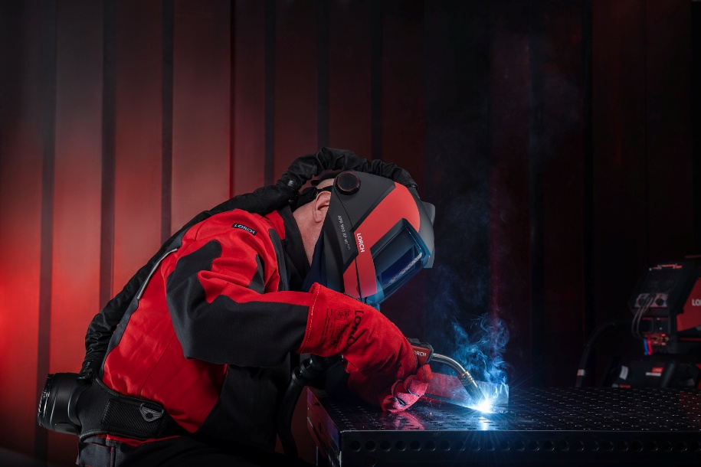
Fig. 1: The new APR 900 PLUS welding helmet – with a larger field of vision to give the welder an even better view of their weld seam.

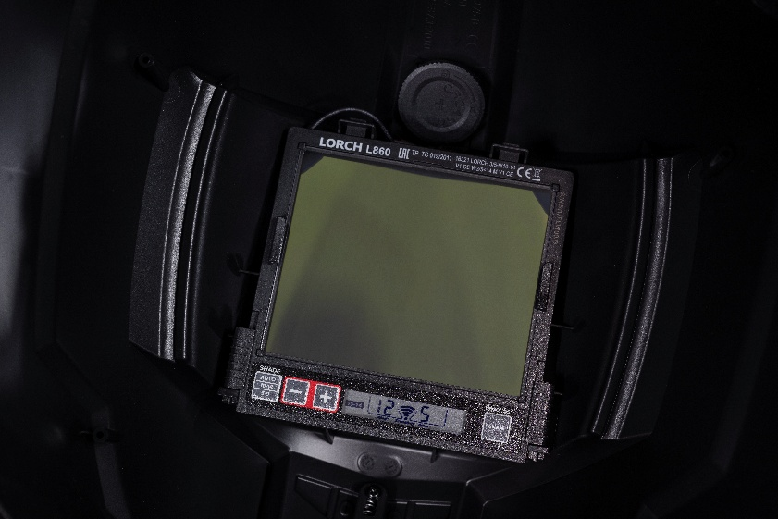
Fig. 2: The practical control panel of the glare protection cassette permits activation of the new soft-delay, spot-delay, and auto-shade functions to render welding even more comfortable.

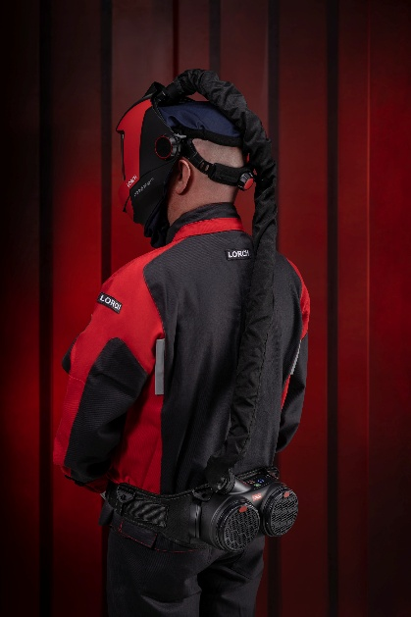
Fig. 3: Secure fit: With flexible adjustment in circumference, height, and cassette distance, the helmet will adjust to any individual head shape. Some models can be combined with a fresh-air system.

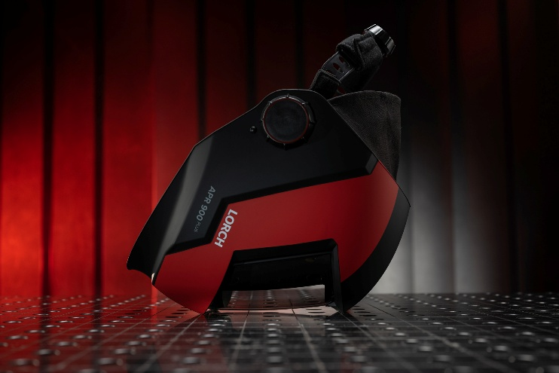
Fig. 4: A sophisticated four-point support on the visor side ensures secure depositing of the auto darkening filter while the slightly recessed front cover remains perfectly protected from scratches.

Press contact:
Lorch Schweißtechnik GmbH presse@lorch.eu
Michaela Schreiter Phone +49 7191 503-0
Im Anwänder 24-26 Print free of charge.
D-71549 Auenwald Voucher copy requested.

