Smart operation, quick torch change, sophisticated technology
Everything under control with the new iQ-LMS Performance torch by Lorch
Together with the new iQS inverter platform, Lorch is presenting another generation of LMS Performance torches to clearly simplify manual welding yet again at the world’s leading trade fair Schweissen & Schneiden (11 to 15 September, Messe Essen). Equipped with a high-quality colour display, an additional workplace LED, and combined with a new and innovative torch connection to the power source, they offer best control, highest comfort, and perfect performance when welding.
"Everything under control" – the new iQS high-performance torch developed by Lorch in its Powermaster version enables comprehensive manual control of welding processes right on site. Even complex welding tasks can be performed easily with the torch remote control, saving time-consuming back and forth between the machine and the workpiece. Equipped with a new, high-quality colour display that allows selection of all primary and secondary parameters, dynamic control, operating mode change, and calling up of QuickAccess menus right at the torch, the torch offers maximum control and maximum comfort alike. A LED additionally integrated into the front of the torch handle is useful as well as it perfectly lights up the welding situation even in dim environments.
Another pioneering innovation is the central connection developed by Lorch, used for the first time in the new Lorch iQS systems, which allows quick and highly comfortable connection of the torch to and with disconnection from the welding power source. The torch plug is simply pushed into the central connection and latches automatically there. A simple push of a button will release it again.
Further advantages of the central connection: Direct docking between the feed unit and the torch-wire guide means that no power source-specific liner adjustment is necessary anymore for torch change and maintenance. The lamella contact used warrants highly efficient and extremely stable current transmission at up to 600 amperes. A smart torch identification and a new, robust CAN-Bus protocol that ensures precise torch operation and updates of the torch software at any time via the iQS welding system complete the features of the high-performance torch and make it ready for the future of industrial welding.
The new iQ-LMS Performance torches are based on the LMS torches, successfully introduced only in the autumn of 2022, which already drew attention by their technical sophistications and outstanding ergonomics. Among other things, they offer innovative current nozzle cooling, optimal current transfer across the torch, and perfect gas coverage, ensuring clean weld seams in particular when welding aluminium and stainless steel. This saves rework and lowers production costs. A stable arc, design to ensure easy repairs, and gas-saving shielding gas routing through the torch also contribute to more sustainable welding together with the optimised wear part consumption. To further sustainability, the packaging of torches and wear parts is made entirely of recycled cardboard.
Andreas Rimböck, head of torch development at Lorch: “The new LMS Performance torches perfectly adjusted to the new device generation of the iQS give us optimal welding performance, sustainability, and comfort for our customers. The high welding quality and top ergonomics of the torch actively facilitate everyday work for the welder, enabling them to fully focus on their work for perfect weld seams.“
Lorch at Schweissen & Schneiden 2023: Hall 5, Stand C28

Lorch Schweißtechnik GmbH is a leading manufacturer of arc welding systems for industrial applications, the demanding metal craft, as well as for use in the automation with robots and collaborative robot systems. In-house developed helmet and torch systems add to ensuring optimal welding results. Lorch high-quality systems have been produced in one of the world’s most state-of-the-art welding system productions in Germany and exported into more than 60 countries for more than 65 years. Welding technology by Lorch combines great practical benefits, very simple operation, and high economic efficiency, setting new technology standards on the market.
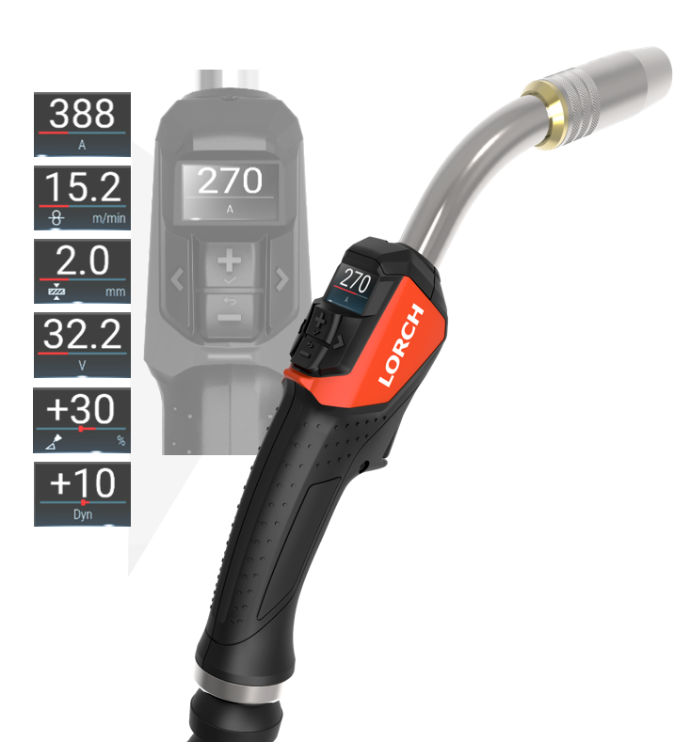
Fig. 1: The Powermaster version with high-quality colour display makes it possible to set all parameters right at the torch and to keep them in view.
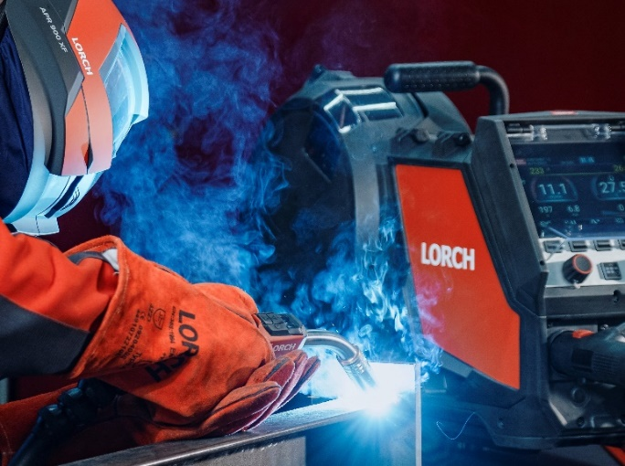
Fig. 2 The iQS LMS Performance torches warrant perfect synergy between the power source and torch.
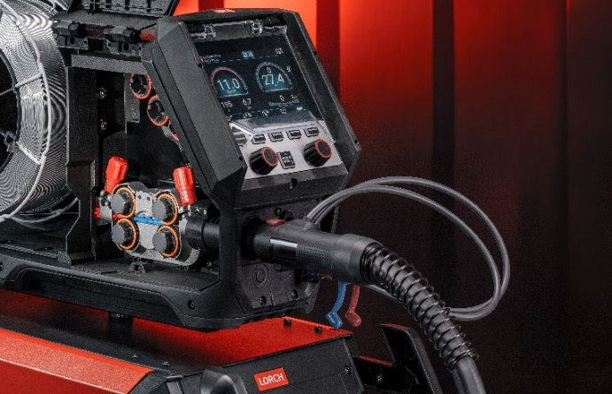
Fig. 3: Switching torches takes no more than a few seconds thanks to the new Lorch central torch connection.
Press contact:
Lorch Schweißtechnik GmbH
Corinna Baketaric
Im Anwänder 24-26
71549 Auenwald
Germany
presse@lorch.eu
Phone +49 7191 503-0
Print free of charge. Voucher copy requested.

