New R-series by Lorch: Robust housing and state-of-the-art welding technology for the workshop
The perfect entrance model for everyone who just wants to start welding
Lorch Schweißtechnik GmbH brings state-of-the-art inverter technology, combined with a highly robust housing and simple operation, to the workshop with its new R series. Inverter welding units consume much less energy, thereby clearly making an important contribution to resource protection. According to the “Plug and Play” principle, they also offer a simple entrance into MIG-MAG welding for less experienced welders.
Highly effective and easy-to-operate welding units are an indispensable tool in any metal processing crafts operation, in car workshops, and in agriculture alike. The R series stands out with its robust and compact housing, an intuitive control panel, and modern inverter technology in hard practical use. The new device generation now offers MIG-MAG perfection to industry standards for crafts and small operations.
Perfectly adjusted welding programmes are available for all common applications in workshop and assembly. The tried and tested “3 steps to weld” operating concept permits quick and safe operation of the system: The welder starts out by selecting the desired process on the practical dial switch, along with 2- or 4-stroke operation, followed by the matching welding programme. It doesn’t matter if welding or brazing is performed with steel, aluminium, stainless steel, or flux-cored wire: Digital performance electronics control the optimal parameters in the background, always supplying the best arc. A well-structured graphics display shows the welder all relevant parameters at a glance, visualising in an easy-to-understand manner what effects various settings have on the weld seam. The electronic power control of the inverter also makes it possible to change parameters as required even while welding.
Equipped with a robust housing and in a compact build, the system fits under any workbench. The impact protection on the grips not only protects the display, but also serves as a practical suspension for the torch. Large rear wheels facilitate rolling over obstacles and uneven ground, while braked rollers secure a stable stance. A 20-litres gas cylinder can be loaded easily via the low, ergonomic loading shelf.
The quick exchange system for the wire feed rolls is very handy as well. A holder with simple plug-in system helps to quickly replace the feed rolls without tools. The system also offers space for four wire feed rolls that can be distinguished easily by the colour marking of their rings. Use of double grooved rolls allows the welder to switch quickly and simply to a second wire diameter. All of this saves unnecessary equipment time.
Further details, such as the tried and tested standard welding current connection and the universal Euro central connection for all common torches make work with the R series even simpler and more flexible. The R series can also be used for electrodes and TIG welding.
Lorch is offering the R series in two performance versions, with 200 and 300 amperes respectively. The R 200 is getting maximum performance out of the 230 V grid, welding sheets up to eight millimetres thick at up to 200 amperes. With a peak current of 300 amperes, the R 300 is easily able to utilise wire diameters of 1.2 millimetres and sheets up to 15 millimetres thick.
Maximilian Hipp, product manager at Lorch Schweißtechnik: “With the new R series systems, we offer our customers true MIG-MAG power at the workshop price. Robust and easy to operate, it facilitates everyday work of welders and production managers alike. With state-of-the-art inverter technology, it combines maximum energy efficiency with optimal welding performance, thereby not only protecting the environment but also the wallet. The R series is equipped for any welding task ex works. It is the ideal partner in crafts and workshop.”

Lorch Schweißtechnik GmbH is a leading manufacturer of arc welding systems for industrial applications, the demanding metal craft, as well as for use in the automation with robots and collaborative robot systems. Lorch high-quality systems have been produced in one of the world’s most state-of-the-art welding system productions in Germany and exported into more than 60 countries for more than 65 years. Welding technology by Lorch combines great practical benefits, very simple operation, and high economic efficiency, setting new technology standards on the market.
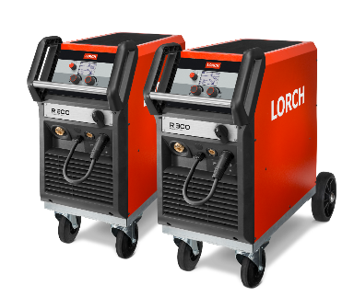
Fig. 1: Perfectly robust and effective: the new R series for workshop and construction site use in the 200- and 300-ampere power versions

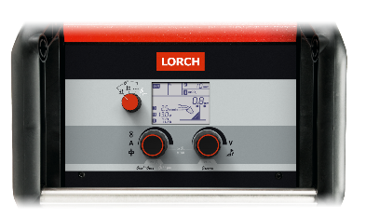
Fig. 2: To the perfect weld seam in a few steps: Simple operation and a well-structured graphic display gives the welder full control of the weld seam at all times.

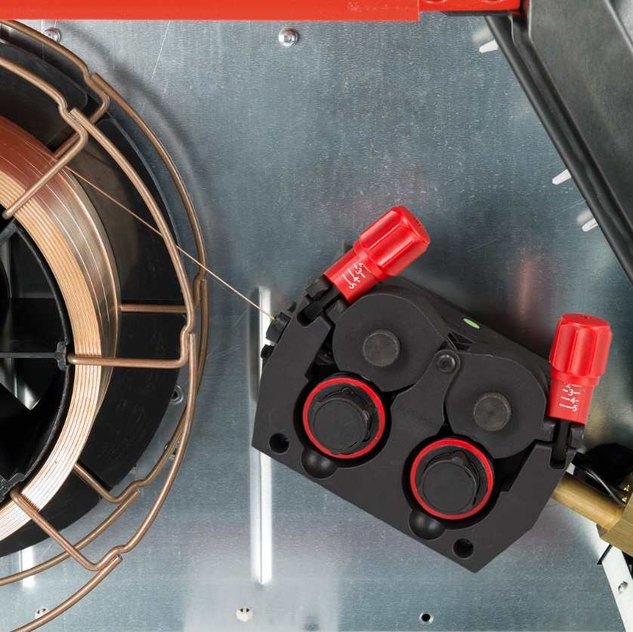
Fig. 3: Quick and tool-free wire roll exchange: A practical quick exchange system makes it possible to save valuable time.

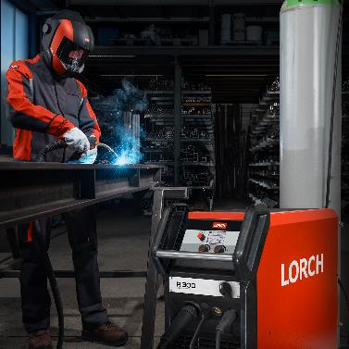
Fig.4: New R-series by Lorch: Robust housing and state-of-the-art welding technology for the workshop

Press contact:
Lorch Schweißtechnik GmbH
Lisa Michler
Im Anwänder 24-26
D-71549 Auenwald
Germany
presse@lorch.eu
Phone +49 7191 503-0

Print free of charge. Voucher copy requested.

