Innovations as key for greater cost and resource efficiency
“Smart means things with a future” –
Lorch Schweißtechnik at Euroblech 2022
Under the motto of “Smart means things with a future”, Lorch Schweißtechnik is presenting the entire range of innovative welding solutions at Euroblech 2022 in Hanover from 25 to 28 October. Visitors can get an overview of smart and sustainable solutions, from cutting-edge welding systems to cobot and robot solutions as well as a brand-new helmet generation, on a stand of 130 sqm in hall 26.
All companies are facing the task of further optimisation of their production processes due to the increasing scarcity of resources and skilled workers. Lorch Schweißtechnik acts as a pioneer in collaborative welding, showing how to master this task in a specific case with its successful cobot welding solution. With its individual additional components, such as a turn-tilt table, its intuitive operation, and the optimally coordinated welding processes, it is deemed a benchmark in manufacture today. The new compact welding cell for robot welding, developed by Lorch Schweißtechnik and Yaskawa together, is also presented in Hanover. The turn-key configured welding cells can be taken into operation after just a few minutes. Their compact build keeps their footprint low.
The Lorch MicorMIG is the universal genius among the welding systems: robust, simple to operate, suitable for all common materials and innovative thanks to NFC technology. As a perfect all-rounder, the MicorMIG-series offers high added value to small and medium-sized enterprises. It can be used across a vast area of use: from conventional MIG-MAG welding to pulse welding and as an alternative for more elaborate TIG welding.
The new R series has its trade fair première. It is an equipment generation Lorch developed specifically for MIG-MAG welding in crafts and light industry. In it, Lorch is connecting innovative inverter technology with the tried and tested properties of a transformer system such as robustness, longevity, and simple operation. With its clear, practical control panel and a perfectly coordinated performance, the R series is the workshop machine of the future, facilitating the necessary switch to modern, energy-saving welding technology.
How to start into the digitally linked world of welding without any great effort is demonstrated by Lorch's often used and successful internet-based Lorch Connect solution. This solution has the special perk of the Connect Gateway, which can be easily connected to any Lorch welding unit. It transmits all welding data to the Lorch Connect portal either by Wi-Fi or through a wired network connection while welding is underway. This allows quick retrieval of the data for documentation or analysis.
With the APR 900, Lorch is presenting a new generation of auto darkening filters in Hanover. Developed in-house by Lorch, these helmets are ergonomically designed to the applicable work directives. Many little innovations considerably reduce the welder's stress while welding. With its many adjustment options, it offers a perfect fit while a high-end glare protection cassette ensures a crystal-clear view with perfect colour rendition. The available protection levels 3 - 14 permit use for all common welding procedures. One version of the APR 900 will be equipped with a modern respiratory system in addition to other practical details.
“By presenting innovative solutions in all areas of welding production, we are showing impressively at Euroblech 2022 how companies can optimally position themselves for the future, and how they can already save plenty of costs and resources today,” Jonas Kappel, head of product management and marketing, summarises the trade fair concept. “No matter if in automation, digitalisation, or improvement of welding processes and welding environments,” Jonas Kappel continues, “new technologies offer many options today for positively designing change and optimising production processes to render them ever more effective.”
Lorch at Euroblech 2022: Hall 26, stand M17

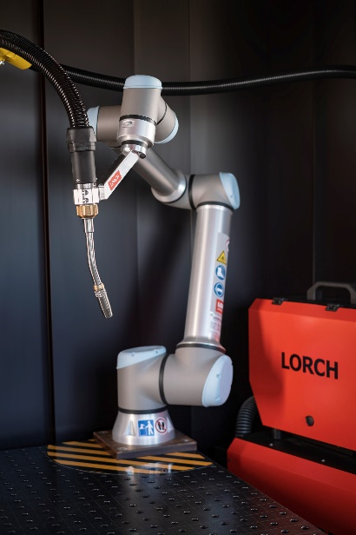
Fig. 1: Lorch cobot solutions: the ideal instrument for small and medium-sized enterprises aiming to start automating welding processes.
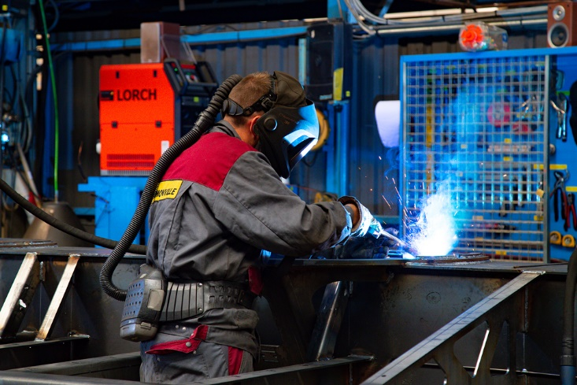
Fig. 2: The universal genius among the welding units: the Lorch MicorMIG series – easy to operate, high-performance, and extremely flexible thanks to its upgrade capacity.

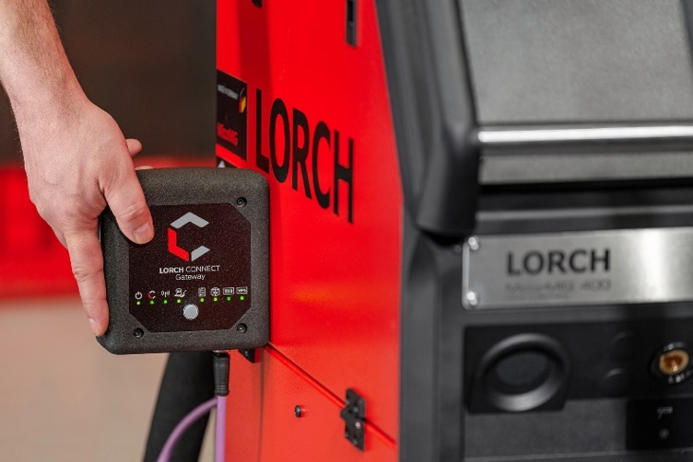
Fig. 3: Warranting easy recording of all the important welding data: the Lorch Gateway and the Lorch Connect web platform.

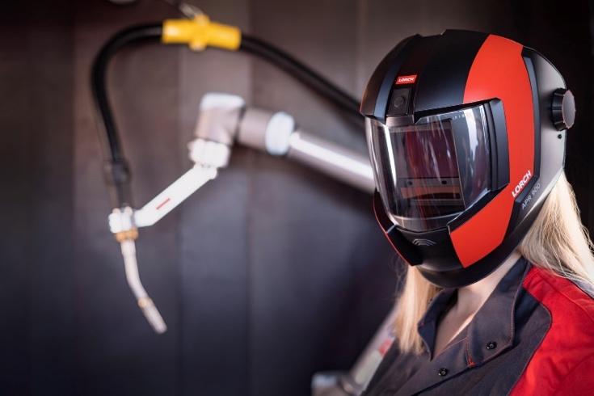
Fig. 4: Not only does it look futuristic, it also offers plenty of innovation: APR 900 – The new generation of auto darkening filters by Lorch.
Press contact:
Lorch Schweißtechnik GmbH
Lisa Michler
Im Anwänder 24-26
D-71549 Auenwald
Germany
presse@lorch.eu
Phone +49 7191 503-0
Print free of charge. Voucher copy requested.

