Flexibly mastering any work situation – now and in the future
The MicorMIG series by Lorch is the perfect all-rounder for companies
Greater efficiency, maximal flexibility, protection of resources: Companies are facing great challenges in product manufacture today. The MicorMIG series by Lorch Schweißtechnik gives them an inverter to offer solutions to many different requirements. Robust, easy to operate, suitable for all common materials, and innovative with NFC technology, this all-rounder offers great added value whilst remaining futureproof, in particular for small and medium-sized companies.
Steel, stainless steel, aluminium? MIG-MAG, TIG, or MMA? With its excellent upgrade facility, the often tried and tested welding processes, and its simple, intuitive operation, the MicorMIG series offers maximum flexibility during daily use. Companies are able to adjust the devices very quickly to fit their individual needs and apply them across a wide-spread area of use, from classical MIG-MAG welding, to pulse welding, to an alternative for the more elaborate TIG welding. Installation of the corresponding upgrades, for example, will turn a MicorMIG into a MicorMIG Pulse system within seconds. This way, companies can enter pulse welding simply and cost-efficiently, welding virtually spatter free in the area of the transition arc as well. Cost-intensive rework is rendered unnecessary by the stable pulsed arc that can be controlled very well even by beginners – saving valuable production time.

Three steps are all it takes for the perfect welding result
The intuitive operation of the MicorMIG enables welders to get started quickly and easily. Combined with dynamic control technology and the pre-defined Synergic welding programmes, all further parameters are set automatically after selecting material/wire/gas and the welding process. Every welder can adjust the arc dynamics individually – from hard to soft – to match the depending on the work task, welding position, and personal welding feel. Intuitive handling turns the MicorMIG into a simple and highly efficient tool for pros and beginners alike.

Robust, long-lived, and always up to date
The robust build of Lorch welding units, well tried in practice, ensures longevity and reliability. Additionally, every inverter is always working on the latest technical status and remains open to future innovations. Thanks to the NFC function, additional welding processes, welding programmes, and functions that simplify work can easily be installed retrospectively at any time – quickly and without any external support. On top of this, often-repeated welding jobs can be saved on NFC job cards and called up again quickly on demand. NFC technology makes it possible to build a personalised authorisation system for operating the welding systems, making it possible to limit parameters, restrict access, or lock the entire system. Recording and analysis of the welding production data are provided for simply and cost-efficiently via the Lorch Connect cloud solution. There’s no simpler way to progress towards industry 4.0.

Always the right process at hand
The MicorMIG series offers the Lorch welding processes SpeedArc and SpeedUp that have been often tried and tested in practice. They increase the speed for MIG-MAG welding, reducing distortion and optimising weld seam quality by high-quality process control. This clearly reduces rework. Fume emission and noise are now reduced as well. The latest innovation by Lorch, the MicorTwin (modified MIG-MAG) process, even allows the welding of thin and medium-thickness sheets (1 to 8 millimetres) offering a TIG like appearance. Any welder can achieve perfect weld appearance simply and reproducibly this way. Some companies even no longer need to keep double equipment at hand anymore. Highly specialised TIG welders are also immensely relieved by this.

Welding in a modern and resource-protecting manner – Lorch offers comprehensive support and testing for companies
“Companies in the welding and fabrication industry are currently intensively looking for approaches to optimise production processes and set their operations up ready to face the future. We at Lorch support them as best we can,” Jonas Kappel, head of product management & marketing of Lorch Schweißtechnik GmbH, explains the added value of the MicorMIG as an all-rounder. Companies can secure a no obligation test from Lorch in order to get to know the significant advantages of the MicorMIG series. “No matter if it’s about getting started, switching, or increasing capacities: the MicorMIG is an ideal tool that offers immense flexibility, is highly effective whilst remaining future-proof,” Jonas Kappel emphasises. For more information on the MicorMIG and to request a demonstration, see www.micormig.com.

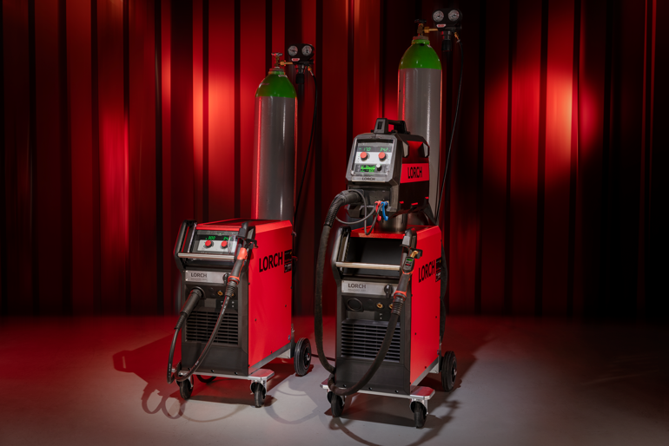
Offering companies maximum uses and MIG-MAG welding at the highest level: the MicorMIG series by Lorch Schweißtechnik.
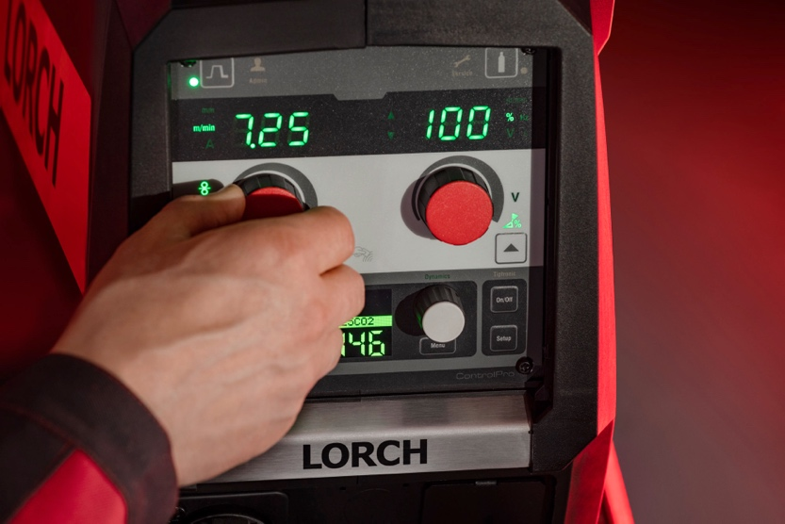
Convincing and inspiring: the simple intuitive operation of a MicorMIG. Welders can focus on the important tasks and get started quickly and easily.

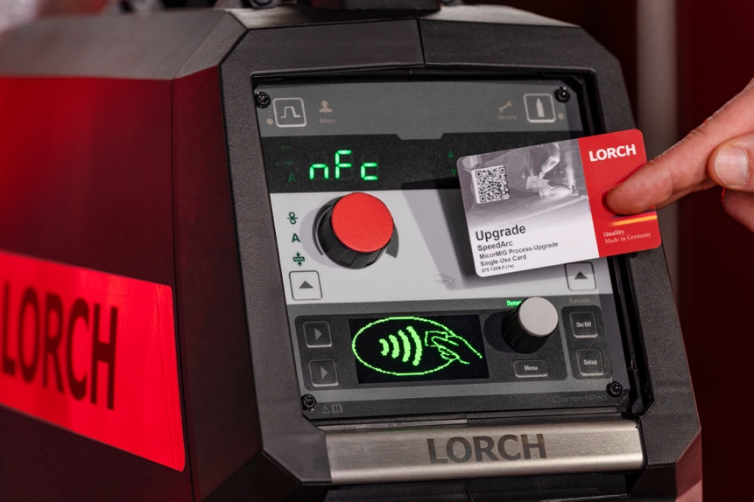
Future-proof: State of the art NFC technology makes it possible to install additional welding processes, welding programmes, or jobs on any MicorMIG within seconds.
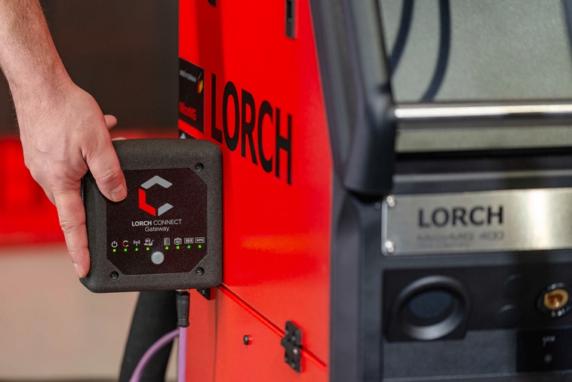
Transparency in welding: Lorch Connect simply records and evaluates all the important production data.
Press contact:
Lorch Schweißtechnik GmbH
Lisa Michler
Im Anwänder 24-26
D-71549 Auenwald
Germany

presse@lorch.eu
Phone +49 7191 503-0
Print free of charge. Voucher copy requested.

