TIG weld appearance at MIG-MAG speed

Complete demanding exposed welds twice as fast with the new MicorTwin welding process by Lorch

Beautiful weld seams at the highest speed: The new MicorTwin welding process by Lorch Schweißtechnik makes it possible to perform demanding exposed welds, which were usually still completed using the time-consuming TIG process, much more quickly and more easily by MIG-MAG welding. In addition to an outstanding weld seam quality, MicorTwin offers twice the welding speed and much easier handling than the TIG process.
The TIG process used to be used in order to achieve particularly beautiful weld seams with even attractive chevrons in aluminium, stainless steel (CrNi) and thin- to medium-walled steel applications. The challenge here is that the pure TIG process is time-consuming and cannot compete with the MIG-MAG process’ productivity. The new MicorTwin welding process by Lorch not only achieves twice the welding speed, but also even offers a weld appearance that lives up to the TIG welding results, as evidenced by a comparison of the weld seams. Comfortable dynamic settings make it possible to customise weld appearance and to choose from a range from fine to coarse chevrons for the weld seam. In particular parts such as frames (bicycles, vehicles), racks (tables, chairs, beds), and many other objects that depend on excellent exposed “visual” welds can be produced easily this way. Frank Knuf, responsible development welder at Lorch, says: “I never would have expected a MIG-MAG process to be capable of producing such an outstanding weld appearance at such speeds.”
Another advantage of MicorTwin is its simple handling. The welding programmes have been optimised for the entire area of application, allowing welding work to commence immediately without any elaborate adjustment of the welding parameters. This achieves perfect weld appearance without losing the good control capacity of the MIG-MAG procedure. In particular in times of rising competitive pressure and costs, this solution offers great additional perspectives for companies.
The prerequisite for the MicorTwin Upgrade is a MicorMIG system with the pulse process enabled. The MicorTwin is, therefore, available for all performance classes (300, 350, 400, 500 amp) of the MicorMIG Pulse series by Lorch. The innovative welding process is already part of the FullProcess package for new systems, without increasing the price. Existing MicorMIG Pulse systems (from the delivery year 2018 onwards) can be upgraded with the MicorTwin easily via an NFC-card.
“The new welding process has enabled us to convert many applications where the required weld appearance was only possible using the TIG process before to the much more efficient MIG-MAG one now,” says Maximilian Hipp, responsible product manager for the MicorTwin at Lorch Schweißtechnik. In addition to the excellent weld appearance and enormous speed advantage, the procedure makes personnel deployment planning possible in a more targeted manner. Hipp: “The simple handling of the MicorTwin enables virtually any company to produce high-quality visually exposed welds at high productivity rates, relieving the burden on highly specialised TIG welders while giving MIG-MAG welders a new process that is simple but leads to the highest quality.” Some companies can even cease to keep double equipment at hand. The MicorTwin can achieve beautiful, even weld seams in particular in the connection of thin- and medium-walled sheets of 1-8 millimetres.

Lorch Schweißtechnik GmbH is a leading manufacturer of arc welding systems for industrial applications, the demanding metal craft, and use in automation with robots and collaborative robot systems. Lorch quality systems have been produced in one of the world’s cutting-edge welding system production facilities in Germany for more than 60 years, to be exported to more than 60 countries. Welding technology by Lorch combines great practical benefits with very simple operation and high economic efficiency, setting new technology standards on the market.

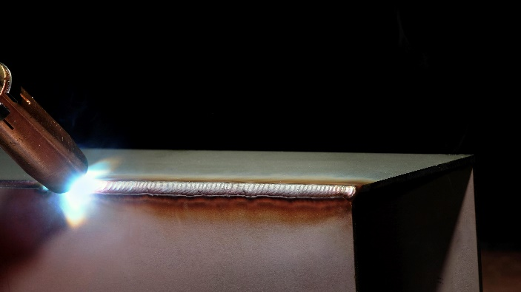
Fig.1: Finest weld seams at twice the speed with the innovative MicorTwin welding process by Lorch.

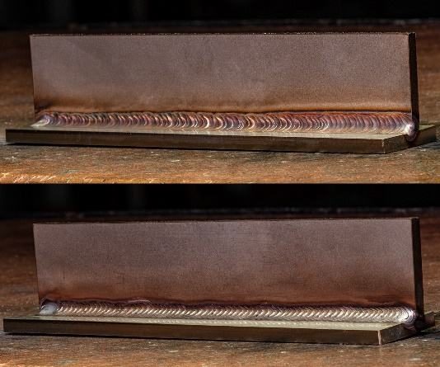

Fig.2: The comparison shows that the MicorTwin (below) offers a weld appearance that lives up to the one produced by the TIG procedure (above).

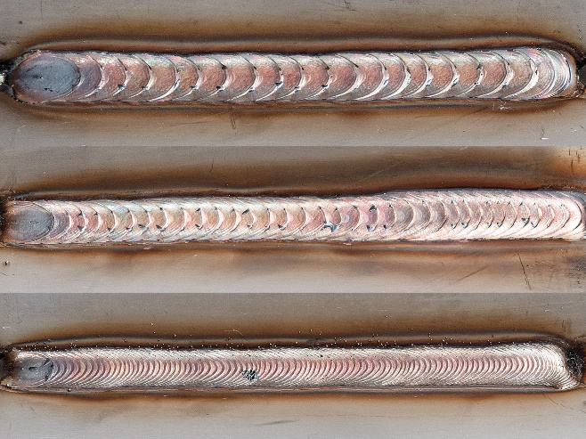

Fig.3: The matching weld seam is only the push of one button away: The desired weld chevrons can be set from coarse (above) to normal, to fine weld chevrons (below) by the dynamic control.

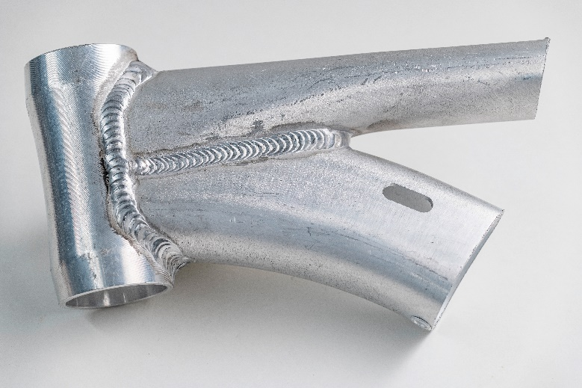

Fig.4: Even the finest weld seams in the demanding light-metal area (here: aluminium) can be welded easily and in outstanding quality with the new MicorTwin welding process.

Fig.5: The MicorMIG Pulse series by Lorch forms the basis for the MicorTwin process. It is available in the performance classes of 300, 350, 400 and 500 amps.

Press contact:
Lorch Schweißtechnik GmbH
Lisa Michler
P +49 7191 503-0
F +49 7191 503-199
Im Anwänder 24–26
D-71549 Auenwald
Germany
Print free of charge. Voucher copy requested.

