Quick installation, simple operation, excellent weld seams

The turn-tilt table by Lorch offers Cobot automation on a new level

With the Cobot Turn 100 A turn-tilt table, Lorch Schweißtechnik is putting an additional component for the Lorch Cobot Welding Package on the market that makes welding production with the collaborative robot much more efficient yet again. The two-axis manipulator can be easily integrated into the production process, while interaction of the Cobot and positioner is optimised by the Lorch Motion software developed by Lorch.
The trend towards fully and partially automated welding keeps increasing. With the Cobot Welding Package, Lorch Schweißtechnik is already offering the ideal solution for small and medium-sized businesses to easily automate welding processes and clearly increase quality by precise programming and reproducibility of the weld seams. In combination with the new manipulator, more demanding workpieces can also now be welded whilst still maintaining the best quality.
The Cobot Turn 100 A can be installed in any welding workplace, either mounted on a table or laterally on the side of the table. It has capacity to handle parts with a radius of up to 750 millimetres, a height of up to 550 millimetres, and a weight of up to 100 kilograms. At a tilt angle of 0 to 90 degrees and an unlimited rotation angle, it always offers the ideal welding position and therefore and optimal welding quality. Elaborate turning and setting up the workpiece by hand is no longer necessary – valuable working time is gained, and the welder will be clearly relieved.
The positioner can be programmed at once and intuitively via the shared operating panel following a simple upgrade of the Cobot operating software. The Lorch Motion Software fully integrated in a URCap ensures that programming of the Cobot and the turn-tilt table are optimally aligned with each other. Lorch Motion defines positioning of the two axes, configures speed, and also specifies partially synchronous movements with the Cobot as desired. The assistant system for roundseam welding of rotation-symmetric parts, for example, only requires input of the radius and desired welding speed in the system. The software will automatically calculate the optimal rotation speed of the positioner as well from this.
Lorch paid special attention to the safety concept. During production operation, a laser scanner generates a virtual environment that monitors the work area. Production stops if anyone enters the active protection field (1.5 m distance from the work surface), increasing the permitted movement speed of the Cobot between the weld seams and speeds up the process even more.
Caren Dripke, department head for robotics development at Lorch says: “The welding Cobot by Lorch, in combination with the new turn-tilt table, increases welding performance clearly once again. It is possible to specify the optimal position for each weld seam now, and the entire welding process can be performed by the Cobot on its own. This not only increases welding quality but also relieves the welder from the time- and labour-intensive re-clamping processes. The net welding time increases, and he can focus on other tasks.” An added benefit is that: “The simple handling makes the solution quickly ready for use in the company. Its high efficiency brings a very fast return on investment.”
The Cobot Turn 100 A for the Lorch Cobot Welding Package is available immediately. Previously installed Cobot solutions by Lorch can also be easily retrofitted with the turn-tilt table via plug & play.

Lorch Schweißtechnik GmbH is a leading manufacturer of arc welding systems for industrial applications, the demanding metal craft, and use in automation with robots and collaborative robot systems. For more than 60 years, Lorch quality systems have been produced in Germany in one of the world's cutting-edge welding system productions, to be exported to more than 60 countries. Welding technology by Lorch combines great practical use, very simple operation, as well as high economic efficiency, setting new technology standards on the market.

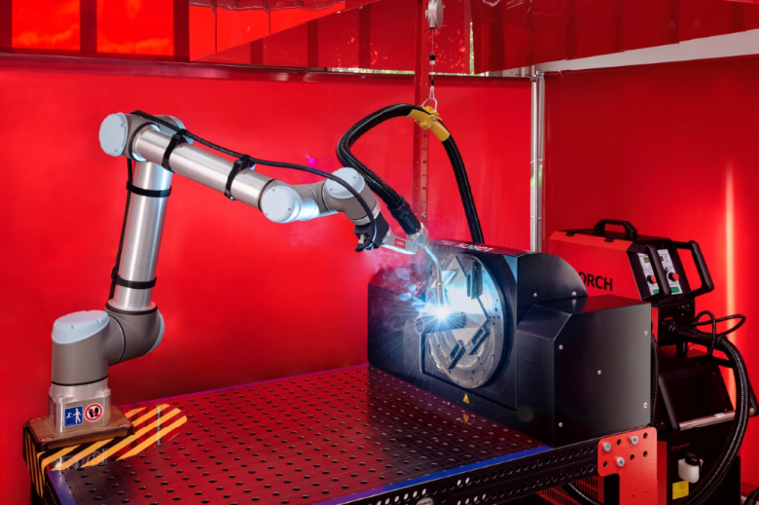
Figure 1: A successful duo: the Lorch Cobot Welding Package combined with the new Cobot Turn 100 A turn-tilt table.
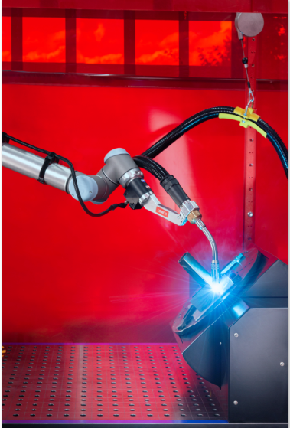
Figure 2: With a tilt angle of 0-90° and an unlimited turning angle, the Cobot Turn 100 A always puts the workpieces into the ideal welding position.

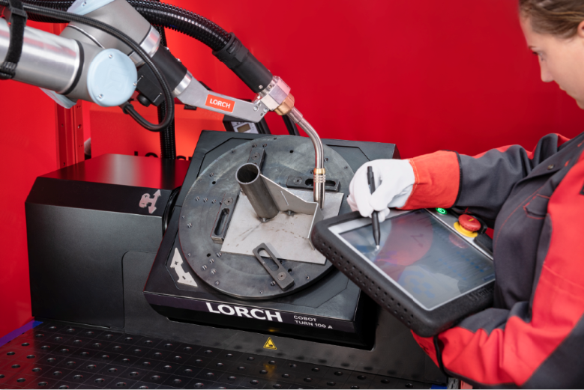
Figure 3: The settings for the turn-tilt table are made via the easily operated Cobotronic software of the Cobots.
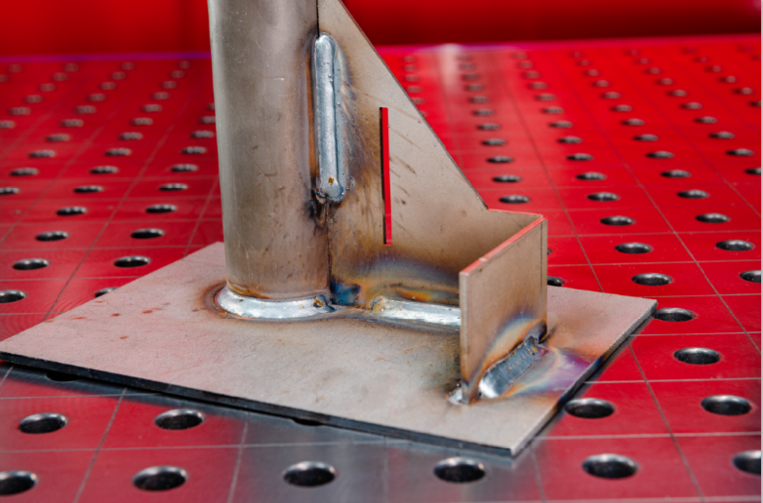
Figure 4: The turn-tilt table allows the Cobot to weld more complex parts in a single programme sequence as well. Multiple clamping and re-clamping of the workpiece that would cost time and effort is not necessary.

Press contact:
Lorch Schweißtechnik GmbH
Lisa Michler
P +49 7191 503-0
F +49 7191 503-199
Im Anwänder 24–26
D-71549 Auenwald
Germany
Print free of charge. Voucher copy requested.

