Extracting welding fume where it arises

New fume extractor torches from Lorch protect welders’ health

Lorch’s inception of their cutting-edge Speed welding processes has already made a significant contribution with the reduction of welding fume. However, a certain amount of fume cannot be avoided during welding. Realising this fact, Lorch Schweißtechnik is now unveiling their latest line of fume extractor torches. It enables the health of welders to be protected and offers companies a solution to the increasingly stringent limits for alveolar dust (A dust). The new torches set themselves apart with their compact design, highly efficient fume extraction and excellent welding performance.
Compliance with dust limits of 1.25mg/m³ was made mandatory by the Technical Rules for Hazardous Substances - TRGS 900 - at the end of 2018. These stringent limits pose a string of challenges for any company engaged in performing welding jobs. Key measures companies can already take today to ensure conformity with these limits are the application of low-emission welding processes, e.g. Lorch's Speed processes, the installation of extraction equipment in the production halls or even extraction arms mounted directly above the welding bench. However, companies looking for a more practical solution increasingly focus on extraction built into the torch. This is because the targeted and effective capturing of the welding fume directly at the torch, i.e. at the place of its generation, offers tremendous advantages: In addition to dramatically reducing the air volume that needs to be extracted, this approach provides for extraction directly at the arc, keeping the harmful welding fume from even coming close to the welder's respiratory tract.
Lorch’s latest generation of fume extractor torches consolidate these advantages into one seamless practical solution: Tipping the scales at merely 1.1 to 1.5 kg and featuring an exceptionally compact design, these new torches are not much larger or heavier than conventional MIG-MAG torches. The unique positioning of the extraction openings directly at the head of the welding torch allows an ultra-efficient extraction close to the weld pool. Due to the conical shape of the suction head, the shielding gas also flows out at a higher speed, so that it reaches the weld pool unhindered. This design guarantees a stable arc even in forced positions and decreases the risk of porosity. Finally, since narrowing towards the bottom it also improves the welder's view during welding.
Lorch makes their fume extractor torches available in three performance classes with 280, 320 and 550 amp, with the first two versions being cooled by air and the 550 amp model boasting a water cooling system. All torch models can be purchased with a rugged leather sleeve that is designed to keep the extraction hose safe from spatter or any sharp edges on the workpiece. Better still, the combination of these torches with Lorch's innovative Powermaster function lets the welder control all essential parameters directly at the torch built in control panel. All three performance classes can be effortlessly connected to all extraction systems available on the market today that are capable of achieving an effective extraction capacity of 55-65 m³/hour (measured at the torch head) when combined with the new torches.
Lars Braun, Product Manager at Lorch Schweißtechnik GmbH, concludes: “Our new fume extractor torches provide companies with the best solution available to stay in compliance with ever stricter requirements and more stringent dust limits, enabling them to protect the health of their welders. Highly innovative, these torches offer the perfect blend of performance and functionality that today's welders have come to expect from state-of-the-art work equipment: Compact design, superior extraction efficiency and a perfectly ergonomic shape that is sure to produce an excellent weld seam every time.”
Lorch Schweißtechnik GmbH is one of the leading manufacturers of arc welding systems for industrial applications, the demanding metal working, as well as for use in automation with robots and collaborative robot systems. For more than 60 years, Lorch's premium quality systems have been manufactured in Germany at one of the world's most cutting-edge manufacturing plants for welding equipment and exported to more than 60 countries. The welding equipment engineered by Lorch merges first-rate suitability for real-world applications with superior ease of use and outstanding efficiency, setting new technological standards in the marketplace.

Fig. 1: Highly efficient fume extraction, a compact design and excellent welding performance are the distinguishing qualities of new fume extractor torches engineered by Lorch Schweisstechnik.

Fig. 2: There is a clear difference between welding with and without the use of the fume extractor torch: The targeted extraction directly at the arc minimises the dispersal of welding fume drastically.

Fig. 3: Lorch's new fume extractor torch in action: An ideal tool when it comes to staying in conformity with ever stricter regulations imposed on dust limits.
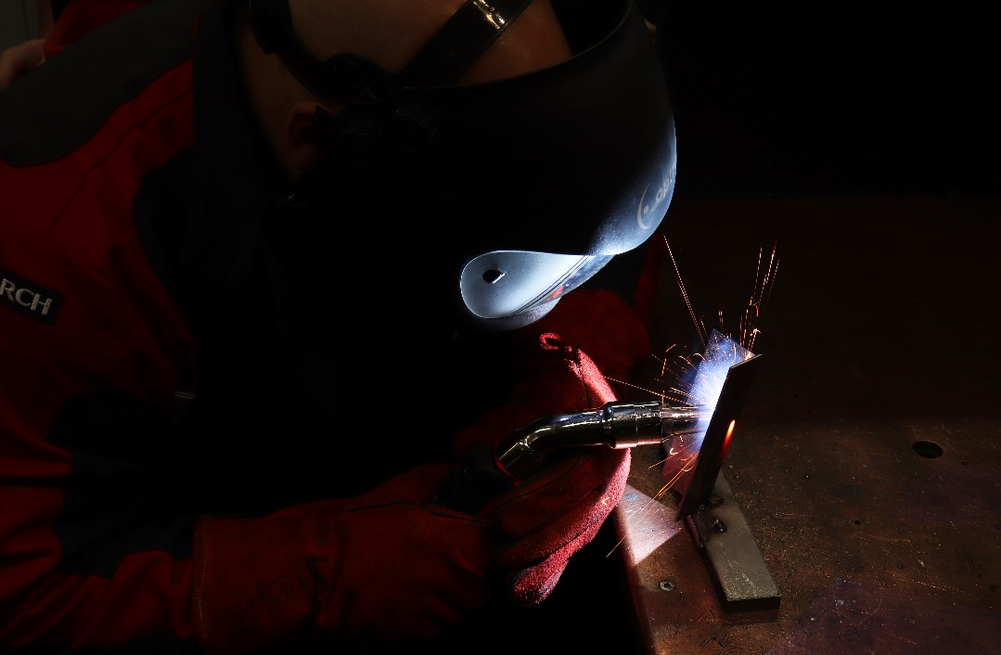

For more information, log on to www.lorch.eu
PR contact:
Lorch Schweißtechnik GmbH
Lisa Michler
T +49 7191 503-0
F +49 7191 503-199
Im Anwänder 24-26
71549 Auenwald
Germany
Reprint free of charge. Specimen copy requested.

