On growth track
Lorch Schweißtechnik GmbH announces the establishment of the new subsidiary Lorch South Pacific Pty. Ltd.

Lorch Schweißtechnik has had a long and successful history of welding equipment sales in the South Pacific region (Australia, New Zealand and the Pacific islands) under private branding arrangements. The establishment of the new subsidiary, Lorch South Pacific Pty. Ltd. is in line with the company’s strategic geographic expansion plans. The subsidiary opens up the region to the full Lorch product portfolio and establishes a long-term commitment to distribution partners and end-user customers.

“I have a long history with Lorch; they are an amazing company with some of the best engineering talent in the world. They’re a technology and innovation leader focused on developing smart welding solutions that drive customer productivity, backed with exceptional service and support. Lorch is well advanced and ready for the next great industrial revolution 4.0, meeting the demand for intelligent, digitalised systems and networking solutions. Lorch has leading, game changing welding solutions for South Pacific major industry sectors including mining, general fabrication, structural steel and ship building. I am delighted to be partnering with Lorch and looking forward to bringing quality, cutting edge German welding technology to the South Pacific market” says David Wilton, Managing Director and co-owner of Lorch South Pacific Pty. Ltd..

Lorch Schweißtechnik GmbH is a leading manufacturer of electric arc welding systems for industrial applications, metalworking, partially automated solutions and robot automation systems. For more than 60 years, Lorch's premium quality systems have been manufactured in Germany at one of the world's most cutting-edge manufacturing plants for welding equipment and exported to more than 60 countries. The welding equipment engineered by Lorch merges first-rate suitability for real-world applications with superior ease of use and outstanding efficiency, setting new technological standards in the marketplace.

Figure: Are pleased about the foundation of Lorch South Pacific (LSP): Cataldo Sposato (international Lorch Sales Director), Wolfgang Grüb (Lorch owner and CEO), David Wilton (Managing Director LSP), Ronald Weber (Managing Director and CSO Lorch) and Stefan Krämer (CFO Lorch). (f.l.t.r.)
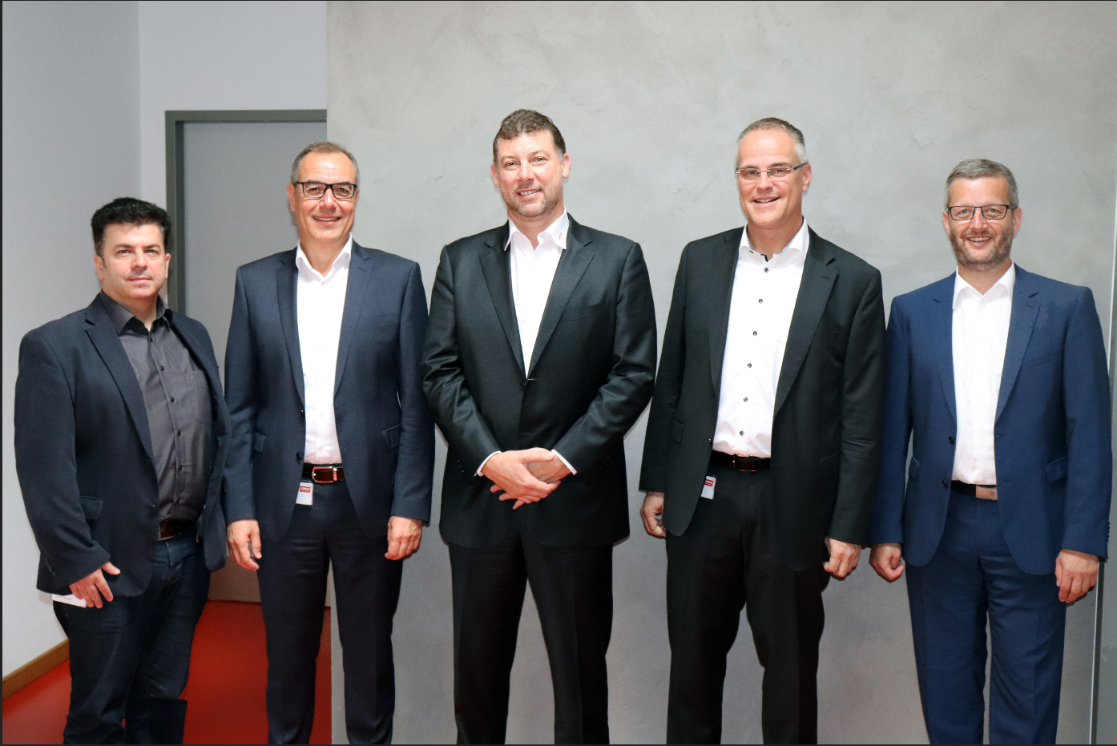

Additional information is provided at www.lorch.eu

contact:
Lorch Schweißtechnik GmbH
T +49 7191 503-0
F +49 7191 503-199
Im Anwänder 24-26
71549 Auenwald
Germany

Reprint free of charge. Specimen copy requested.

