Lorch Schweißtechnik GmbH: Technology partner for e.GO Life, the first electric city car developed using Industry 4.0 methods
Real-time capable data documentation guarantees short development time

Scheduled for market launch at the end of 2018, the e.GO Life is a compact electric city car that was created at the RWTH Aachen Campus using highly iterative and agile development and production methods. As a technology partner since the development phase of the project, Lorch Schweißtechnik GmbH offers innovative, fully digital welding processes designed for seamless integration in Industry 4.0 environments, therefore ensuring reliable information availability as a prerequisite for a modern development and production environment.
At the end of the year 2018 the first cars of the e.GO Life series will leave the production hall in Aachen-Rothe Erde. What’s special about the e.GO Life is the use of state-of-the-art Industry 4.0 technologies, which enabled an extremely short development time of only three years, as well as low-priced prototype and small-series production. This made it possible to develop the close-to-production car with a budget of just under 30 million euros. Four different facilities of the RWTH Aachen Campus are involved in the development: the European 4.0 Transformation Center (E4TC), the Demonstrationsfabrik (DFA Demonstration Factory), the Aachen Center for Additive Manufacturing (ACAM) and the Aachener Werkzeugbau Akademie (WBA Tool Making Academy).
The manufacture of a lightweight chassis is a central aspect of the e.GO Life concept. To reduce weight, simple square aluminium profiles are welded together to create a sophisticated and sturdy frame construction. Early simulations led to the development of a high-quality chassis, in which the rigidity of the battery compartment was utilised for improving the passive safety of the entire vehicle.
To achieve an optimal chassis, it was necessary to build different e.GO prototypes and preproduction models in the DFA Demonstration Factory. The development team there uses equipment from Lorch Schweißtechnik GmbH. The specialist for digital welding processes was chosen for the project due to the use of technology that allows complete digital documentation of the welding process, which allows optimal access to all necessary welding parameters. An integrated standard interface (CAN-bus) enables automation, manual and mobile input and documentation of the welding process data using the innovative documentation systems Q-Data, Q-Sys or a cloud connector – ideal for networked data exchange via Industry 4.0, as well as continuous optimisation of the development and production processes.
Comprehensive data documentation is also especially important for the manual welding processes, which were used primarily in the prototype production of the e.GO Life. Recording and documentation of the welding parameters for these processes is no problem. This makes it possible for the developers to further optimise the frame construction or the welding process by means of iterations on the basis of reliable data.
“The environment of the RWTH Aachen Campus helped make it possible to develop this vehicle with a budget of just under 30 million euros. With our highly iterative prototype development concept we demonstrated that visionary solutions can be developed in a relatively short time of only three years to market launch. We are very pleased to have found Lorch Schweißtechnik GmbH as a development partner, which today already offers highly connected Industry 4.0 capable solutions that can easily be integrated in an agile development environment,” says Professor Günther Schuh, CEO of e.GO Mobile AG.
“Lorch Schweißtechnik GmbH is proud to be able to support such an ambitious and future-oriented project as the e.GO Life. As one of the most innovative manufacturers of welding solutions, who for more than ten years has been equipping its welding equipment with a standardised digital interface, the “LorchNet,” we are doing our utmost to integrate welding processes in digitised development and production processes, in order to guarantee optimal cost effectiveness,” explains Achim Rausenberger, Director of Research, Development and Technology at Lorch Schweißtechnik GmbH.

e.GO Mobile AG
A manufacturer of electric cars, e.GO Mobile AG was established in 2015 by Prof. Dr. Günther Schuh. The 230 employees at the RWTH Aachen Campus benefit not only from the flagship project StreetScooter, but also use the unique campus network of some 360 technology enterprises and research institutes. Agile teams work on the development of various low-priced and customer-oriented electric cars for short-range traffic. For series production, e.GO Mobile AG is currently getting its new factory in Aachen-Rothe Erde ready for operation. www.e-go-mobile.com
Lorch Schweißtechnik GmbH
Lorch Schweißtechnik GmbH is a leading manufacturer of electric arc welding systems for industrial applications, metalworking, partially automated solutions and robot automation systems. For more than 60 years, Lorch's premium quality systems have been manufactured in Germany at one of the world's most cutting-edge manufacturing plants for welding equipment and exported to more than 60 countries. The welding equipment engineered by Lorch merges optimal suitability for real-world applications with superior ease of use and outstanding efficiency, setting new technological standards in the marketplace.

Captions
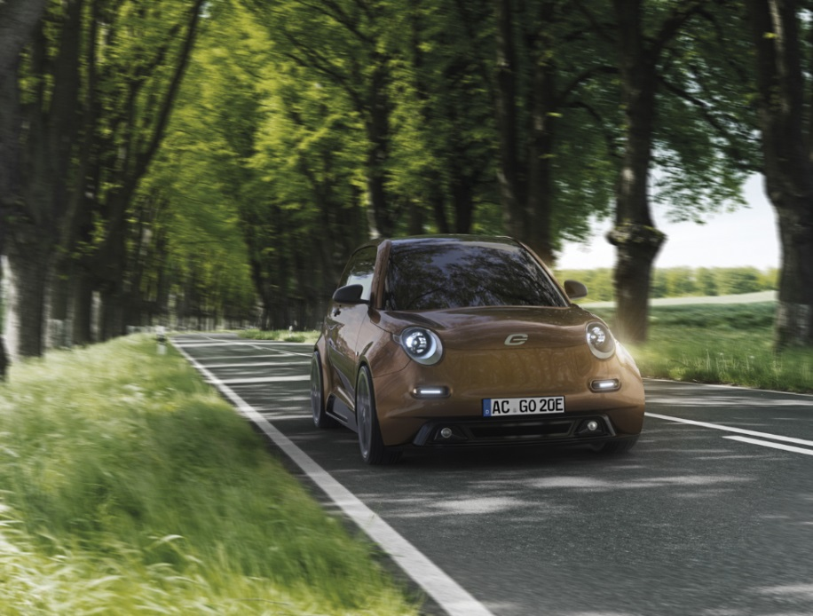
Innovative e.GO Life concept: highly iterative prototype development and intelligent networked production processes resulted in a practical and affordable electric city car

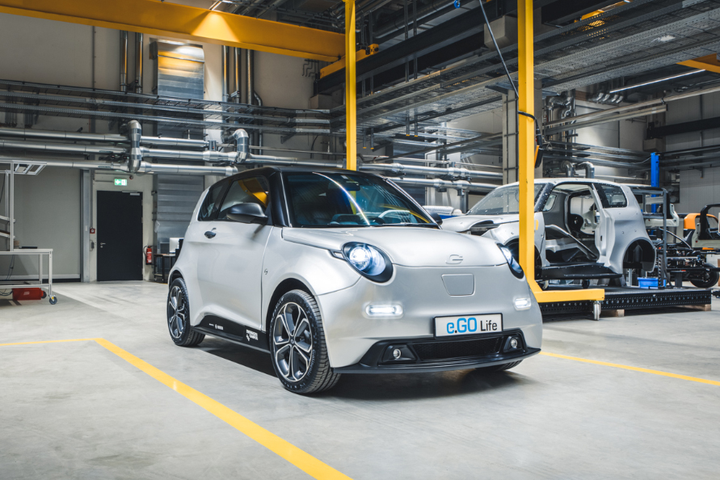
Short development time thanks to Industry 4.0: The first prototypes of the e.GO Life were produced in the demonstration factory of the RWTH Aachen Campus

For further information please visit www.lorch.eu

PR contact:
Lorch Schweißtechnik GmbH
Sandra Vix
T +49 7191 503-0
F +49 7191 503-199
Im Anwänder 24-26
71549 Auenwald
Germany

Reprint free of charge. Specimen copy requested.

