Unbeatably smart: the new, portable professional TIG welding machine with All-In technology and battery power
MicorTIG 200: maximum flexibility and mobility during TIG welding

Say goodbye to lugging around cables: Now, for the first time, Lorch Schweißtechnik lets you cut the cord while TIG welding with the MicorTIG 200. This portable TIG welding inverter can be operated effortlessly with three types of power sources: regular 230 Volt mains, generator power or power supplied by a battery. This ground-breaking innovation will be shown at the world’s leading trade fair SCHWEISSEN & SCHNEIDEN 2017 in Düsseldorf between September 25th and 29th.
Previously, companies were required to invest a lot to place professional TIG weld seam in hard-to-reach or far-flung places. Not any more: the MicorTIG 200 is now cutting down this effort tremendously. With a weight of only 6.8 kilogrammes, the welding inverter is easy to carry, yet sturdy enough to stand up to the toughest jobs in the workshop or on site. Exceeding the requirements defined in crash protection standards by a factor of three (80 centimetres versus the 25 centimetres required by the standard), the machine is without equal in its class.
Another feature that sets it apart from its competitors in this device class is its All-In technology. Depending on the application at hand, the inverter can be hooked up to a regular 230 Volt mains supply, a generator or a MobilePower battery pack. This versatility affords the user maximum flexibility and eliminates the need to hunt for a power outlet or drag along long connecting cables. Better yet, its patented MicorBoost technology delivers unrivalled power: Working in a similar way as the turbocharger in a car, the unit can tap significantly higher voltage reserves. In addition, the cutting-edge power electronics and the stand-by functions built into the MicorTIG 200 provide for exceptionally high energy-efficiency and, thus, the lowest possible power consumption.
Perfect arc, intuitive operation
Now sporting a feature normally found in industrial TIG systems only, Lorch’s portable inverter system comes with a non-contacting HF (high frequency) ignition. Ignition is triggered with a press of a button (the tungsten electrode is not touching the workpiece) - a feature previously unheard of in battery-powered welding. Another highlight of the MicorTIG 200 is the integrated pulse function with up to 5 kHz (pulsing and fast pulsing), which offers additional advantages to the welder when working with thin sheets.
But, we did not stop there: the MicorTIG 200 also offers an exceptional operating concept. Firstly, even the standard model “BasicPlus” comes with the “3 steps to weld” operating concept. The additional features built into the “ControlPro” model with OLED display are comprised of symbol-controlled operation and language selection as well as a job memory holding up to ten TIG and electrode jobs - all in all, equipment options that you would normally expect from much larger systems.
Despite these numerous additional features, the machine offers effortless and convenient handling during everyday use thanks to its intuitive navigation, setting the new gold standard in its class for portable TIG welding systems.
Highly efficient: Control the welding current directly at the torch
Also unique in this class of machines is a feature the MicorTIG 200 offers in combination with the Lorch Powermaster torch: controlling the welding process remotely directly at the torch. The welding current is indicated in an LED field on the torch, while the current can be turned on and off or adjusted individually with a press of a button at the torch (Up-Down button). No more need to switch back and forth between workpiece and machine. All operating variants can also be combined with common foot and hand remote controls. The new MicorTIG 200 will be available starting with the end of Q1/2018.
Hall 10, Stand A42

Lorch Schweißtechnik GmbH is a leading manufacturer of electric arc welding systems for industrial applications, metalworking, partially automated solutions and robot automation systems. For 60 years, Lorch's premium quality systems have been manufactured in Germany at one of the world's most cutting-edge manufacturing plants for welding equipment and exported to more than 60 countries. The welding equipment engineered by Lorch merges first-rate suitability for real-world applications with superior ease of use and outstanding efficiency, setting new technological standards in the marketplace.

Figure 1: No matter if connected to a 230 Volt mains supply, generator power or power supplied by a battery - the new MicorTIG 200 by Lorch ensures maximum flexibility and mobility during TIG welding in both operating variants "ControlPro" and "BasicPlus" (from right to left).

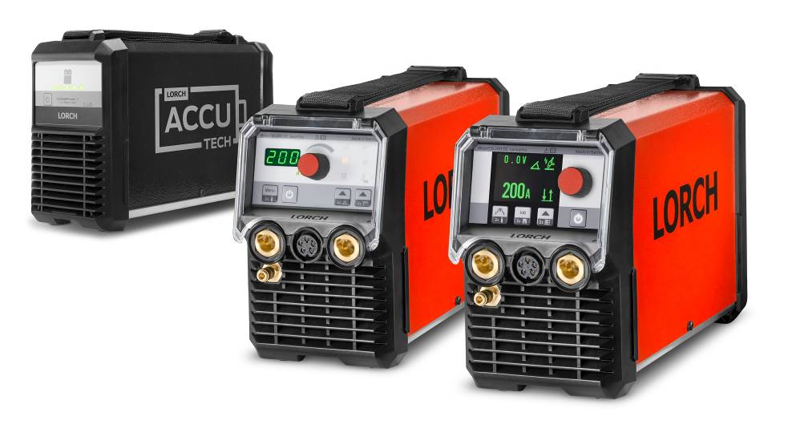
Additional information is provided at www.lorch.eu

PR contact:
Lorch Schweißtechnik GmbH
Sandra Vix
T +49 7191 503-0
F +49 7191 503-199
Im Anwänder 24-26
71549 Auenwald
Germany

Reprint free of charge. Specimen copy requested.

