New class of MIG-MAG pulse welding machines

MicorMIG Pulse: the new series by Lorch Schweißtechnik offers the optimal entry into the world of pulse welding
A pioneer in the field of MIG-MAG pulse technology, Lorch Schweißtechnik offers companies operating in industry and metal working a perfect jumping-off point into the world of low-spatter MIG-MAG pulse welding with their brand-new series MicorMIG Pulse. These new machines are guaranteed to produce weld seams of top-notch quality even in the difficult transition arc range. Lorch is unveiling the MicorMIG Pulse along with the new generation of their MicorMIG machines at the world’s leading trade fair SCHWEISSEN & SCHNEIDEN in Düsseldorf between September 25th and 29th.

Goodbye, transition arc: As the inventor of the SpeedPulse processes, Lorch stands for supreme quality in the field of MIG-MAG pulse welding. By adding the brand-new MicorMIG Pulse series to their product family, Lorch is expanding their pulse welding portfolio and is now offering customers - in addition to their high-performance flagship, the S-series - another option to benefit from standard pulse technology. Whether they use the technology on steel, stainless steel or aluminium, customers can now say goodbye to the transition arc and rely on a pulse process that is guaranteed to afford them low-spatter welding without any tedious rework along the entire synergic curve. The MicorMIG Pulse unleashes its full potential especially when used for material thicknesses between two and eight millimetres. Another plus: The machine operates with a stable frequency, generates little noise and produces impeccable welds thanks to a “smooth” seam transition. Just as the MicorMIG family, the MicorMIG Pulse series is available in four power variants (300, 350, 400 and 500 amperes) and offers an exceptional price-performance ratio. These qualities make the MicorMIG Pulse uniquely suited to become the all-around smart solution for industrial metalworking as well as applications commonly found in small and medium-sized enterprises such as locksmith's shops or metal construction companies.

Added benefit: smart equipment and optional Speed processes

Lorch added new features that benefit both, the new MicorMIG Pulse series as well as the new generation regular MicorMIG. One example of these useful new features is the innovative quick-change system for the wire feed rolls, which will come standard with all future MicorMIG Pulse and MicorMIG machines and cut the set-up times required for changing the material to a minimum. Other examples include the heavy-duty carriage and the optimised MF-08 fully protected wire case, which increases reliability and guarantees effortless handling in difficult work environments. Better still, all MicorMIG series machines remain upgradeable throughout their lifetime thanks to integrated NFC technology. This technology makes it possible to install additional welding programs and processes such as SpeedArc or SpeedUp later on in a quick and easy manner. NFC technology also allows the welder to transmit their welding parameters quickly and safely to the machine using an NFC card - which makes this technology ideal for end-to-end quality assurance.

Outstanding performance - simple and intuitive operation

Both MicorMIG series make operation as effortless and intuitive as can be - which is of high importance during everyday use. As an example: the welder can adjust the arc from soft to hard according to his specific requirements. This operating concept works across all machines of the series, and customers can choose between the operating variants Basic, BasicPlus and ControlPro. The Basic variant makes the switch from a transformer machine to an inverter completely effortless. BasicPlus marks the entry into the advantageous synergic operation. The ControlPro variant turns the task of adjusting the settings into child's play and comes with TipTronic job management, which allows the welder to store up to 100 welding jobs.

“With our two MicorMIG series we are treating our customers to unrivalled welding performance and infinitely adjustable intelligence combined with extra easy handling and an exceptional price-performance ratio. No matter which MicorMIG machine they opt for, any welder will acquire a tool that is ideally equipped to manage any future challenges thanks to its unsurpassed upgradability” says Jonas Kappel, product manager of the MicorMIG series, summing up its benefits.

Both product lines – MicorMIG Pulse and the MicorMIG including all new equipment options – will be available in early 2018.

Hall 10, Stand A42
Lorch Schweißtechnik GmbH is a leading manufacturer of electric arc welding systems for industrial applications, metalworking, partially automated solutions and robot automation systems. For 60 years, Lorch's premium quality systems have been manufactured in Germany at one of the world's most cutting-edge manufacturing plants for welding equipment and exported to more than 60 countries. The welding equipment engineered by Lorch merges first-rate suitability for real-world applications with superior ease of use and outstanding efficiency, setting new technological standards in the marketplace.

Figure 1: Best welding performance – even in the difficult transition arc range with the new series MicorMIG Pulse

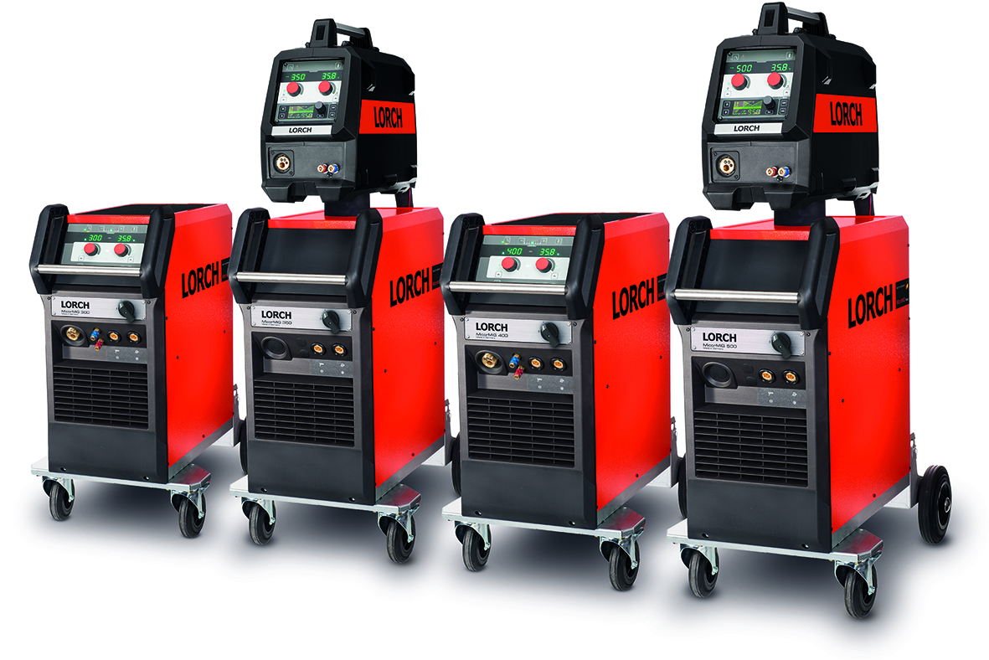
Additional information is provided at www.lorch.eu

PR contact:
Lorch Schweißtechnik GmbH
Sandra Vix
T +49 7191 503-0
F +49 7191 503-199
Im Anwänder 24-26
71549 Auenwald
Germany

Reprint free of charge. Specimen copy requested.

