Lorch Schweisstechnik are a leading manufacturer of electric arc welding systems for industrial applications, metalworking, partially automated solutions and robotic automation systems. For 60 years, Lorch's first-class welding technology and intelligent software systems are designed and manufactured in Germany. Our production facility, which is one of the world’s most, advanced factories for welding machine production, is located 30km from Stuttgart. The welding equipment engineered by Lorch merges first-rate suitability for real-world applications with superior ease of use and outstanding efficiency, setting new technological standards in the marketplace. During its long history, Lorch has bought many new and unique processes and concepts to market and continues to push boundaries even further.
If you would like to work with this dynamic and diverse company, we are currently recruiting for a
Distribution Channel Sales Manager GB & Ireland
In order to further develop and manage the sales network for the whole GB and Ireland region in cooperation with and reporting to the responsible Lorch Country manager.

The Role and key duties include:
- Maintaining and strengthening existing Lorch sales partner network
- Developing new distributors and potential new sales partners
- Working out a regional sales strategy in accordance with the overall Lorch UK strategy
- Responsibility for sales of the existing Lorch range via the sales partner network as well as introducing new Lorch products
- Increasing market awareness and developing a sustainable increase of Lorch market share in the region
- Recognise and react to market trends by suggesting, developing marketing actions and sales offers

The ideal candidate will:
- Be comfortable working independently and from their own initiative to achieve mutually agreed targets
- Have experience in sales of welding machines, preferably gained from a welding machine manufacturer or welding equipment dealer (although experience of sales of other high value Capital equipment will be considered)
- Have knowledge of welding processes and technology at an appropriate level-although training would be provided
- Have a full UK drivers licence
- Have experience of working with a CRM system

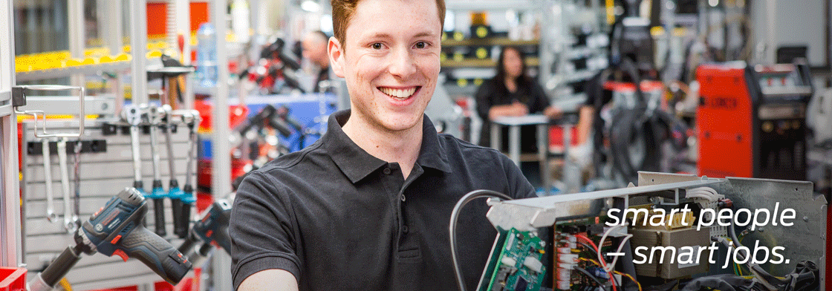

Working Environment:
- Frequent travelling within the British Isles and Ireland, which will require overnight stays
- Occasional European/Worldwide travel as when required
- Located within the UK
- Hybrid working model, from home office and Lorch UK office

What we offer:
- Opportunity to work for a market leading Global machine manufacturer
- Excellent remuneration package (Competitive Basic salary with additional OTE)
- Company vehicle
- On-Going training and personal development
- Pension Scheme
- Competitive Holiday entitlement

Interested? Contact in the strictest confidence:
Lorch Schweisstechnik Ltd
Mr Matt Stacey
Unit 15 Littleton Drive,
Cannock,
Staffordshire,
WS12 4TS.
hr.uk@lorch.eu

