Company
Name
Street
Postal code city
Country

THis is one hell of an offer!

Especially for you, dear Mr XXX,

our offer for the Lorch Cobot Welding Solutions.

Opportunity Number / SAP Offer Number / Date
XXX/ XXX / XXX

Your contact:

Lorch partner distirbutor
xxxxxxxxxxxxxxxxxxx

T XXXXXXXXXXXXXX
M XXXXXXXXXXXXXX

Optional
xxxxxxxxxx

Contents of your offer
Dear Mr. XXXX,
As agreed, you will receive our offer for our new Lorch Cobot Welding Solution as follows. Due to the information we received from you at the visit of your company, we are confident that the Lorch Cobot Welding Solution is the perfect solution for your product range.

The technical information included in this offer will allow that you are able to make a smart, seminal investment decision.

- Description and technical characteristics of the Cobot
- Description and technical characteristics of the power source
- Description and technical characteristics of the torch
- Description of the laser scanner
- Lorch Cobotronic Software
- Content of the Cobot Solution
- Prices and payment conditions
- Attachments recommended by Lorch
- Lead time and warranty
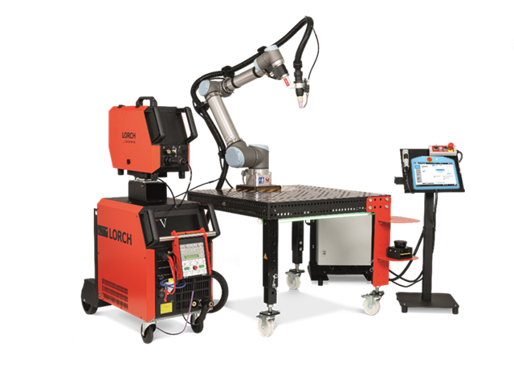

Description of Cobot
Boasting more than a decade of experience in collaborative lightweight robot systems, the current market leader in Cobots brings you the UR10e, a system that provides everything that is essential to a medium-sized welding company:

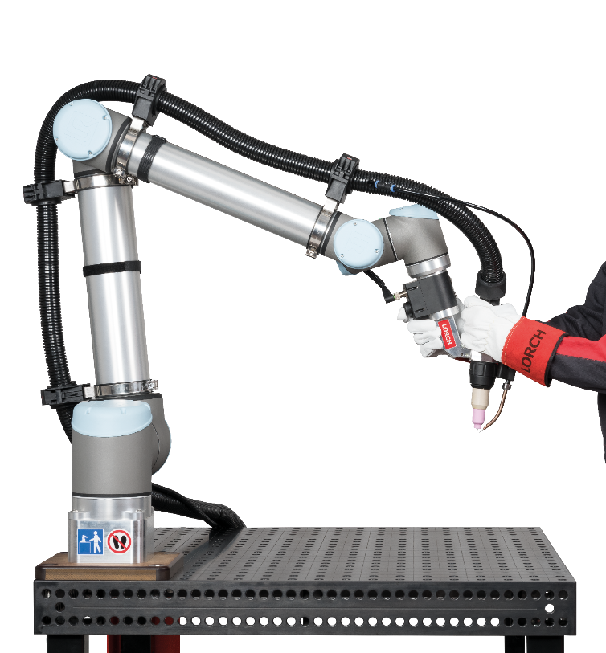
- Extensive range
- Sufficent extended bearing load
- Low-maintenance technology
- Sophisticated technology

A chance for the welding industry
Collaborating means working together. Cobot welding: Man and machine support each other during welding. The Cobot completes a precise movement of the torch while the welding system delivers the perfect weld – over and over again. A system born for automating small and medium production runs. In the past robots were limited to round and longitudinal seam welding, but now robot welding excels especially in the areas of contour and segment welding. Once set up properly (which is the main responsibility of the welding specialist in charge), the Cobot will weld complete batches with perfection.

- The welding specialist stays in complete control of the system, the Cobot acts as a tool, and the execution of the jobs is delegated. Straightforward and requiring only minimum investment costs, this type of automation is the solution to major challenges that are currently problematic for the industry, e.g. lack of skilled labour and increasing cost pressures.

- One key factor is the ability to use collaborative robots without any special additional protective equipment. The exceptional ease with which they can be installed and operated allows Cobots to become an essential team member at your company in no time at all and without the need for extensive training

Cobot welding is robot welding for medium-sized companies. With the difference that it is extremely easy.

Straightforward operation: Thanks to a touch display and intuitive user interface

From the start, the intuitive user interface makes it easy to learn and use this new technology. You quickly gain a firm grasp of the basics and can extend your knowledge in a concise, 3-day training program on commissioning, operation and the included welding functions that is designed to enable you to: Use the Lorch Cobot Welding Solution straight away for the benefit of your company.

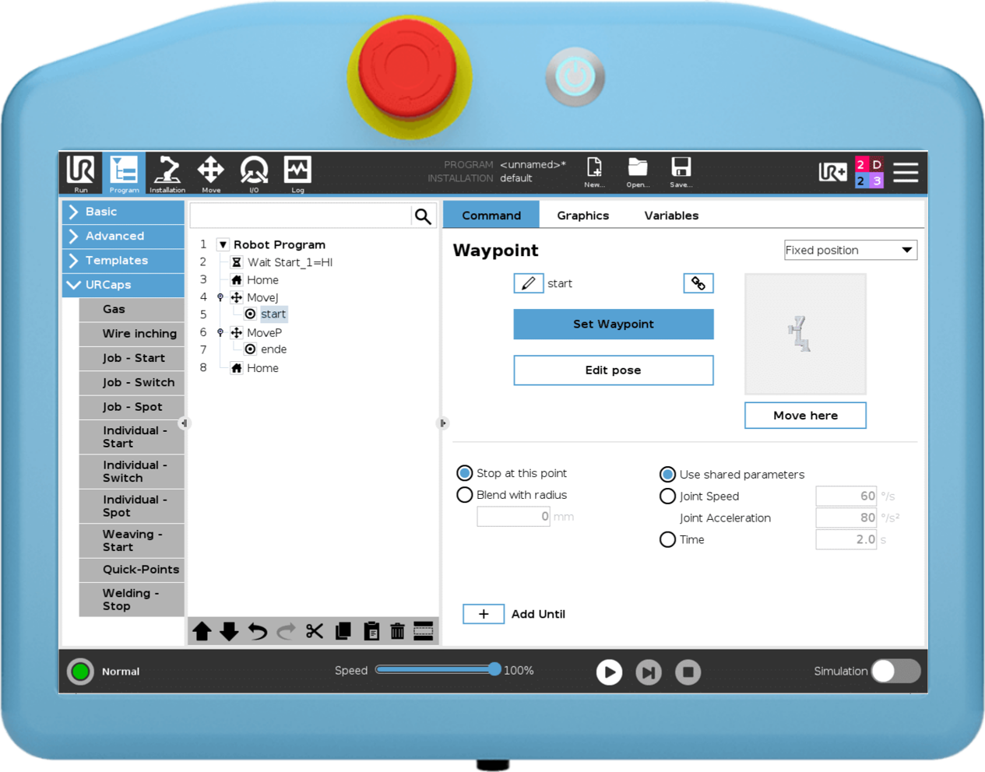

1.3 The new way to program: Free Drive function
One of the biggest challenges in robot welding was learning how to programme the robot. Otherwise, one remained dependent on external experts who had only a limited knowledge of welding. Once a company's own employees have undergone lengthy training, they are usually not with the company for long, because another company is desperately looking for precisely this qualification.

You can activate the Free Hand function to manually move the Cobot / the torch to the position where it is supposed to start and end. You use the same function to program intermediate points and sections. Quickly and simply without the need for extensive prior experience.

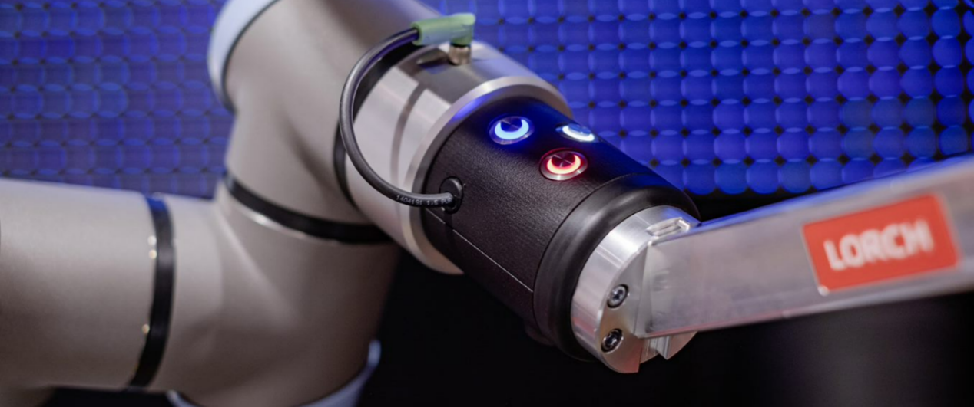

Technical data of the Cobot
Feature | Characteristic
Weight: | 33,5 kg
Action radius: | 1300 mm
Bearing load: | 12.5 kg
Repeat point-to-point accuracy: | +- 0,05 mm
Degrees of freedom: | 6 rotating joints
Assembly: | Fixed on the hole pattern table
Power supply: | 230 Volt 1 Phase
Other: | 1-year manufacturer’s warranty, optional 2-year warranty

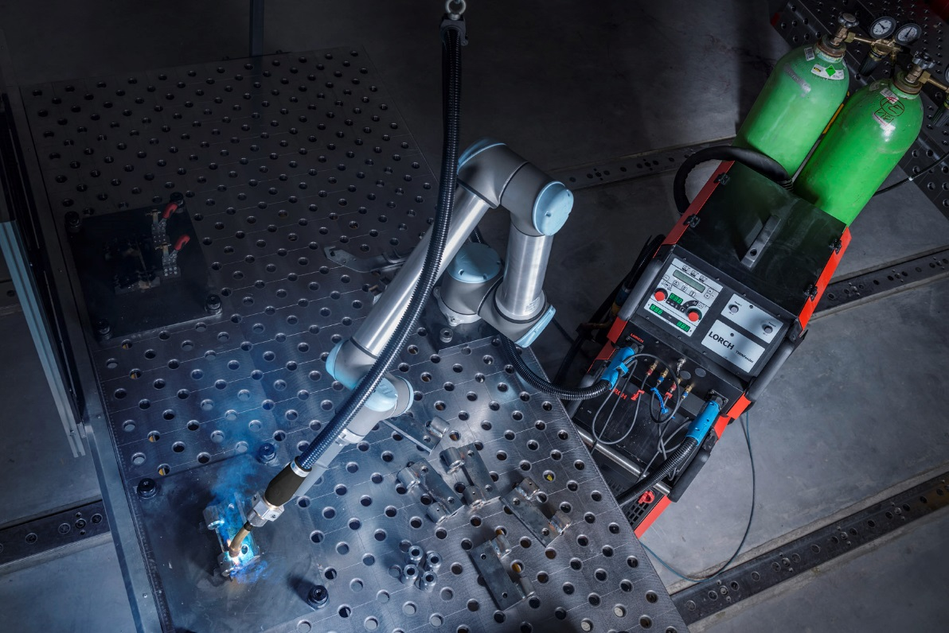
Example picture: The offered system deviates from the picture

Description of the power source
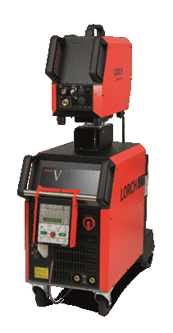
For years, Lorch has been setting exclamation marks in TIG welding with its V series. Thanks to its impressive arc characteristics and the 20 kHz pulse function for a particularly deep penetration with minimal distortion, it produces welds that inspire.

And it's clear that we only want to pass on the best of the best to you in our Lorch Cobot Welding Solution. Because if there's one thing you expect from robotic welding, it's top seam quality in addition to corresponding productivity. And that's exactly what the V30 AC/DC W Cobot delivers. It doesn't matter which fusion-weldable material you have in front of you. Even welding aluminium is no problem with the AC-DC version. Added to this are the already familiar Tiptronic, which stores the ideal setting for up to one hundred seams, and ignition properties optimised for automated welding.

Yet the V30 AC/DC W Cobot doesn't look like a typical robot system, nor should it. Because your welding system should be just as flexible as your cobot. In the cobot version, with cylinder trolley, not only is the accommodation of the gas cylinder solved, but the system also remains fully mobile in your production.
With 300 A and peak duty cycles, a wide range of applications is guaranteed. In addition, it comes with a special cobot interface that optimally prepares it for cobot welding.

The water cooling system ensures optimum user safety through rapid torch cooling. In addition to your user, you also benefit directly from this. The water cooling system not only ensures optimum service life, it is also responsible for the longevity of the torch wear parts. This not only saves money, but also ensures that you achieve consistently good welding results over a longer period of time.

Description of the welding functions

AC-DC

Use the DC setting for welding steel, stainless steel, copper, titanium and other materials. With the AC setting, positive pole ignition and automatic dome control ensure perfect arc shaping for aluminium welding. The special AC shape with optimised current balance produces a good cleaning effect and a controllable weld pool. Used not only for aluminium but also for magnesium and its alloys.

Non-contact HF ignition
Reliable, contactless ignition thanks to optimised HF ignition (High Frequency) for automated welding.
TIG ignition is contactless with high-voltage pulses. Since the tungsten electrode does not touch the workpiece, there are no tungsten inclusions in the seam and the electrode is protected. As a result, you benefit from a long electron life and the highest seam quality

Pulse

With the pulse function, you can ensure controlled heat input and stunning seam scaling for visible seams in any position.

20 kHz high frequency pulsing

Maximise the focus and stability of your arc with high-frequency pulsing for deeper penetration and minimised distortion. In addition, with high-frequency pulsing you benefit from a higher welding speed in general and less distortion when welding thin sheets. Another positive side effect for your employee: the reduced noise emissions during this process lead to less workplace stress.

Description of torch
The perfect interaction between the welding system and the torch is crucial for the welding performance on the robot. That is why we have developed a new robot torch especially for your Lorch Cobot Welding Solution. Exactly what you want for cobot welding of fusion-weldable materials: the LTR 350. The result is high-quality TIG welds for all fusion-weldable materials and an excellent appearance of the TIG welds.

- Extra robust design of torch components
- Current at 60% duty cycle 350A AC
- Electrodes up to 3.2 mm thick, making the torch not a limiting factor in the system
- Corrugated tube hose package that perfectly protects hoses and cables from kinking and damage
water-cooled
- Massive cooling by heat pipe technology for longer service life and more user safety.
- Incl. initial equipment set and setting gauge for TIG electrodes

Equipped with wear parts that provide for optimum current transfer and maximum welding performance.

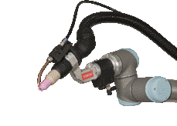
The torch holder is designed in such a way that, in addition to maximum stability, it has only a minimum of interfering contour and thus enables optimum component accessibility in daily use.

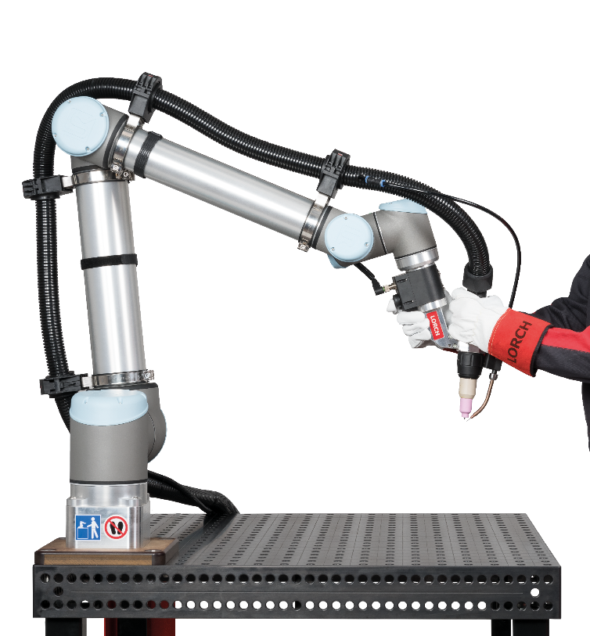
Hose package handling:

Since the TIG process is extremely sensitive to external influences, we decided to use a hose package handling system directly on the cobot for this process. This special set consists of four holding clamps and ensures that the hose package is guided as smoothly as possible and any vibrations caused by attachments are avoided. In addition to the hose assembly, the cable of the flange with the enabling switch is also guided along the cobot by means of Velcro straps. In addition, neither the torch hose assembly nor the supply line come into conflict with the cobot movement.

Description of the laser scanner
For the optimal safety of your operator, a laser scanner forms the basis of our safety concept. This excludes the possibility of injury during operation.

Sick NanoScan3
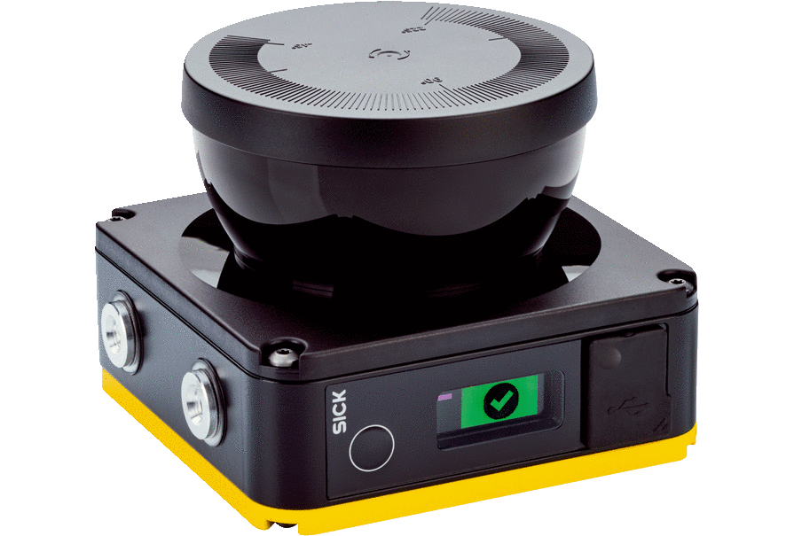
The NanoScan3 safety laser scanner is the world's smallest safety laser scanner, and its robustness and precision make it a perfect match for our Cobot Welding Package.
Since the scanner has a limited monitoring range (protective field) of 3 metres, the number and mounting of the laser scanners depends on the setup conditions of the Cobot system on site.

Functional description
With the help of the NanoScan3, an area of 2000 mm around the welding workplace is scanned, as shown in the following diagram. If this area is undershot during operation, an acoustic warning signal will first sound. If this is ignored and the system is approached to within 1500 mm during operation, the Cobot automatically stops its work and interrupts the Weld seam. This new concept excludes the possibility of injury to the employee. Another positive effect: the speed of the Cobot can be increased compared to classic MRK applications, which means that processing times can be reduced, especially for many transfer tasks.

Setup scenario - 1 laser scanner
This offer includes the safety package with one laser scanner. In this case, the system must be surrounded by at least two non-reversible walls. The setup could look like the following graphics. The setup in another corner is also compliant.
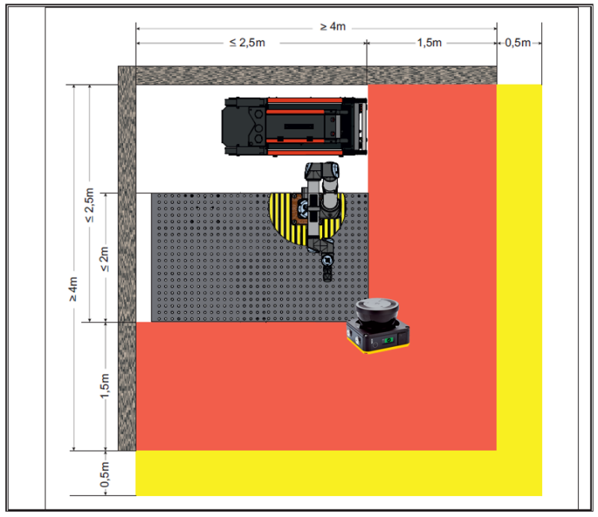

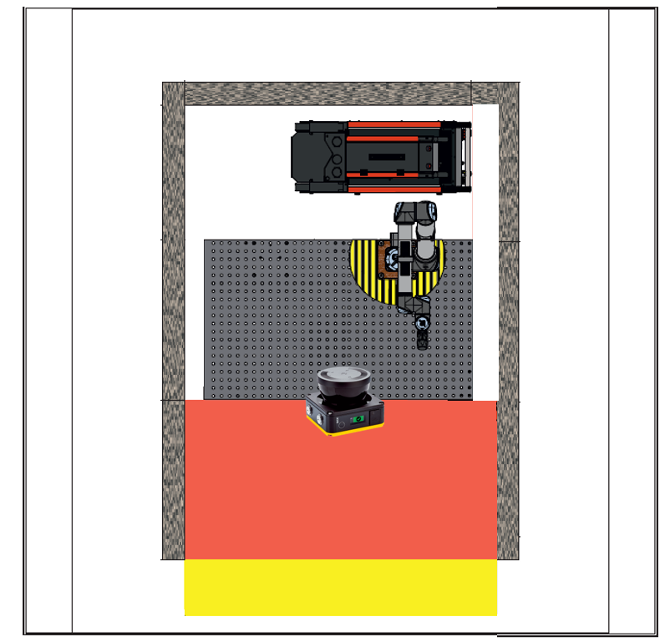

Lorch Cobotronic Software

The distinguishing feature of the Lorch Cobot Welding Solution is its software. From our welding experts for your welders: perfectly matched to the welding equipment made by Lorch. The addition of special control functions turns the universal Cobot into a first-rate tool for welding experts. This makes creating new programs a cinch. You can choose between the classic Robot Job Mode, the advanced Individual Mode with full parameter access to the power source or the innovative Assistant Mode, which suggests to the user optimum system settings including robot travel speed based on the welding task.

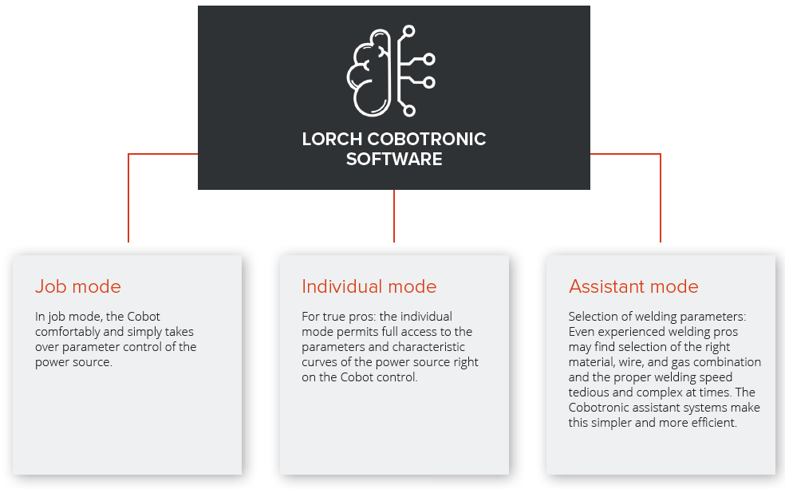

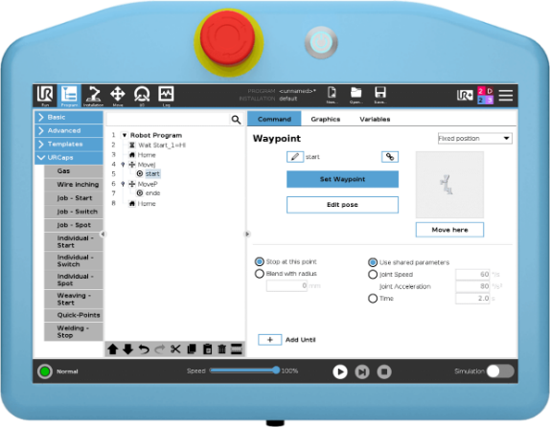
One control panel: Access to all components

In practice, one often sees two hand robot workstation are two hand-held control panels for programming. One for the robot programmer, one for the welder. This is advantageous if one not really know the work of the other. With the Cobot, the welder has all the skills in one hand. Thanks to the Lorch Cobot interface, he has full access to all the access to all relevant functionalities of the relevant functionalities of the welding system.

Cobot and welding parameters

Everything in one place while the classic job-based mode leaves a great many parameters stored in the welding system, Individual Mode makes it possible to select, set up and save all relevant parameters in the robot control. Monumental advantage: This makes backing up the parameters a breeze and makes work easier thanks to the ability to load existing programs.

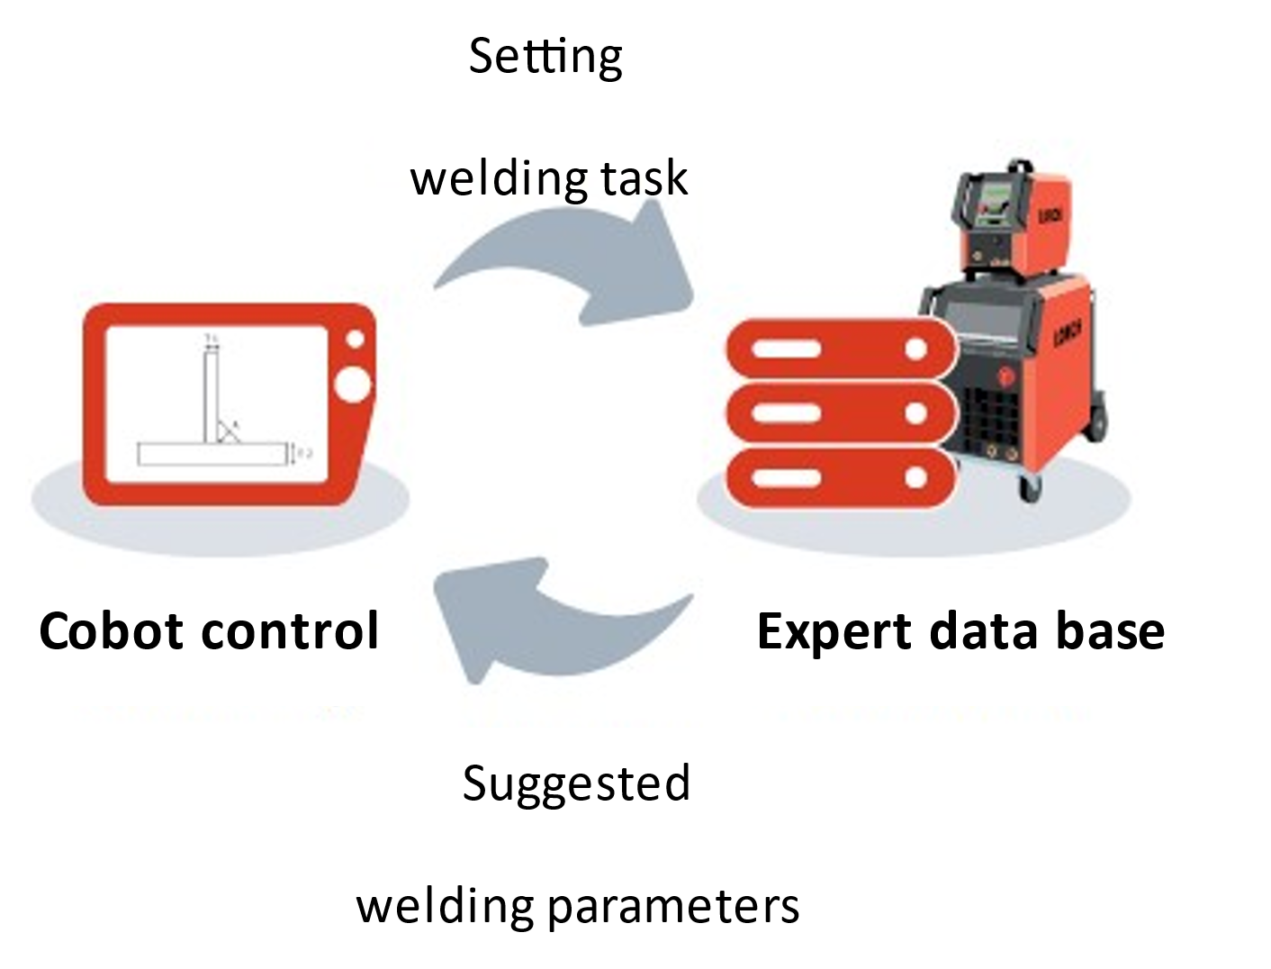
An even easier way to the perfect weld seam

You will always have quick access to the best settings, perfectly matched to the power source, the welding process, and the torch. Simply tell the Cobot control what you wish to weld (e.g. fillet weld, 6 to 4 mm steel), and the system will suggest parameters for the best possible welding process, detailed parameter settings and even the travel speed of the robot best suited for the job.

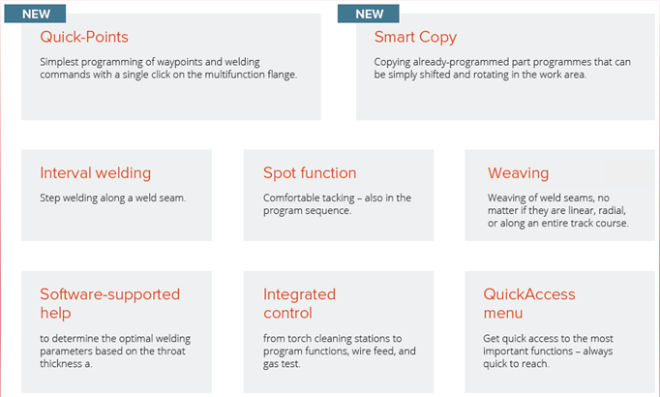
The future can be upgraded

The Lorch Cobot Welding World now also gives you the option of selecting equipment of your Cobotronic software just as you need it. Additional functions support you in your individual production needs and work processes. Our welding experts continually develop our scope of functions. Later further developments are, of course, upgrade-capable.

Your perfect gateway into the digital era

Use Lorch Connect to digitise, analyse, and reliably optimise your welding processes. The start into the Lorch Cobot Welding World takes you one step closer to Industry 4.0.
Take two with the Lorch Connect Gateway, now serially integrated. It allows you to use Lorch Connect, the simple and cost-efficient cloud solution for reliable recording and analysis of your welding production data, comfortably and without any additional costs! Performance and analysis, as well as documentation of results, are particularly important for automation.
Enjoy free access to the Lorch Connect Portal for 1 year and try out the digital services entirely without any risk.

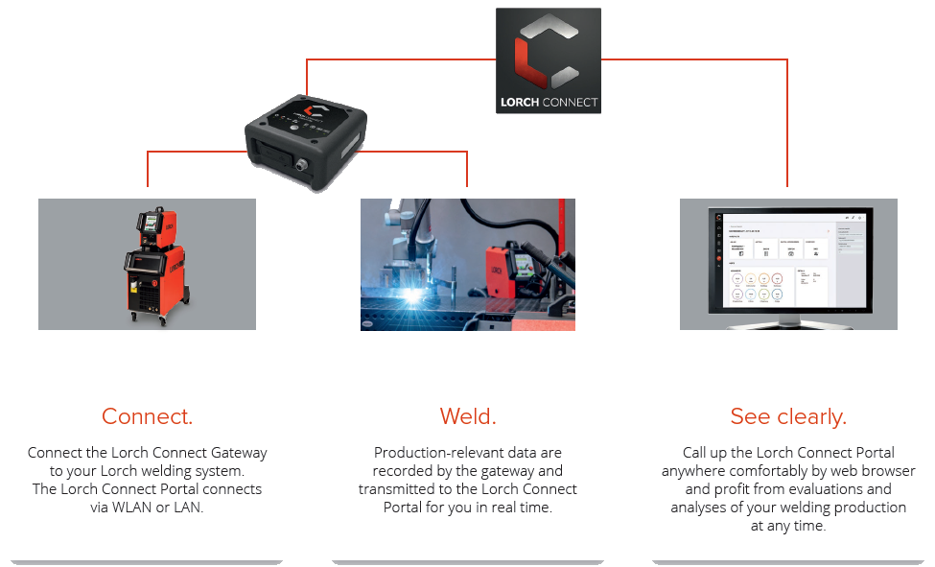

Content of Cobot Solution

☐ Art.-Nr. 241.2504.0
- UR10e including control and touch operation panel with 1 year guarantee
- V30 AC/DC with external operator panel, Water cooling system and 3 years industry warranty
  - Special-Cobot-Interface
  - Optimised ignition for automated welding
  - Stick check
- Feed 1 Cobot
- Lorch LTR350 HPT Cobot torch, 4.5 m hose package with initial supply set, electrode setting gauge for TIG electrodes
- Equipment for handling the hose package
- Multifunction flange - with control button for FreeDrive activation and three freely assignable function buttons
- Operator Panel
- Function pushbutton with emergency stop
- Safety package with laser scanner and enabling switch
- Signal column
- Floor marking tape
- Welding gloves
- Cobot equipment for installation on welding bench (hole dimension 16/28)
- Ground cable 70 mm2
- CE marking with individualized declaration of conformity (provided that it is set up and used as intended: Cobot for welding on a welding table with hole size 16 or 28)
- Lorch Connect Gateway
- URCAP Lorch Cobotronic version "Basic"
  - It includes:
    - Welding (job and individual)
    - Tack welding
    - Gas and wire control
    - Weaving
    - Interval welding
    - Quick points – programming via multifunctional flange
    - Smart copy – direct copying or moving of parts
    - AVC – smart seam tracking (as soon as available)

Prices and payment conditions
☐ | Cobot Welding Solution Art.-No. 241.2504.0  Accoring to article 5 | 78.877 €
☐ | Cobot Welding Solution services  Installation + function check 1 day  End customer training 2 days | 1.200 €  2.400 €
 | Complete price for the complete solutions (without VAT) | 82.477 €

Terms of payment: 14 days net. 50% before delivery, 50% 30 days after delivery.

Not included in the price:
- Possible necessary structural measures
- Welding table for fixation of the Cobot
- Power lines and equipment up to the connection points for the individual media, pressure reducers
- Extraction and filter system
- Consumables such as gas and welding wire
- Possible inspections / special certifications (TÜV, etc.)
- Programming

Our prices are fixed prices and are net prices plus the value added tax valid at the time of performance.
The above mentioned price is DAP (factory/warehouse of the customer).

Attachments recommended by Lorch
Designation |  | Mat. No. | Price
 | Signalling column | 240.9903.0 | 232,00 €
 | Protection for operation panel for UR10e | 240.9900.8 | 368,00 €
 | Protection glass interface for UR10e (1 pcs.) | 240.9900.9 | 89.90 €
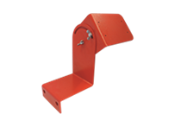 | UR10e holder for operation panel LM16/28 | 240.9907.6 | 131.00 €
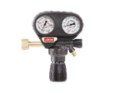 | Pressure reducer Pro Ar/CO2 200 bar 32/24 | 570.9265.0 | 87,00 €

Delivery time and guarantee
The delivery time is approx. 5 days after receipt of initial payment and agreement of the contract conditions. The delivery time matches the present capacity planning and is nonbinding. You will receive the valid delivery time with the order acceptance.
The guarantee for your UR 10e is 1 year from time of installation. For your power source, you have a 3-year Lorch warranty upon registration of the power source.

