“Schweissen & Schneiden“– in Essen from 11 to 15 September 2023
Lorch Schweißtechnik presents the future of welding
High-end technology on 433 square metres – Lorch welding technology is going to set new standards at the world’s leading trade fair “Schweissen & Schneiden” 2023 in Essen. Be it with a brand-new MIG-MAG inverter platform for industrial welding, innovative automation solutions with welding Cobots, or optimised solutions around occupational safety and health protection – visitors will find everything to render welding even faster, more efficient, and more comfortable in future at Lorch’s trade fair stand.
MIG-MAG welding on the highest level
Immediate access to welding data, state-of-the-art networking, a perfect arc, very simple operation, and easy service that keeps the welding unit in best shape even in daily production: these are the demands to welding units of the future. Lorch presents the practical implementation of these requirements in the form of a newly developed inverter platform to be presented live on site at the stand of Lorch Schweißtechnik in hall 5 at “Schweissen & Schneiden. Lorch is creating a new reference point for challenging welding tasks with many innovations – including a new torch generation precisely optimised to the system for highest welding quality.
Precisely adjusted automation solutions
Another focus of the trade fair presentation is the subject of automation, which holds a central role in light of soaring costs and a continuing lack of specialists. As a pioneer and leading provider of Cobot solutions, Lorch is showing how companies can use the flexible myCobot modules to easily compile their custom Cobot solution to optimally solve their specific welding tasks. There will also be a live presentation of how further practical functions and features help in making automated welding even simpler.

Optimal protection for the user
Optimisation of the working environment is another focus that spans all welding processes and applications. Lorch is presenting many solutions for this in its product range to minimise or even eliminate welding fume emissions during welding. This covers everything from innovative welding processes such as the Lorch Speed processes to considerably reduce welding fumes, to special fume extraction torches, to specifically designed respiratory ADFs that warrant continuous fresh-air supply for the welder.
“We are going to prove the potential still left in the MIG-MAG welding processes and what welding is going to look like in future on the world’s leading trade fair. We have developed highly practice-oriented solutions with our customers in the last few years. We are looking forward to presenting the results of our new high technology in inverter technology, automation, and work safety alike to show how much improvement is still possible in industrial welding,” says Jonas Kappel, head of product management and marketing at Lorch Schweißtechnik GmbH.

Lorch at “Schweissen & Schneiden“ 2023: Hall 5, stand C28

Lorch Schweißtechnik GmbH is a leading manufacturer of arc welding systems for industrial applications, the demanding metal craft, as well as for use in the automation with robots and collaborative robot systems. In-house developed helmet and torch systems add to ensuring optimal welding results. Lorch high-quality systems have been produced in one of the world’s most state-of-the-art welding system productions in Germany and exported into more than 60 countries for more than 65 years. Welding technology by Lorch combines great practical benefits, very simple operation, and high economic efficiency, setting new technology standards on the market.

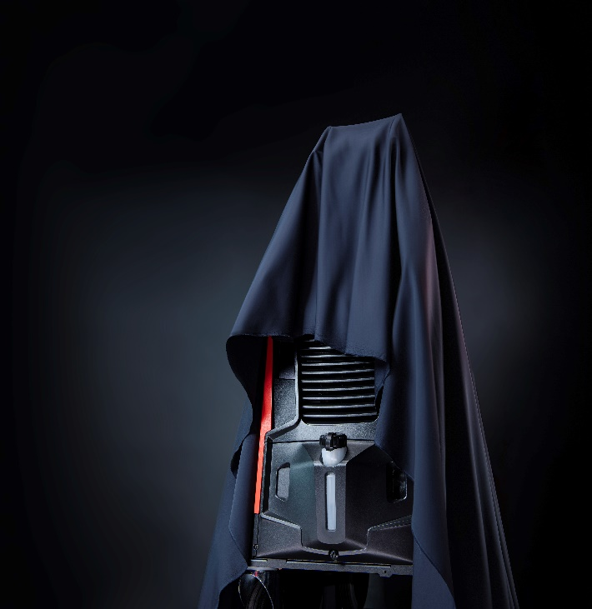
Figure 1: To be revealed at the trade fair stand of Lorch Schweißtechnik: the brand-new MIG-MAG inverter platform by Lorch for industrial welding.

Figure 2: Combined with a linear axis or with other practical additional features – the myCobot modules allow companies to compile their perfectly customised automation solution.
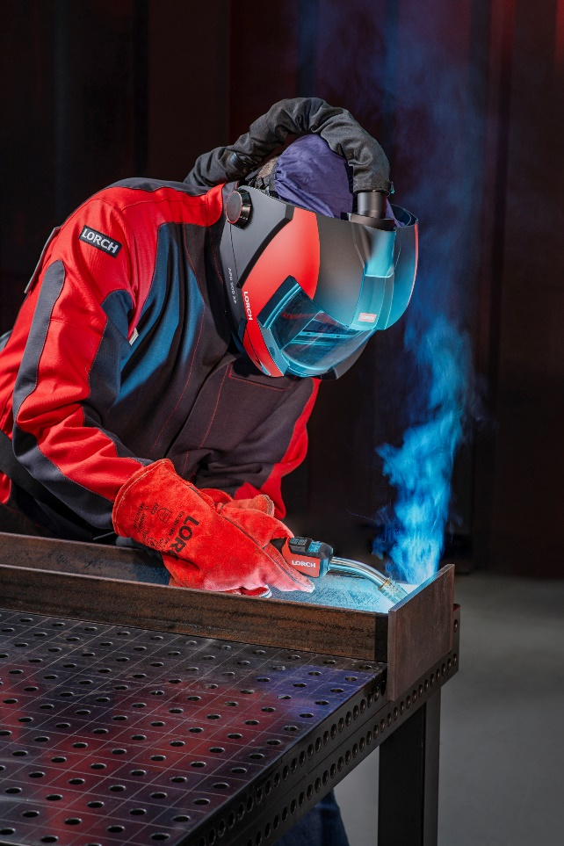
Figure 3: For optimal health protection: the new APR 900 XF, combined with a PAPR fresh-air unit.

Press contact:
Lorch Schweißtechnik GmbH
Corinna Baketaric
Im Anwänder 24-26
71549 Auenwald
Germany
presse@lorch.eu
Phone +49 7191 503-0
Print free of charge. Voucher copy requested.

