Multifunctional, high-performance, user-friendly
Diverse and flexible uses – the new MF-09 wire feeder by Lorch
Thanks to a modular build, a bulk pack feed version, flexible change-over from water to gas, and many other handy features – the new wire feeder by Lorch offers the perfect solution for any production situation, leaving nothing to be desired in user friendliness and robustness either. The MF-09 thereby ideally supplements the newly developed iQS inverter platform by Lorch Schweißtechnik.
Long weld seams, large parts, or difficult welding situations, as in ship or railway constructions – the new, customisable MF-09 wire feeder by Lorch perfectly adjusts to any production environment with its modular build and mobility. Thus, it increases the working radius around the welding source in the blink of an eye by intermediate hose packages that can be installed on the feeder case easily. The MF-09 can be combined with a wire reel housing or used at heights as a feeder version without a housing. The easily accessible wire feeder is sophisticated in every detail and offers a perfectly coordinated quick exchange system: Simplified without screws, it allows quick change of the robust and durable Lorch feed rolls. Whether the feeder case is water- or gas-cooled is determined by the matching intermediate hose package, to be easily attached and installed with a single click by the welder.
Lorch meets practical requirements regarding mobility and transport capacity of the MF-09 with three design elements: Sliding rails in the bottom make the case slide more easily when used on the ground, preventing damage to the feeder case housing as it is pulled back and forth. To render the feeder case even more mobile, 65-millimetre rollers or a 125-millimetre heavy-duty chassis set can be attached. The reliable feeder case fixture for transport and storage on the system warrant a simple and stable mandrel solution and a sophisticated floor design that helps the welder find the matching position for latching most easily.
Lorch considers the system idea in the MF-09’s user interface (HMI system) having been carried over from the iQS inverter platform unchanged. It has the advantage of being user-friendly, since the welder is familiar with user guidance and can make full use of all practical features of the iQS-system just as always. This includes free choice between touch and rotary pushbutton operation, the intuitive operating concept, or a seven-inch TFT display that allows reading of the displayed welding data even from a greater distance. The welder can keep the an eye on the basket spool in view via a lateral window in the feeder case housing, while a lamp integrated in the wire feed space facilitates wire change even in badly lit situations. Since operator protection is typical for Lorch, the MF-09 housing is completely made of plastic, making it fully insulated and very well suitable for safety-technically challenging areas of use.
Jonas Kappel, head of product management and marketing at Lorch:
"The entirely new wire feeder MF-09 specifically developed for the iQS gives your customers the perfect all-round-carefree package for production. Flexible configuration, mobile and maximally user-friendly, it offers the matching solution for any usage scenario."
Lorch at “Schweissen & Schneiden“ 2023: Hall 5, Stand C28

Lorch Schweißtechnik GmbH is a leading manufacturer of arc welding systems for industrial applications, the demanding metal craft, as well as for use in the automation with robots and collaborative robot systems. In-house developed helmet and torch systems add to ensuring optimal welding results. Lorch high-quality systems have been produced in one of the world’s most state-of-the-art welding system productions in Germany and exported into more than 60 countries for more than 65 years. Welding technology by Lorch combines great practical benefits, very simple operation, and high economic efficiency, setting new technology standards on the market.

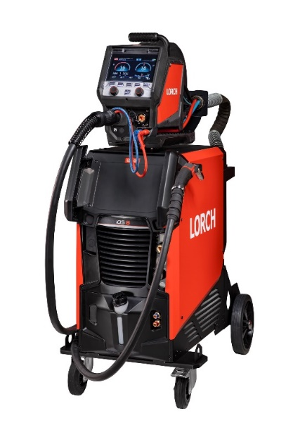
Figure 1: Ideal unit: the new iQS with the matching wire feeder
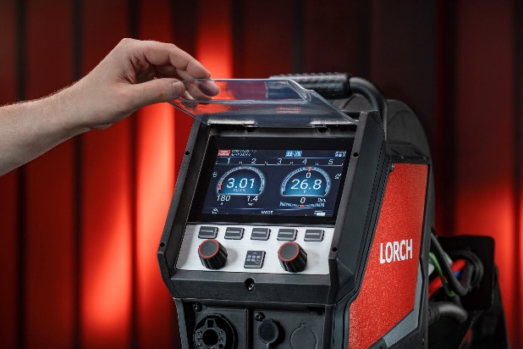
Figure 2: The 7-inch TFT-display allows the welder to keep an eye on all the important parameters at the wire feeder as well.
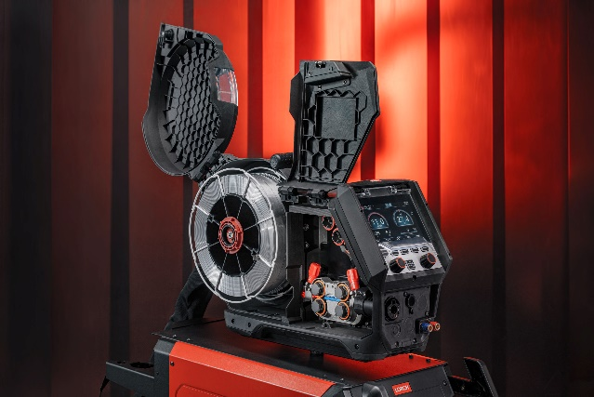
Figure 3: Unfolding sides warrant easy access to the wire feed space.
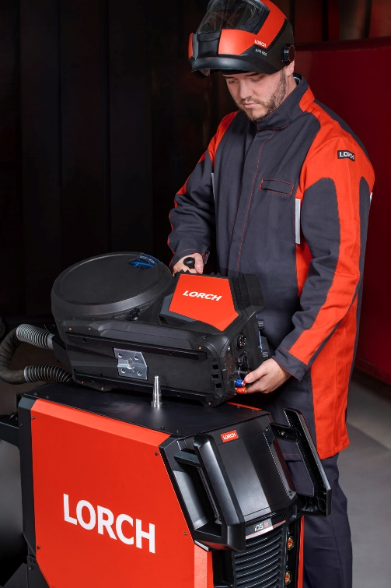
Figure 4: The practical mandrel solution helps to quickly install the wire feeder.

Press contact:
Lorch Schweißtechnik GmbH
Corinna Baketaric
Im Anwänder 24-26
71549 Auenwald
Germany
presse@lorch.eu
Phone +49 7191 503-0
Print free of charge. Voucher copy requested.

