Lorch Schweißtechnik is revolutionising MIG-MAG welding
iQS – the new, smart way of welding
Lorch Schweißtechnik is setting a new benchmark in MIG-MAG welding with its groundbreaking iQS inverter platform. Developed in close coordination with the customer and presenting a range of integrated innovations, the company is showcasing the future of industrial welding at the world’s leading trade fair Schweissen und Schneiden in Essen from 11 to 15 September. The Smart Process Control Engine (SPC) is raising development and deployment of new welding processes onto an entirely new level. Comprehensive networking allows faster service, and the Smart Cockpit gives customers further significantly simplified and intuitive operator guidance. A torch generation perfectly aligned with the new technology complements the many innovations while turning the iQS into an inverter platform with unprecedented capacities.
SPC and RCS: New high-end technologies increase performance
The innovative Smart Process Control Engine (SPC), for which a patent application has been filed already, forms the core and the perfect highlight of the new machine platform. The high-end technology developed by Lorch allows even faster welding process development and transfer to the system, saving time and money for everyone investing in an IQS, while significantly accelerating return on investment. The newly developed RCS (Rapid Current Shutdown) technology adds another important hardware component that ensures a particularly clean short-circuit resolution with little spatter and even better weld seam quality. The weld pool can also be controlled more precisely, enabling better welding of thin sheets that are not even three millimetres thick. A new generation of inverters makes the individual processes run even more stably and quietly. Of course, all MASTERS.OF.SPEED processes known to date will be available for the IQS as well.
Encapsulated air duct to protect the inverter and control unit
Sophisticated design increases unit robustness and user-friendliness. The inverter is protected from dust and dirt in the best manner possible by an encapsulated air duct that ensures that neither the power nor the control unit will come into contact with the air flow required for cooling. Vibration-optimised mounting of the control boards generally contributes to longer system service lives. All aspects have been considered in unit design as well, as the iQS’ new visual design language speaks of robustness and innovation. A modular and service-oriented water cooling concept simplifies repair and replacement of the cooling and the new Lorch central connection with plug-in and push-button technology, optimally matched to the iQS, renders swapping of torches easier than ever.
Welding 4.0 with digital networking
Further expansion of networking is another highlight of the new device platform. The new platform makes the welding unit a high-end terminal for Industry 4.0. The customer is able to upload new welding processes or test versions of characteristic curves quickly and easily – even during the active production process – via Ethernet or Wi-Fi, keeping the system up to date at all times. Welding data such as duty cycle, welding time, and welding parameters can also be read out and evaluated right away. This will also facilitate servicing of the machines in future. The complete connection to Lorch Connect removes all obstacles from digitalisation and transparency in production.
Intuitive and safe operation
The iQS offers a new level of operation: not only does it let the welder choose freely between high-quality touch and rotary pushbutton control but both systems can be controlled easily even with welding gloves. The rotary pushbuttons are placed for easy reach even with the protective flap of the display folded down. The operating concept of the Lorch systems, which has already received high praise from users, has been improved once again, significantly reducing training times at the machine. The menu can be customised to welding situation, user qualification, or personal preferences. The number of submenus has been kept low and the symbols of already familiar icons have been adopted for easy recognition. Explanatory texts can be displayed for a wide range of settings, facilitating the welding task for the welder. A high-quality, 7-inch TFT display ensures good legibility and will always provide an overview of all important parameters, even at a distance. Operation is additionally simplified by a torch with a dedicated display to permit adjustment of all preferred settings right on the torch and turning the Smart Cockpit and the LMS-IQ torch into a dream team for intuitive and quick operation.

Power versions and robot connection
The iQS can be ordered in the 320 and 400 A power versions, optionally also with an easy-to-mount, innovative wire feeder from the Schweissen und Schneiden fair onwards. A 500 A option is to be put on the market in the course of the coming year. Its high performance range makes the iQS not only ideal for industrial manual welding, but also provides a perfect basis for robot welding. Type-independent robot connection is already in preparation and will offer companies the opportunity to further optimise costs and welding results soon.
“Lorch is establishing the starting point for an entirely new generation of devices with its iQS and the SPC Engine technology. We can provide our customers with high-tech welding processes tailored precisely to their needs more quickly and better customised than ever, enabling them to optimally meet constantly changing market requirements. Developed together with our customers, the systems are characterised by a new level of operating and user-friendliness. The iQS inverter platform offers unprecedented capacities, impressively showing what the future of industrial welding is going to look like,” says Jonas Kappel, Head of Product Management and Marketing at Lorch Schweißtechnik GmbH.
Lorch at Schweissen und Schneiden 2023: Hall 5, Stand 5C28

Lorch Schweißtechnik GmbH is a leading manufacturer of arc welding systems for industrial applications, the demanding metal craft, as well as for use in the automation with robots and collaborative robot systems. In-house developed helmet and torch systems add to ensuring optimal welding results. Lorch high-quality systems have been produced in one of the world’s most state-of-the-art welding system productions in Germany and exported into more than 60 countries for more than 65 years. Welding technology by Lorch combines great practical benefits, very simple operation, and high economic efficiency, setting new technology standards on the market.

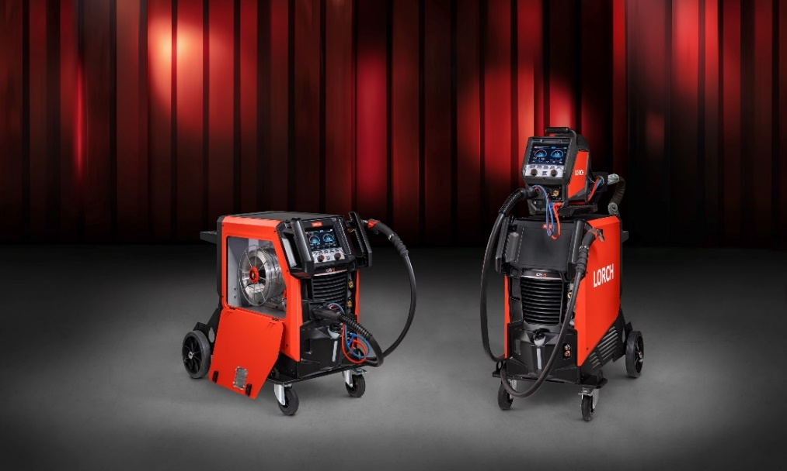
Fig. 1: High-performance, fully networked, capable of learning: the new iQS device generation from Lorch Schweißtechnik – the future of industrial welding.
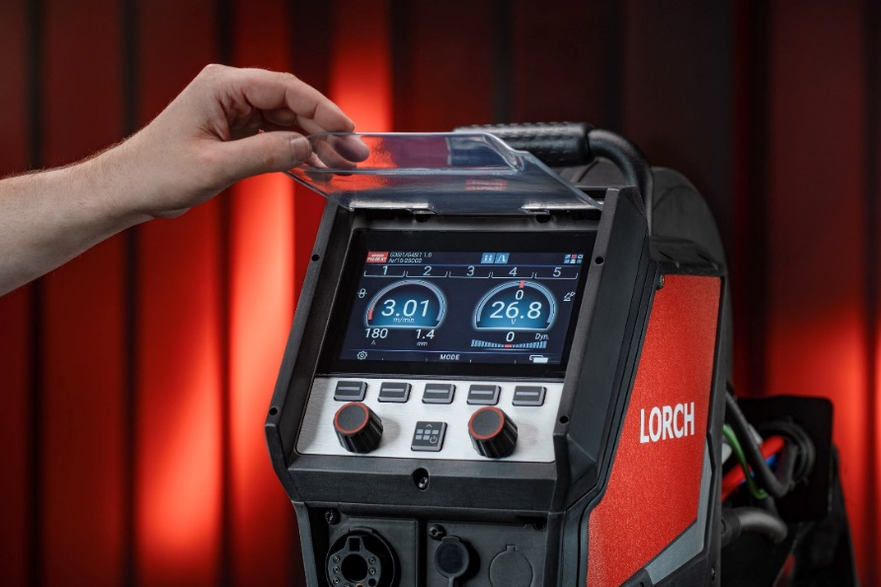
Fig. 2: A glossy display for better colour brilliance, operated by touch or dial, visual representation of the welding process: the high-end display leaves nothing to be desired by the user.

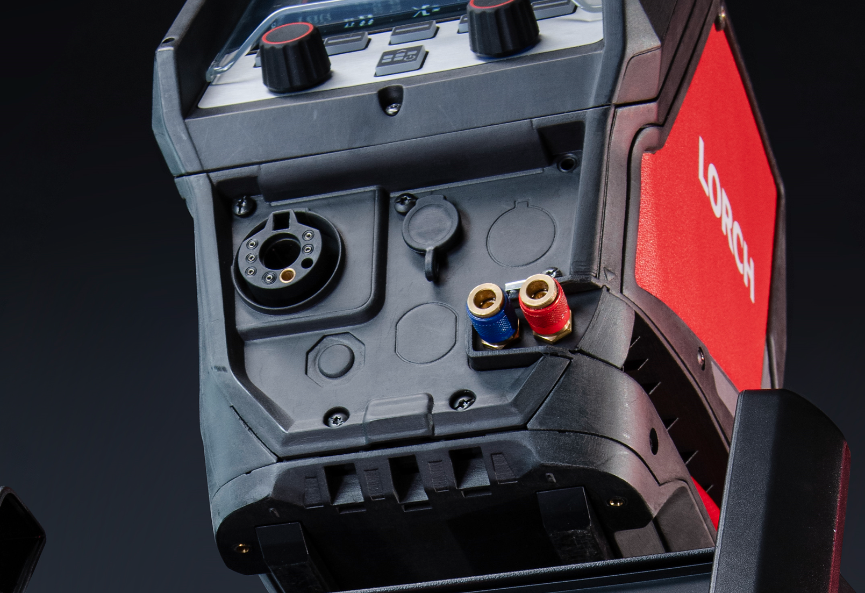
Fig. 3: Simple, fast, better: the new central connection makes changing torches extremely easy. An adapter further permits use of a central Euro connection.

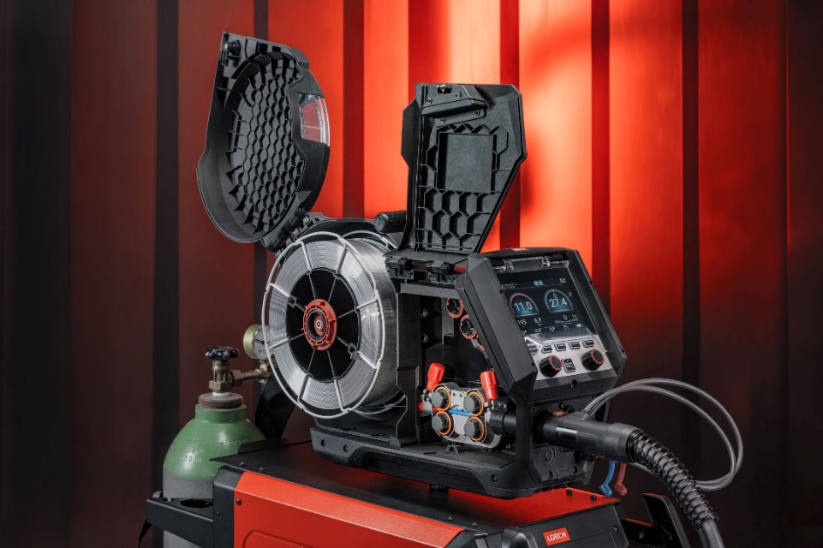
Fig. 4: The MF 09 wire feeder, also newly developed, has a modular design and a new, simplified mandrel fixture

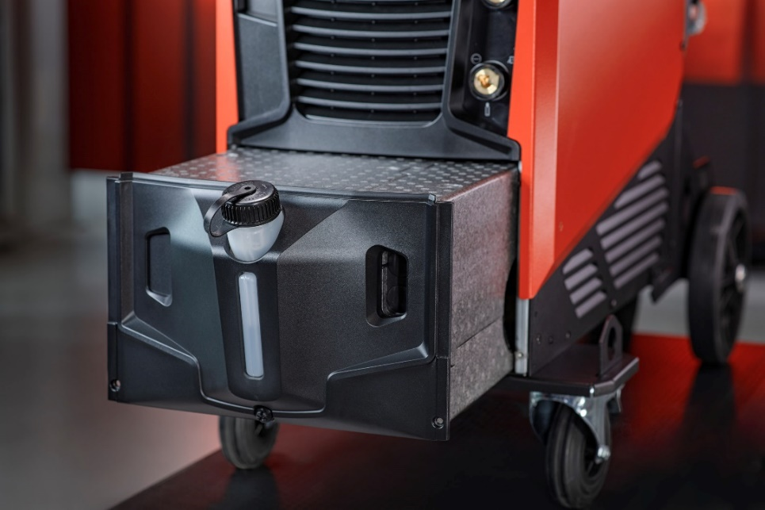
Fig. 5: A modular and service-oriented design meets the needs of maintenance staff on a new level

Press contact:
Lorch Schweißtechnik GmbH
Corinna Baketaric
Im Anwänder 24-26
71549 Auenwald
Germany
presse@lorch.eu
Phone +49 7191 503-0
Print free of charge. Voucher copy requested.

