Ideally supplementing the welding Cobot: Linear axis for greater working space, long parts, and multi-station operation
Collaborative and even more efficient welding with the new Cobot Move by Lorch
The new Cobot Move linear axis by Lorch Schweisstechnik significantly extends the previous application options for Cobot welding: The Cobot’s working radius is increased to more than 4.5 metres thanks to a traversing axis, making it possible to set up much larger workpieces or using multi-station operation on a single worktable. One important special feature of the Lorch solution is the Cobot’s ability to operate without any safety enclosure, permitting easy integration into existing working environments without any great effort.
Lorch Schweißtechnik, a pioneer and market leader in Cobot welding, continues to expand its range with the new Cobot Move. Companies will now be able to weld larger workpieces, or several smaller ones clamped on a worktable, automatically even more easily, clearly increasing their manufacturing efficiency. The core of this new solution is a linear axis with a traversing range of 2,000 millimetres, operated with a high-precision repeatable ball screw drive that achieves traversing speeds of 2 to 160 mm per second. The linear axis can be mounted on any standard welding worktable with a length of at least 2.4 metres. Even already-installed Cobot Welding Solutions with a UR 10e Cobot can be retrofitted with the linear axis easily to extend the Cobot’s working range to more than 4.5 metres.
Various special features help make the solution even more effective. The Cobot can still be used collaboratively and remains CE-compliant. In contrast to any comparable robot solution, it can be used without any additional safety technology such as laser scanners or protective enclosures, which makes installation very quick and easy, and greatly simplifies integration into the existing production environment. Lorch is currently unique on the market with this fully collaborative feature.
Another advantage of Cobot Move is that welding is also possible while the Cobot is traversing on the linear axis. The Cobot joint position will not change at any point, ensuring a uniformly high-quality result of the weld seam. Even very long parts that used to require time-consuming repositioning can now be welded efficiently in a single continuous step thanks to the enlarged working area.
The use of the linear axis also brings great advantages with the so-called "nesting operation", in which series components are welded one after the other on a work table in multi-station operation. Once the first component has been programmed, all subsequent ones can be welded simply by moving the Cobot. The joint position of the Cobot remains the same for each component and guarantees an optimal weld seam. This increases the Cobot’s working space at constant repeat quality. However, nesting operation not only reduces programming effort but also significantly increases productivity: While the Cobot is welding in one station, workpieces can be prepared for the next welding process in other ones at the same time.
Users can use the URCap Lorch Motion with a number of control options for programming the Cobot Move. This software is just as user-friendly as the powerful Cobotronic for all Lorch Cobot solutions. The Cobotronic itself has many additional functions for the user, to be flexibly activated at need. Some of these are the QuickPoints function for easy programming of waypoints and welding commands at the touch of a button, or the SmartCopy one that allows copying of welding sequences once programmed for a part to transfer them to identical parts in different positions in the Cobot’s workspace. The latest innovation in this area is the automatic SeamTracking weld correction, allowing the Cobot to follow a weld seam’s course and warranting best welding quality, even if the workpieces are slightly distorted or a bit outside of the tolerances.
Dr. Ing. Caren Dripke, department head of robotics development at Lorch Schweißtechnik: “The Cobot Move is the perfect complement to our welding Cobot. The additional linear axis not only opens up a significantly larger working area, permitting automated welding of longer and larger workpieces and significantly increasing output in the production of series parts. Its sophisticated axis design also permits unchanged collaborative operation of the system. This means that the system retains its typical flexibility and full accessibility without compromising on safety. This solution is unique on the market at this time.”

Lorch Schweißtechnik GmbH is one of the leading manufacturers of arc welding systems for industrial applications, the demanding metal working, as well as for use in automation with robots and collaborative robot systems. In addition, self-developed helmet and torch systems ensure optimum welding results. For more than 65 years, Lorch's premium quality systems have been manufactured in Germany at one of the world's most cutting-edge manufacturing plants for welding equipment and exported to more than 60 countries. Welding technology by Lorch combines great practical benefits, very simple operation, and high economic efficiency, setting new technology standards on the market.

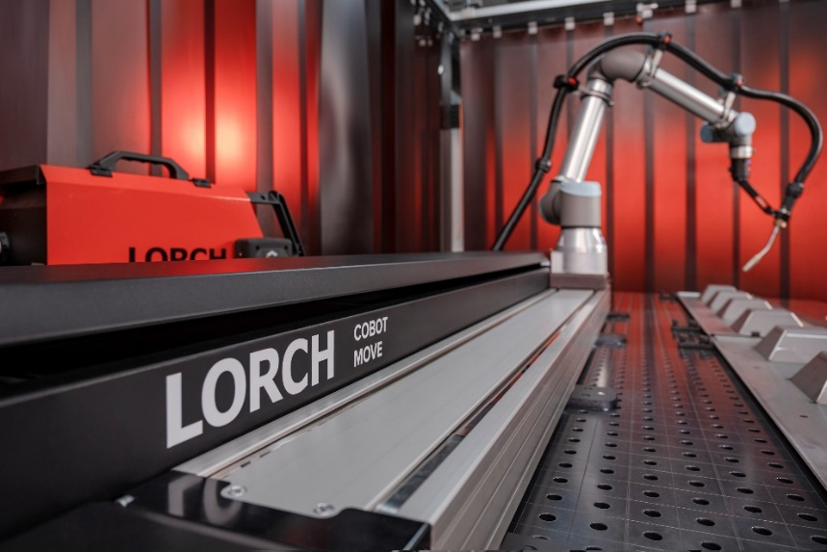

Fig. 1: Advantage of the Cobot Move: Moving the Cobot along the linear axis can weld both repeat elements and long parts in the expanded working area.

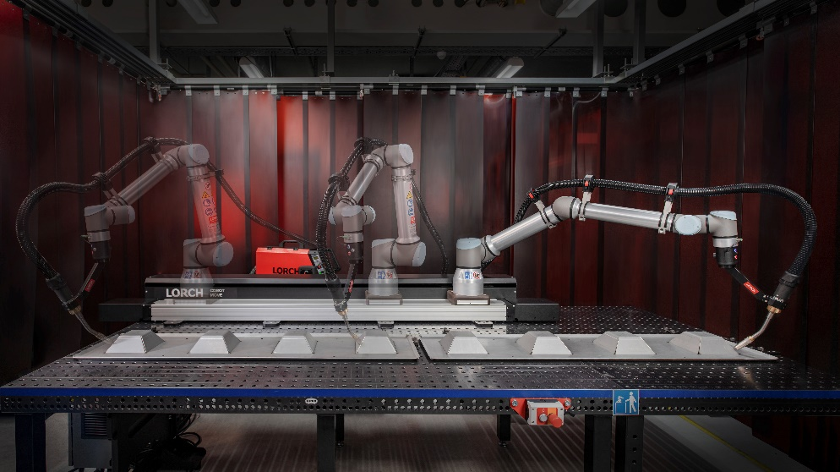

Fig. 2: No additional safety technology needed: The sophisticated axis design means that the welding Cobot can still be used collaboratively. Flexibility and free accessibility of the system are preserved.
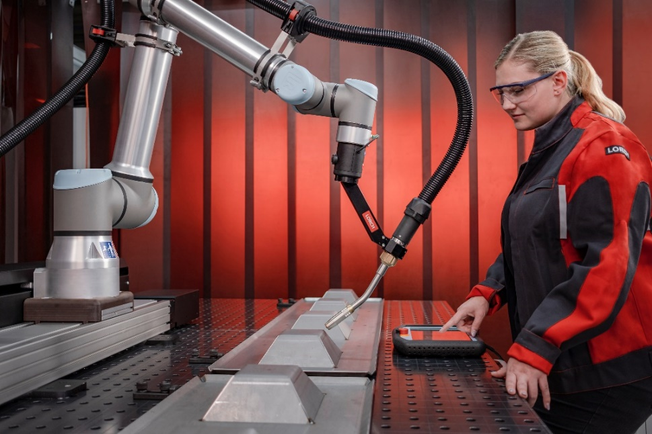

Fig. 3: Fully integrated: The Cobot Move can be easily controlled and programmed using the Lorch Motion URCap.

Fig. 4: The new linear axis extends the welding Cobot’s working radius to 4.5 metres, enormously increasing production capacity.

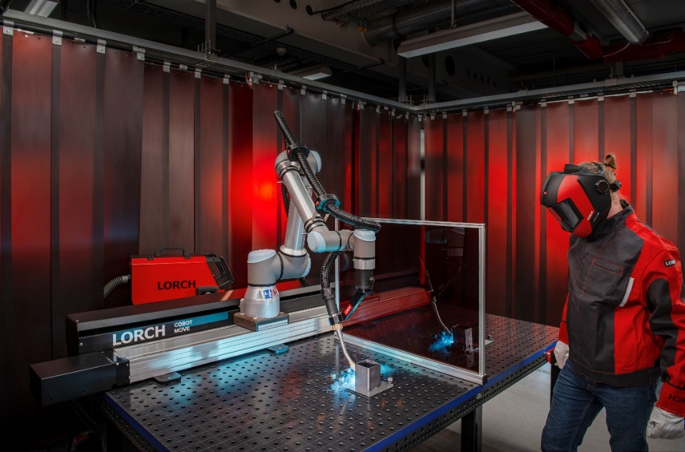
Fig. 5: Efficient processing of series parts: While the Cobot is welding in one station, workpieces can be prepared for the next welding process in other stations at the same time.

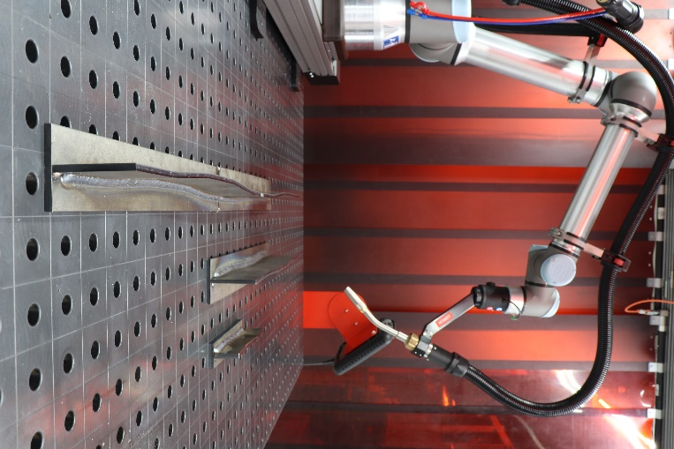
Fig.6: The latest Cobotronic software feature: SeamTracking automatically corrects the weld seam to warrant highest welding quality with the Cobot even if the workpiece is distorted.

Press contact:
Lorch Schweißtechnik GmbH
Lisa Michler
Im Anwänder 24-26
D-71549 Auenwald
Germany
presse@lorch.eu
Phone +49 7191 503-0
Print free of charge. Voucher copy requested.

