Cost, performance, and documentation: All key welding data always in view at a glance

Lorch Connect offers an easy entry into the world of digitally unified welding

Never before has it been this easy to make welding production fully transparent. Lorch Connect now enables companies to track every detail of their productivity and their processes in welding production. The focus linked to the key performance indicators (KPIs) and features of Lorch Connect is placed on the welding times, the cost incurred for each weld seam and the documentation of relevant parameters. All that without the need for an extensive IT installation or large investment sums.
The welding technology and production processes involved to produce a weld seam are certainly complex from a physical standpoint and hinge significantly on the expertise of the welder. Until now, a transparent insight into the welding process was neither common nor could it be taken for granted, even though digital data recording and analysis provide true added value in this particular area. A process in welding production that is digitised and interlinked will deliver essential data and facts about cost and consumption and even help uncover abnormalities and errors.
“With Lorch Connect we have succeeded in offering companies a way to quickly discern potential boosts in productivity without much effort while, at the same time, providing them with an entry point into the world of digitised welding production”, says Jonas Kappel, head of product management at Lorch Schweißtechnik, summarising the benefits of the solution.
The company's long years of experience in the area of digital process technology - Lorch ranks among the pioneers in this field - have enabled them to engineer Lorch Connect as an extremely user-friendly solution: All it takes is to hook up the Lorch Connect Gateway to a compatible Lorch welding system. The gateway transmits all welding data gathered during the welding process to the Lorch Connect Portal - either via a WLAN or a hard-wired network connection. When connected to an optional scanner, the Lorch Connect Gateway can capture such production-relevant data as order number or part information for subsequent analyses and calculations of cost.
The flow of data converges on the Lorch Connect Portal, where it can easily be accessed by the user at any time and from anywhere via a Web browser. The core benefits include such analysis options as the user-friendly dashboard, which displays the key performance indicators, e.g. duty cycles, arc-on times or parameter values, in a quick and clearly arranged manner. Apart from providing a quick overview of the current consumption data, these indicators also make it easier to detect any deviations and errors, allowing for immediate process optimisation.
For the purposes of quickly capturing the actual cost of a part or swiftly getting an idea of how profitable an entire order is, the solution offers direct cost controlling. The basis for the calculation is formulated by individually maintained master data which includes the prices of gases and welding wires as well as the costs of energy and labour. This allows for a straightforward recalculation of orders and the accurate preparation of offers based on comparable orders.
Last, but not least, Lorch Connect can also be used to document the welding data produced by the connected systems: Each individual weld seam is recorded with its production-relevant data and can be retrieved with the associated welding parameters later on. This lets the user effortlessly uncover any deviations and abnormalities in the individual weld seams. Better yet, the solution also provides for traceability in the event of a complaint.
As an added bonus for all Lorch customers: The Lorch Connect Gateway is compatible with more than just all newly purchased systems. Welding systems of the S- and P-series as well as MicorMIG and MicorMIG Pulse machines that are already in use (up to an age of 10 years) can also be connected to the portal via the gateway. Other series of machines are currently under preparation. This extensive compatibility allows companies to make long-term plans for their existing machine park.
All current Lorch Connect features can be used at no charge for a period of one year after purchase of the Lorch Connect Gateway. After that, the solution can be used as a subscription service for 9.90 euros per gateway and month. Customers currently purchasing a new S-series machine are treated to the option of acquiring a customised S-Edition package at a special discount. Aside from Lorch Connect with Gateway and a 12-month user licence, the package also comes with the SpeedUp welding process that allows for dramatically faster vertical-up welding.
“In these challenging times, where decentralised working is becoming another factor of increasing importance, criteria such as networking and transparency of the work processes - untethered from a specific location - have become essential to continued success in the marketplace. By cooperating with our users we have managed to devise a solution in Lorch Connect that is relevant to the companies’ everyday business, puts them in a position to work with even greater efficiency, and lets them take their production processes to a new level in terms of cost and flow analysis", concludes Jonas Kappel.

Lorch Schweißtechnik GmbH is one of the leading manufacturers of arc welding systems for industrial applications, the demanding metal working, as well as for use in automation with robots and collaborative robot systems. For more than 65 years, Lorch's premium quality systems have been manufactured in Germany at one of the world's most cutting-edge manufacturing plants for welding equipment and exported to more than 60 countries. Welding technology by Lorch combines great practical benefits, very simple operation, and high economic efficiency, setting new technology standards on the market.

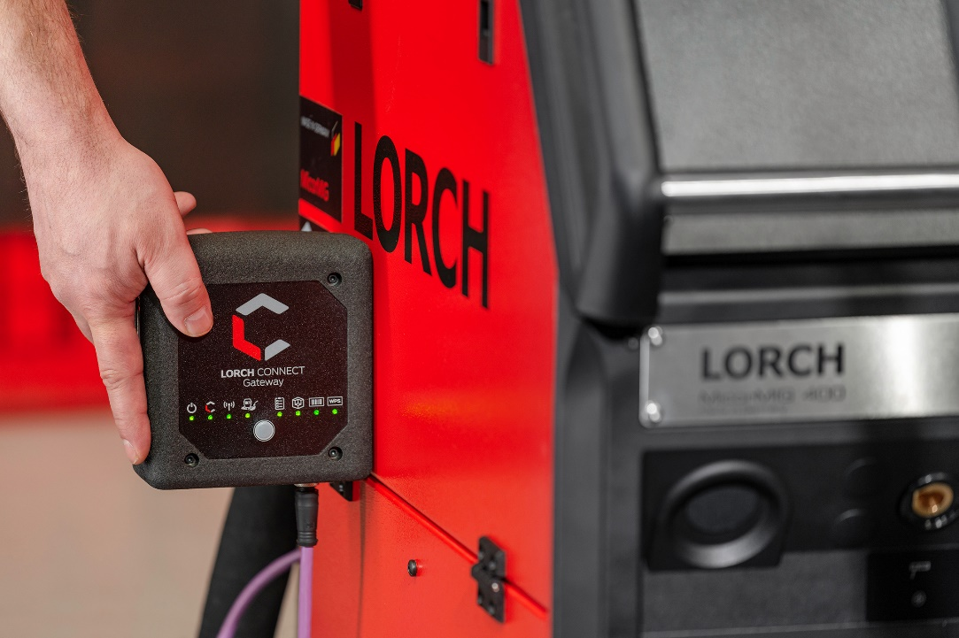Fig.1: Transmitted via the Lorch Connect Gateway, all welding data relevant to production can be accessed directly from any Web-enabled device.

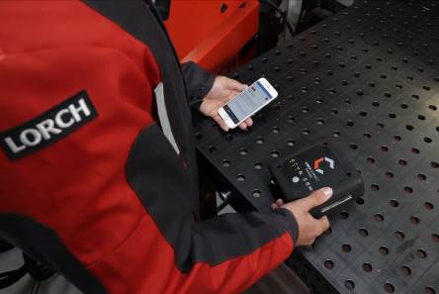
Fig.2: The smartphone as an easy means to retrieve all production-relevant data - this affords the user a way to track the productivity of all welding systems at any time and from anywhere.

Press contact:
Lorch Schweißtechnik GmbH
Lisa Michler
Im Anwänder 24-26
D-71549 Auenwald
Germany
presse@lorch.eu
Phone +49 7191 503-0
Print free of charge. Voucher copy requested.

