MIG-MAG performance torch for the industry of the future
Welding in the top class with the new LMS torches by Lorch
A torch in a pioneering ergonomic shape with many technical innovations allows top-class welding in future. The new Lorch torch has been uncompromisingly developed for increased productivity and low wear to preserve resources.
Designed for the future of welding: This is the principle under which Lorch Schweißtechnik is presenting a new torch family for MIG-MAG welding under the name of LMS at Euroblech 2022. The torch’s ergonomic features have been entirely revised to fit perfectly into the welder’s hand, to reduce fatigue and simplify welding. Optimally balanced, it has a slim and ergonomically shaped handle as well as excellent grip thanks to the raised textured surface and 2K-soft areas. The design with particularly well shaped contour – important, for example, in manoeuvring of the torch – contributes to optimised ergonomics, as does the multi-ball joint. It provides effective strain relief whilst still allowing maximum mobility of the hose package in all directions.
The LMS gained its name of “performance torch” by a number of innovations. Among them are a special shielding gas line – for which a patent is pending – an additional contact tip design which dramatically aides cooling, and optimised gas flow. Consistent implementation of copper-copper connections and highly efficient cooling clearly reduce the overall resistance in the torch and lowers wear caused from thermal strain. The coordinated shape between the contact tip and the inner gas nozzle contour produces a laminar design of the gas flow, thereby ensuring perfect gas coverage that stands out positively in particular when welding. The contact tips which have been drawn counteract the formation of micro arcs in the inner contact tube while the special design of the contact tips adds a wire straightening effect and optimises current transfer to the wire.
The many innovations lead to an extremely stable and reliable arc when welding and produce a noticeably improved material transfer. This reduces the number of unintentional welding interruptions and once again significantly increases welding productivity. The perfect gas coverage and optimal current transfer has considerable advantages when welding stainless steel and aluminium: The temper colours in stainless steel are minimised and the fume and soot from aluminium is reduced. The much cleaner weld seams generally reduce the amount of rework required, thereby lowering production costs. The LMS torch programme is technically rounded off by an easy-to-repair design and a gas-saving separate shielding gas line through the torch. Combined with reduced wear parts use, this renders welding more sustainable.
Lorch is presenting the new torches in two versions on Euroblech: as the standard version and in the Powermaster version with display and buttons for remote control of the Lorch welding system right at the torch handle. The LMS torches are optimised for pulse welding, in particular for the Lorch S- and MicorMIG Pulse series and fitted with a Euro central connection, permitting perfect welding of the Lorch processes on any existing Lorch MIG-MAG system. Both versions are available with the usual hose lengths of three, four, and five metres respectively, and in gas- and water-cooled versions for various amperage ratings from 250 to 500 ampere.
Andreas Rimböck, head of torch systems at Lorch: “Our MIG-MAG torches designed in-house are an important new module in the Lorch portfolio. They fit particularly well in one’s hand thanks to their sophisticated ergonomics, rendering welding much more relaxed. Their many technical features, combined with the Lorch welding unit, maximise welding performance while reducing wear, thereby saving important resources. This way, our new LMS torches are not only loved by the welders but also by the production managers in the industrial environment.”

Lorch Schweißtechnik GmbH is a leading manufacturer of arc welding systems for industrial applications, the demanding metal craft, as well as for use in the automation with robots and collaborative robot systems. Lorch high-quality systems have been produced in one of the world’s most state-of-the-art welding system productions in Germany and exported into more than 60 countries for more than 65 years. Welding technology by Lorch combines great practical benefits, very simple operation, and high economic efficiency, setting new technology standards on the market.

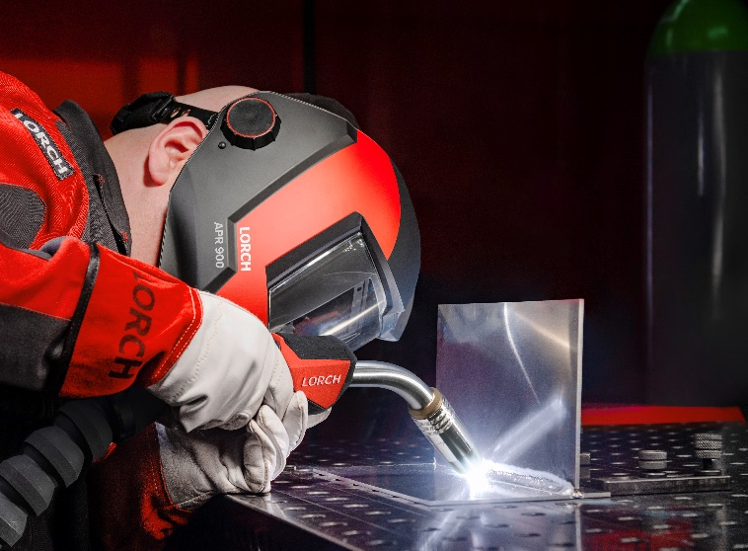
Fig. 1: Fitting perfectly in the hand and uncompromisingly optimised for increased productivity and resource-protecting wear: The new Lorch MIG-MAG performance torches.

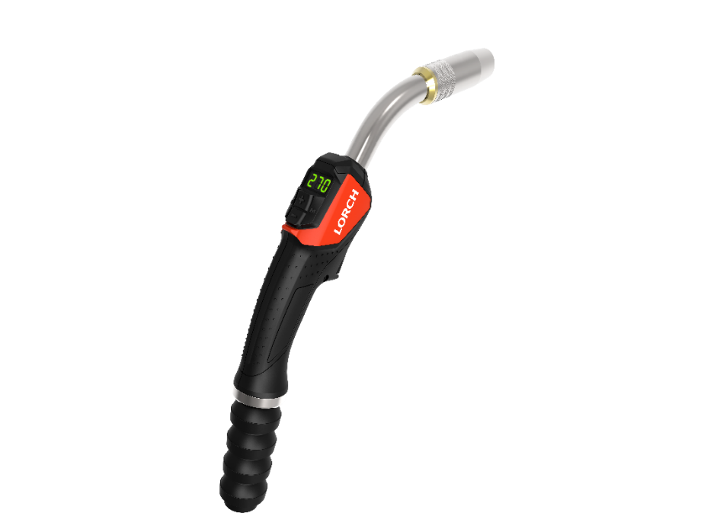
Fig. 2: Optimal gas flow, extremely stable and calm arc, pioneering ergonomic shape: the new LMS torch family by Lorch permits top class welding.

Press contact:
Lorch Schweißtechnik GmbH
Lisa Michler
Im Anwänder 24-26
D-71549 Auenwald
Germany
presse@lorch.eu
Phone +49 7191 503-0
Print free of charge. Voucher copy requested.

