APR 900: Professional helmets for comfortable and safe welding
A new generation of auto darkening filters by
Lorch is setting standards
Lorch welding technology considerably improves everyday work for welders with a new generation of auto darkening filters that combine modern design with innovative technology. The auto darkening filters for fatigue-free welding are available in four different versions: from the APR 900 standard helmet to the APR 900 XF with divisible visor and innovative versions with fresh air supply.
Ongoing improvement of the working conditions of welders is a central desire of Lorch Schweißtechnik. The helmets of the new APR 900 series are a further milestone developed in-house. Many innovations and practical details not only allow the helmets to perfectly adjust to individual needs and the corresponding work demands but also offer highest safety for the welder at optimal view and are designed for harsh and demanding everyday work.
Many special features ensure a comfortable and secure seat of the auto darkening filter. A practical ratchet latching knob at the back of the head simply and individually defines the width and height. The helmet can also be adjusted in length with easy-to-grip lateral sliders for ideal adjustment to the facial shape. Absorbent and padded sweatbands at the forehead and back of the head give the welder additional wearing comfort. The helmet is very light, at only 650 grams for the standard version.
A high-end auto darkening filter in the absolute reference area (1.1.1.1.) with additional True-Colour technology ensures a crystal-clear view of the weld seam. Colour precision is once again improved, while a great field of vision of 98 x 62 millimetres allows an unlimited view of the welding work and its surroundings. Clearly marked welding buttons and a display in a stable angle that can be read at all times allow comfortable settings of operating modes, protection levels, delay, and sensitivity to match the area of application.
Another innovation offers optimised scratch protection: The sophisticated four-point support allows the helmet to rest stably on the visor side without rolling away. The outer, slightly recessed front cover is perfectly protected from contact and scratches. Robustly injection-moulded and certified to N175 B, the front cover can be easily replaced at any time thanks to the practical quick closure. A centred rubberised button in the upper centre of the helmet that can be optimally reached by right- and left-handed people alike permits quick changes to the welding mode without having to take off the helmet. Its recessed position optimally protects it from damage, too.
In addition to the basic APR 900 model, Lorch is offering the APR 900 XF helmet version. It has the advantage of being a divisible helmet with a visor that can be easily folded up along with the auto darkening filter. A curved protective window of clear polycarbonate with a larger field of vision remains on the inside. This still protects the welder well from particles and sparks while performing further work on the workpiece after welding.
Both helmet versions can be combined with a fresh-air system in order to protect the welder from inhaling dust and toxic welding fumes. Connected to the helmets with a flexible ventilation hose, a filter and blower unit operated by rechargeable battery (PAPR) ensures fresh-air supply directly into the helmet. Another safety detail is the integrated acoustic and vibration alarm that warns the welder in time of depleted filters, discharged batteries, or low battery levels. The compact fresh-air unit itself is comfortably carried with the ventilation hose on one’s back and can optionally be attached to the body with a strap.
“The new auto darkening filters by Lorch further relieve the welders to allow them to focus even better on their central welding task. Optimised ergonomics and greatest safety for the welders’ health were of particular importance in development. The high suitability for everyday use and the modern design of the auto darkening filters makes the welders’ profession even more attractive than it already was,” says Maximilian Hipp, product manager at Lorch Schweißtechnik.
For more information, see: www.apr900.com
Lorch Schweißtechnik GmbH is one of the leading manufacturers of arc welding systems for industrial applications, the demanding metal working, as well as for use in automation with robots and collaborative robot systems. For more than 65 years, Lorch's premium quality systems have been manufactured in Germany at one of the world's most cutting-edge manufacturing plants for welding equipment and exported to more than 60 countries. Welding technology by Lorch combines great practical benefits, very simple operation, and high economic efficiency, setting new technology standards on the market.

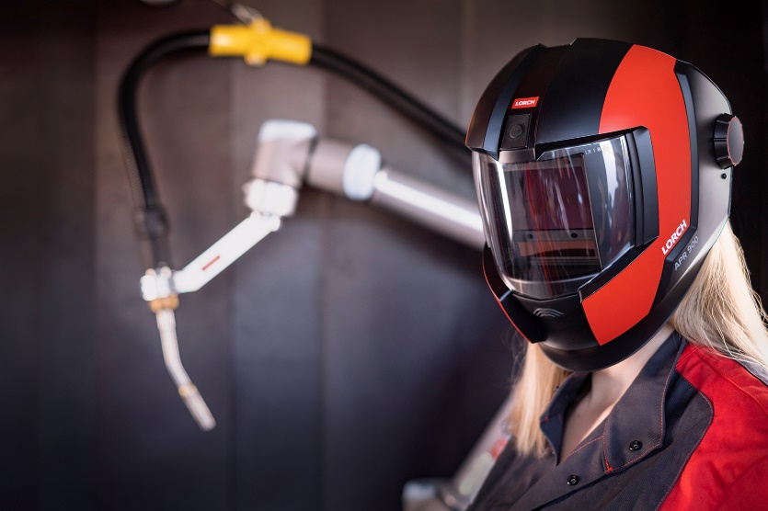
Fig. 1: Fresh design, perfect fit: The new, innovative helmet series
APR 900 by Lorch Schweißtechnik

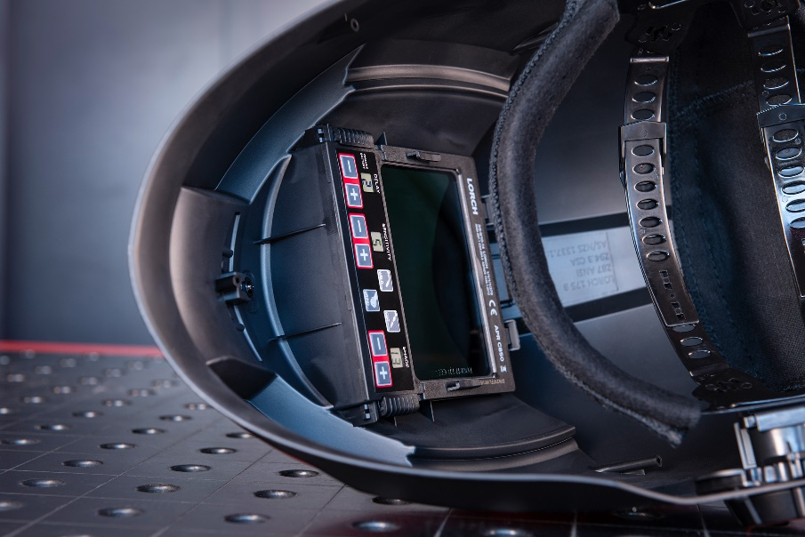
Fig. 2: Simple operation: Operating modes, protection levels, and further menu items such as delay and sensitivity can be set quickly via buttons that are easily accessible.

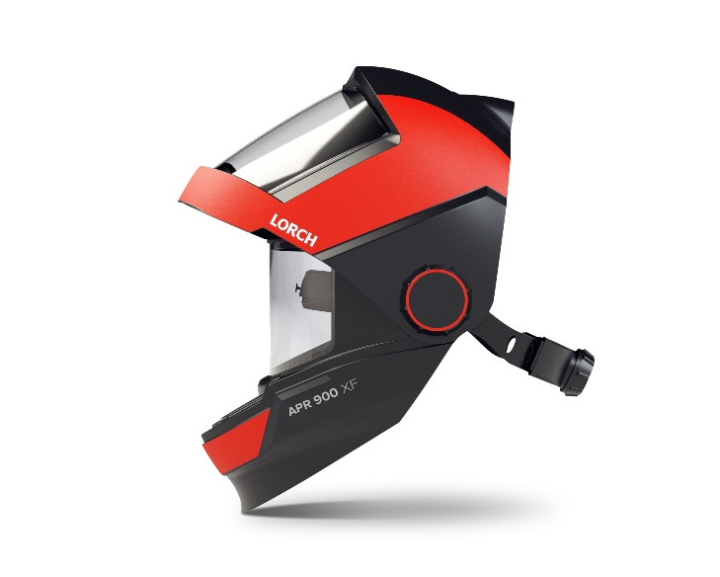
Fig. 3: Practical: The APR 900 XF version folds open, offering absolute protection in grinding and cutting work for maximum view.

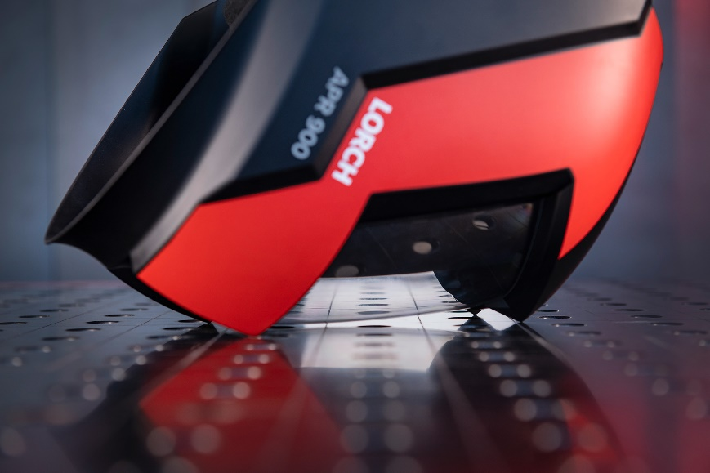
Fig. 4: Innovative: The four-point support has the helmet resting stably while protecting the slightly recessed front cover from scratches.

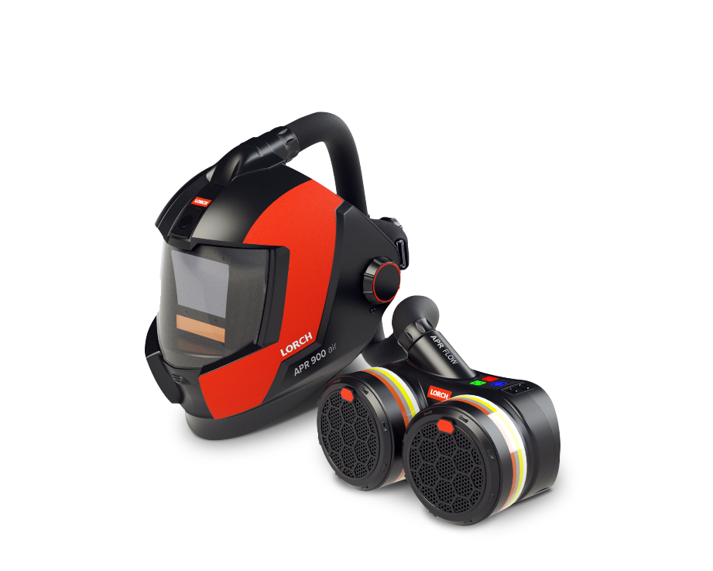
Fig. 5: Well ventilated: Combined with a PAPR fresh-air unit, the welder is optimally protected from welding fumes and dust particles.

Press contact:
Lorch Schweißtechnik GmbH
Lisa Michler
Im Anwänder 24-26
D-71549 Auenwald
Germany
presse@lorch.eu
Phone +49 7191 503-0
Print free of charge. Voucher copy requested.

