More efficient welding with the new Lorch automation solutions and welding processes

Lorch Schweißtechnik GmbH presents options for clearly increasing welding productivity even further with innovative welding technology under the motto of “Smart Welding” at Blechexpo/Schweisstec in Stuttgart from 26 to 29 October. The focus is on automated welding solutions and a new welding process that makes high-quality visually exposed welds with an outstanding weld appearance much faster to complete.
Lorch presents its “Lorch Cobot Welding Package” solution for simple automation that allows small and medium-sized companies to automate welding processes easily and to optimise workflows. With the new Cobot Turn 100 A turn-tilt table, Lorch demonstrates a way to clearly increase efficiency of collaborative welding production even further while reducing strain on the welders, no matter if MIG-MAG or TIG procedures are applied.
On top of this, Lorch presents the “ArcWorld RS” robot welding cell within the scope of the Yaskawa-Lorch cooperation in the area of automation.
For manual welding, Lorch Schweißtechnik presents not only its tried and tested MIG-MAG and TIG systems but also the new, innovative MicorTwin welding process, available for all performance classes of the MicorMIG Pulse series up to 500 amps. It produces welds that live up to the highest visual demands. So far, they often need to be performed using the TIG procedure and are subject to greater time expenditure. MicorTwin makes welding them with the MIG-MAG procedure faster and easier.
Hall 7 stand 7505/7506

Lorch Schweißtechnik GmbH is a leading manufacturer of arc welding systems for industrial applications, the demanding metal craft, and use in automation with robots and collaborative robot systems. Lorch’s high-quality systems have been produced in one of the world's cutting-edge welding system productions in Germany for more than 60 years, to be exported into more than 60 countries. Welding technology by Lorch sets new technology standards on the market by merging great practical use, very simple operation, and high economic efficiency.

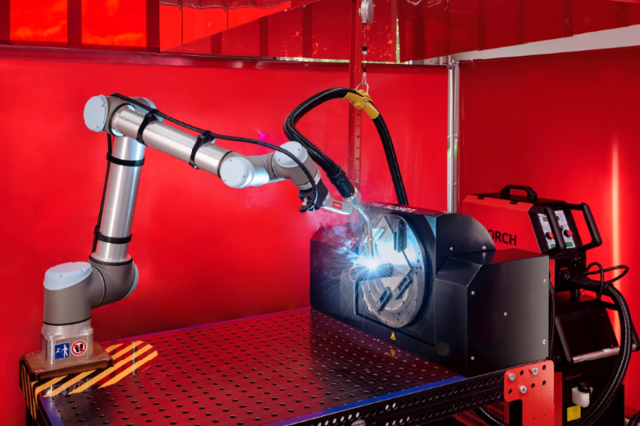
Figure 1: A perfect duo: the Lorch Cobot Welding Package combined with the new Cobot Turn 100 A turn-tilt table.

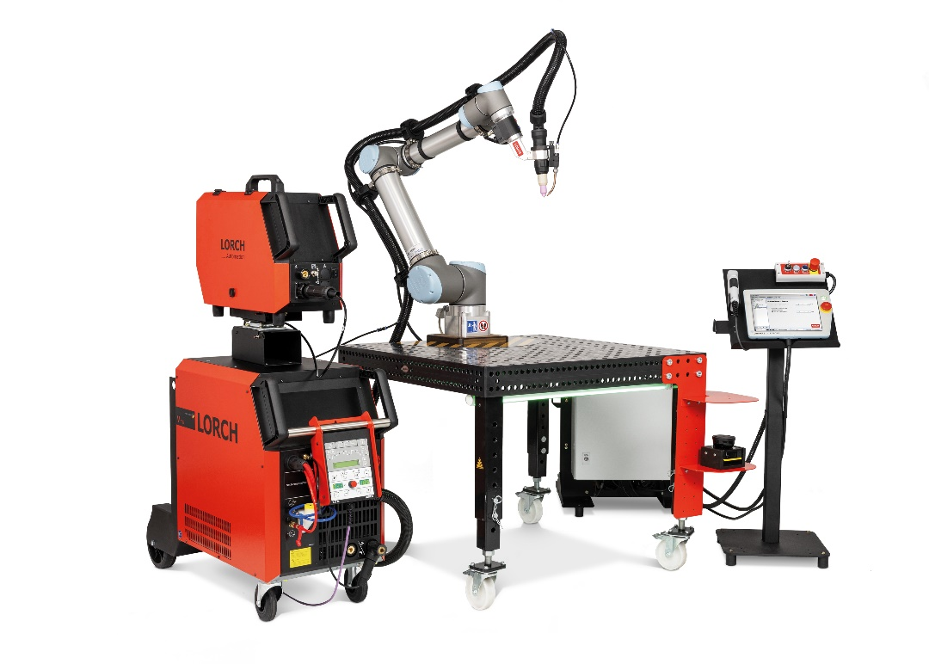
Figure 2: The new Lorch Cobot Welding Package TIG edition allows companies of any size to complete high-quality and perfectly spatter-free weld seams automatically, quickly, and safely.

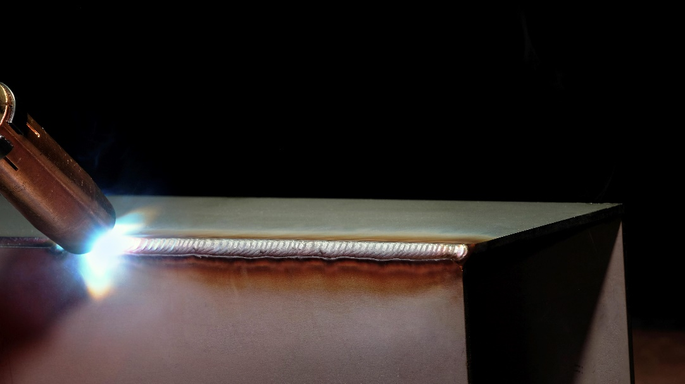
Figure 3: Finest weld seams in half the time with the innovative Lorch MicorTwin welding process.

Press contact:
Lorch Schweißtechnik GmbH
Lisa Michler
P +49 7191 503-0
F +49 7191 503-199
Im Anwänder 24–26
D-71549 Auenwald
Germany
Print free of charge. Voucher copy requested.

