The best from both worlds, combined in a single cell

Lorch Yaskawa compact welding cells are ideal as an easy gateway into automation

With a portfolio of new, turn-key compact welding cells, Lorch Schweißtechnik and Yaskawa enable small and medium-sized enterprises to easily enter robot-automated welding to produce small assemblies with great efficiency and at the highest quality. The welding processes are controlled via a consistent operating interface that makes production even easier.
These new simple, space-saving, and efficient welding cells take just a few minutes to be ready for operation. Their compact build keeps their footprint small and makes them easy to relocate later. The special cell construction maximises freedom of movement for the robot and permits complete integration of the welding power source in spite of its small size. The welding cells perfectly supplement manual workplaces like this.
The welding cells are available as the ArcWorld HS Micro, with a footprint of 1.3 square metres, and the ArcWorld RS Mini with a footprint of 2.3 square metres. A maxi version with the ArcWorld CS is also available for larger parts or customer-specific requirements. The platform and housings are equipped with a blue polycarbonate glare protection and use the tried and tested MOTOMAN AR900 robot by Yaskawa. With their rotating turntable that permits setting up parts of up to 100 kilograms on either side, the RS Mini compact welding cell offers a very high parts throughput. Parts with up to 100 kilograms can be produced in the HS Micro with its attached table as well.
The S3- and S3-RoboMIG XT with their complete Lorch Speed welding processes are available as welding power sources (MIG-MAG). The combined Lorch and Yaskawa solution is made special by integrating the control in a single operating panel. The Universal Welding Interface (UWI) is used to program robots, to set and select the welding processes. The optimal adjustment of the components makes operation of the welding system much easier.
The welding cells are an enclosed, compact system that can be integrated very easily into any production environment. With their glare protection and safety functions, they easily comply with all provisions under labour law. The exhaust stack integrated in the roof also simplifies connection to extraction devices. The high-performance robot affords all functions of a welding robot and warrants very high seam quality and repeatability.
“We consistently implement the “Plug & Weld” concept with the Lorch Yaskawa compact ArcWorld RS Mini and HS Micro welding cells while offering companies greatest safety in installation, clearly increased productivity, and highly automated welding environments in industrial robot quality,” says Daniel Lang, product manager for Robotics and Automation at Lorch Schweißtechnik. Companies that want to launch into automated welding without a comprehensive, costly robot project will find this an attractive solution in order to actively handle their current challenges, and to deal in particular with the lack of specialists and competitive pressure.
The compact welding cells are another result of the Europe-wide cooperation agreed by Yaskawa and Lorch Schweißtechnik last year in order to automate production processes specifically in the medium-sized range and to adjust existing structures to a digital modernised production.

Lorch Schweißtechnik GmbH is a leading manufacturer of arc welding systems for industrial applications, the demanding metal craft, and use in automation with robots and collaborative robot systems. For more than 60 years, Lorch quality systems have been produced in Germany in one of the world's cutting-edge welding system productions, to be exported to more than 60 countries. Welding technology by Lorch combines great practical use, very simple operation, as well as high economic efficiency, setting new technology standards on the market.

Yaskawa, at an annual turnover of about 480 Bn Yen (about 3.8 Bn Euro), is a globally acting technology supplier in robotics, drive, and control technology, as well as in solutions in the energy area. Founded in Japan in 1915, Yaskawa has been true to its philosophy of supplying products of the highest quality for more than a century. It has acquired a global peak position for this. Industrial robots of the Motoman brand, for example, are used in robot-based welding, lab automation, packing and handling, as well as automated painting. Yaskawa Europe GmbH's European headquarters are located in Eschborn near Frankfurt.

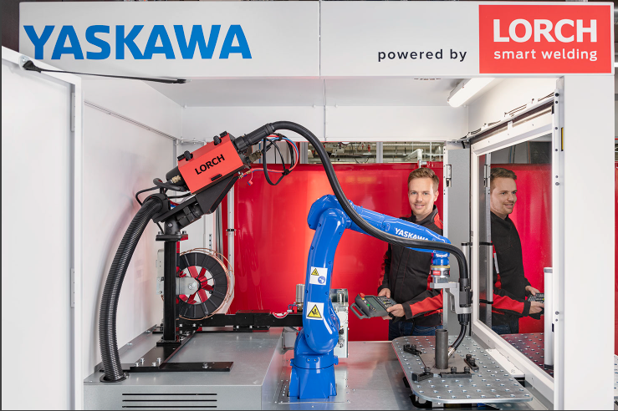

Figure 1: The best from both worlds: the MOTOMAN robot AR 900 by Yaskawa with the Lorch S-RoboMIG XT as a welding current source is at the core of the compact welding cells. The two components are optimally adjusted to each other and easy to operate via an operating panel.

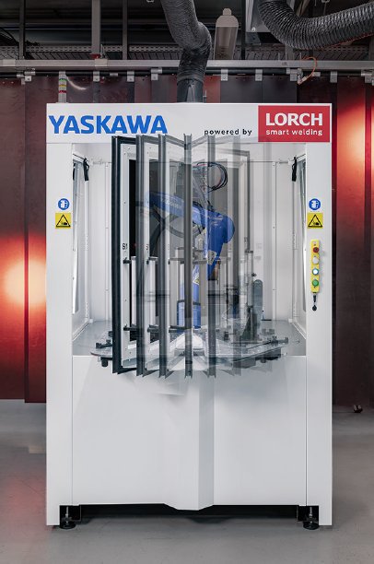

Figure 2: The ArcWorld RS Mini compact welding cell has a footprint of only 2.3 square metres and offers a high parts throughput with the rotating turntable.

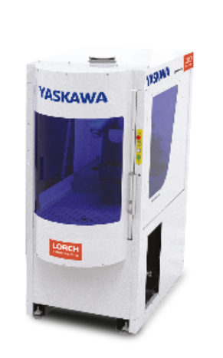

Figure 2: More compact than any other: The robot and welding current source fit on 1.3 square meters in the ArcWorld HS Micro.

Press contact:
Lorch Schweißtechnik GmbH
Lisa Michler
P +49 7191 503-0
F +49 7191 503-199
Im Anwänder 24–26
D-71549 Auenwald
Germany
Print free of charge. Voucher copy requested.

