Lorch Connect: Connect, weld, and see clearly

Networked production offers a great chance for small and mid-size companies

The integration of welding processes into digitised production flows offers the opportunity to boost the transparency and efficiency of production even further. Jonas Kappel, Director of Product Management and responsible for the Industry 4.0 division at Lorch Schweißtechnik GmbH, spells out how even companies of small and medium size can easily benefit from this vital technological step forward without the need for any major investments.
Mr. Kappel, what are the essential aspects when it comes to networking welding technology?
The human element is front and centre in the daily production routine. This is why it is paramount for the networking of welding systems to assist welders and welding supervisors in their work flows and make the productivity of their own value creation chain fully transparent and intelligible.
Where lies the particular challenge to small and medium-sized companies?
We believe that the solution for small and mid-sized companies is not to build their own large-scale IT infrastructure. That would blow the budget of any such company. There are, however, exceptionally elegant approaches to the solution that spring from cost-effective networking and the consistent use of cloud technology.
Which steps has Lorch already taken to make networked welding technology available to businesses?
For more than ten years now Lorch has been furnishing their welding systems with “LorchNet”, a uniform digital interface. In doing so, Lorch has formed an extensive range of welding systems that can be networked with exceptional ease and speed. Our latest digital offer - “Lorch Connect” - now makes it possible to make the systems Industry 4.0-compatible without the need for extensive installation.
What benefits does Lorch Connect offer the user?
The primary advantage is that Lorch Connect offers a user-friendly and straightforward entry into the world of digital welding production. There is no need for profound IT skills, an elaborate IT installation or sizeable investments. Anyone versed in the use of a smartphone and the Internet will have no trouble becoming proficient in using our solution and will quickly be able to work with even greater efficiency and make their production processes more transparent by analysing their cost and flows.
What is the actual installation procedure for Lorch Connect and which functions are available to the user?
True to our principle of “Connect, weld, and see clearly”, installation is as easy as can be and provides an instant overview of the latest consumption data produced during welding. Simply hook up Lorch Connect to the corresponding Lorch welding system and start transmitting the individual welding data generated during the welding process to the Lorch Connect Portal via the gateway. In the gateway, all data converges and can be accessed with perfect ease in a Web browser from anywhere and at any time. An easy-to-use dashboard will then afford the user a quick and clearly arranged overview of such key indicators as duty cycle, arc times or parameter values and put them in a position to spot deviations and optimise the parameters with greater ease.
Does the solution allow for other business-relevant evaluations?
Other services include comprehensive cost controlling based on master data input such as the cost prices of consumables such as gases, welding wires and the cost of energy and labour. This allows for a straightforward recalculation of orders and a preparation of comparable orders that reflects the current circumstances. Last, but not least, Lorch Connect can also be used to document the welding data produced by the connected systems: Each individual weld seam is recorded with its production-relevant data and can be retrieved with the associated welding parameters later on. This lets the user effortlessly uncover any deviations and abnormalities in the individual weld seams. Better yet, the solution also provides for traceability in the event of a complaint.
There are a number of manufacturers who are currently offering solutions for production data recording. What does Lorch do better?
Since welding systems usually have a total lifespan of up to twelve years, most company machine pools are comprised of equipment series that span different years of construction and technological standards. What sets Lorch Connect apart is its ability to seamlessly connect all Lorch welding systems with an age of up to ten years by means of the gateway. This makes it possible to also elevate older model years to the state of the art and integrate them effortlessly into the digital network. To my knowledge, no other manufacturer can match this type of “investment protection”.
For which target groups / company size is Lorch Connect the ideal solution?
It is not important to Lorch Connect if you digitise one machine, 200 machines or more than 1,000 welding stations. The key factor is the purpose for which you use digital networking. Being linked to Lorch Connect might even be advantageous to a small metal workshop operating with only one welding system as it allows the shop to document their welding data. By contrast, a company with 50 welding stations will certainly focus on the ability to measure productivity and analyse day-to-day-operations and on the option to view the current consumption data at a quick glance. Furthermore, the solution also provides clues for process optimisation by comparing various welding stations. Both companies - whether they operate with one or a multitude of welding systems - will be able to benefit substantially from digitisation - each in their own way.
Would it not be wise to factor in the aspect of networking when you purchase new equipment?
Absolutely, which is why we have created special bundles that offer customers an easy way into the world of digitisation and do not involve any kind of financial risk. When including the digital portion with their order for a new system, the customer will, for instance, be able to test Lorch Connect at no charge for one year and decide at zero risk whether this solution is the right fit for their business.
Are plans for additional Lorch Connect applications already in the pipeline?
Most certainly. Lorch Connect forms a pivotal foundation for many other digital services we will be offering in the future. These may be geared towards remote service functionality and quality monitoring or span the range from the traceability of welder qualifications to WPS specifications management. We will team up with our customers in the search for new potentials and incorporate these applications step by step into the platform.
What is the best approach for a customer who wants to use Lorch Connect at their company?
The best way to proceed is by turning directly to one of our local sales partners. There, customers will have an opportunity to get up close and personal to Lorch Connect in a live demonstration. Our sales partners will also give concrete advice on how to incorporate the solution into the customer's own production environment. If requested, they will provide on-site assistance with set-up and installation.
Lorch Schweißtechnik GmbH is one of the leading manufacturers of arc welding systems for industrial applications and the demanding metal working trade as well as for use in automation with robots and collaborative robot systems. For more than 60 years, Lorch's premium quality systems have been manufactured in Germany at one of the world's most cutting-edge manufacturing plants for welding equipment and exported to more than 60 countries. The welding equipment engineered by Lorch merges first-rate suitability for real-world applications with superior ease of use and outstanding efficiency, setting new technological standards in the marketplace.

Author:Rochus Rademacher, specialised journalist, Tübingen, rade@ikt-innovation.de

Figure 1: Jonas Kappel, Head of Product Management and responsible for the Industry 4.0 division at Lorch Schweißtechnik GmbH

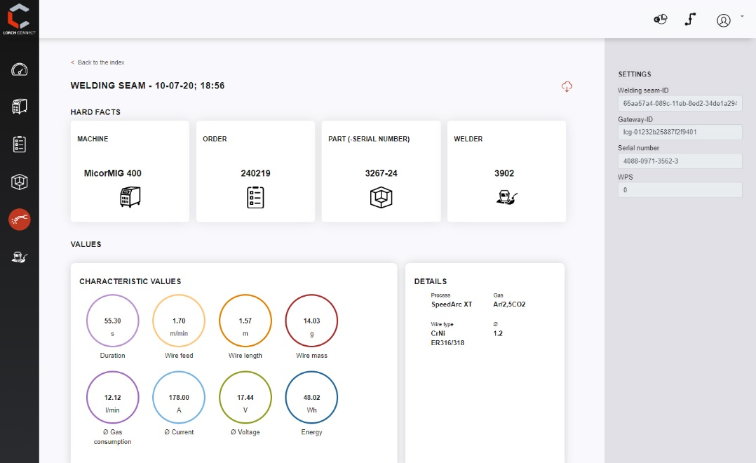
Figure 2: Each individual weld seam with the associated parameter values is documented in the Lorch Connect Portal and can be retrieved at any time. Irregularities or deviations can then be corrected quickly.

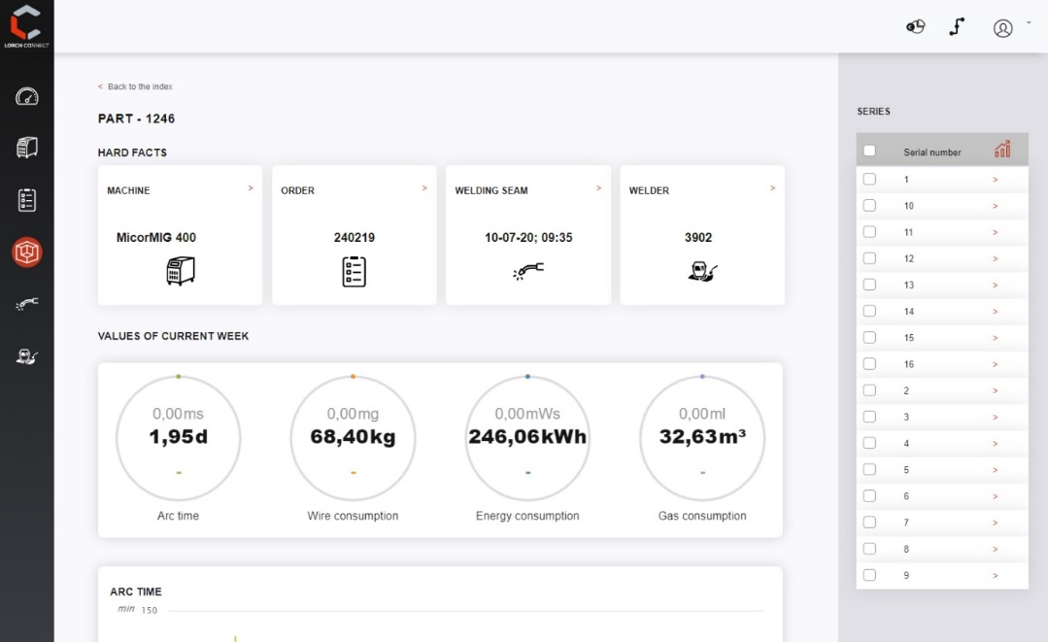
Figure 3: All important KPIs, such as arc times, wire consumption or energy consumption are displayed quickly and clearly on the dashboard. In this way, the user always has productivity in view.

PR contact:
Lorch Schweißtechnik GmbH
Lisa Michler
T +49 7191 503-0
F +49 7191 503-199
Im Anwänder 24–26
71549 Auenwald
Germany
Reprint free of charge. Specimen copy requested.

