TIG welding with top speed, reliability and quality thanks to the collaborative robot

Lorch offers a comprehensive Cobot solution for demanding TIG welding tasks

On the heels of their tremendously successful launch of Cobot MIG-MAG Welding Packages, Lorch Schweißtechnik is now launching a Cobot solution for TIG welding. This new TIG version of the welding Cobot allows companies to weld even smaller batches of particularly challenging components with the utmost speed, reliability and TIG quality. This solution offers businesses enormous economic potential, especially in the TIG segment, where finding skilled labour has become especially difficult.
Collaborative robots, so-called Cobots, are marked by their exceptional price-performance ratio and ease of use as well as by their outstanding versatility across a wide range of applications. With their latest Cobot application Lorch is now extending this quantum leap to the field of TIG welding. Lorch's solution is comprised of a Cobot UR 10, the Lorch Cobotronic software, a Lorch welding system including high-output torch and such additional accessories as a sophisticated safety package. The service package also includes consulting, training and all-inclusive support - all provided by Lorch's certified Cobot partners on site. The MIG-MAG version of the Cobot UR 10 has already shown its merits as a tool for the fast and efficient series production of small and medium batches and has been employed with great success by its users. Lorch has now optimised the system even further for the complex tasks in TIG welding.
Operating with a high-frequency pulse process with up to 20 kHz, the welding system allows for automated TIG welding at extremely high speed. Also improved were the ignition characteristics of the power source, which now provide for enhanced automated use. The Cobot-optimised torch holder ensures stable and reproducible torch guidance with perfect accuracy. The Cobot solution devised by Lorch makes it possible to complete welding tasks on thin sheets with and without filler metal. For welding applications that are supposed to be performed with filler metal an optional automated cold wire feeder can be integrated into the Cobot Welding Package. This option provides a quick and effective way to reliably deliver the filler metal during the welding process.
Just as its counterpart included in the Lorch Cobot Welding Package for MIG-MAG welding, the TIG edition of the Cobotronic software used for controlling the Cobot is intuitive and can thus be operated without any special programming skills. With the help of the so-called “teaching”, the welding Cobot learns the exact progression of the weld seam. During this process, a Free Drive function, which in the TIG solution is attached directly at the torch holder in the perfect ergonomic position, will guide the torch to the various waypoints such as the start and the end point. Once set up, the Cobot will weld each product in the batch with consistent quality and absolute perfection.
One special feature of the Lorch TIG Cobot is its integrated safety concept. The laser scanner nanoScan 3 guarantees maximum safety for the user by safeguarding the work area with a protective field and an additional warning field, which are put in place at a distance to the work surface of 1.5 m and 0.5 m, respectively. If entering the activated warning field, the operator will be warned with an acoustic signal and the Cobot will reduce its speed. If the operator reaches the protective field, the Cobot will immediately shut down with an emergency stop. This reliably prevents collisions between the operator and the system during the welding process. Depending on the size of the workstation, the monitored area can be expanded by the installation of a second scanner. Another benefit: The new safety concept ensures an exceptionally high transfer speed between the individual points of the weld seam. This boosts the productivity of the system significantly - especially if the job involves a large number of small welds or even tack welds.
“Lorch's latest Cobot edition lets companies increase the productivity of their TIG welding operations to a substantial degree. The advantages to these businesses start with an easy-to-use system that is highly versatile and capable of completing challenging welding applications, such as those found in the food, pharmaceutical or furniture industry, with extraordinary ease. They also benefit from the system's ability to weld small to medium batch sizes with both significantly faster speed and with the expected top quality every time”, states Paul Spronken, Head of Automation Solutions at Lorch Schweißtechnik, summarising the advantages of the Cobot TIG edition. Better yet, the relatively low capital expenditure associated with this solution will pay for itself in a short time even for small to medium batch sizes. Last, but not least, companies are less dependent on sparse skilled labour, which is especially hard to find in TIG welding: Once the Cobot solution has been set up, the work processes can be completed by one operator. The high process quality eliminates the need for rework, while the automated execution of the steps in the welding sequence produces weld seams of first-rate quality every single time.
Lorch Schweißtechnik GmbH is one of the leading manufacturers of arc welding systems for industrial applications and the demanding metal working trade as well as for use in automation with robots and collaborative robot systems. For more than 60 years, Lorch's premium quality systems have been manufactured in Germany at one of the world's most cutting-edge manufacturing plants for welding equipment and exported to more than 60 countries. The welding equipment engineered by Lorch merges first-rate suitability for real-world applications with superior ease of use and outstanding efficiency, setting new technological standards in the marketplace.

Fig.1: The new TIG edition of the Lorch Cobot Welding Package provides businesses of any size with a quick and reliable automation process that produces perfectly spatter-free weld seams of the highest quality.

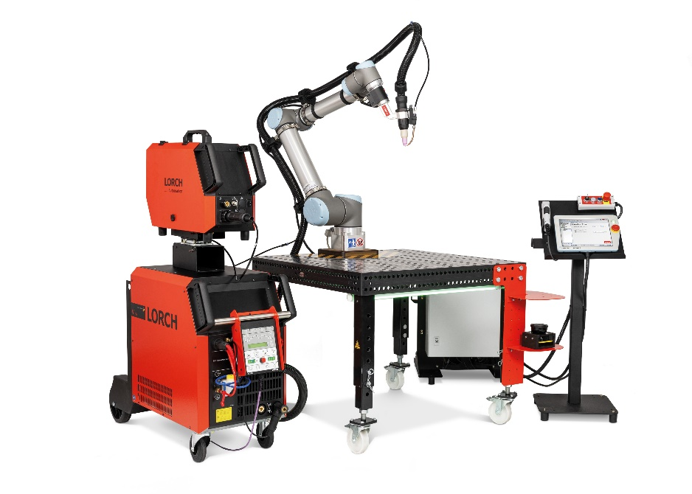

Fig.2: An optional cold wire feeder can be fitted for welding applications that are executed with filler metal. The wire electrode is delivered directly to the TIG arc via a wire guide.
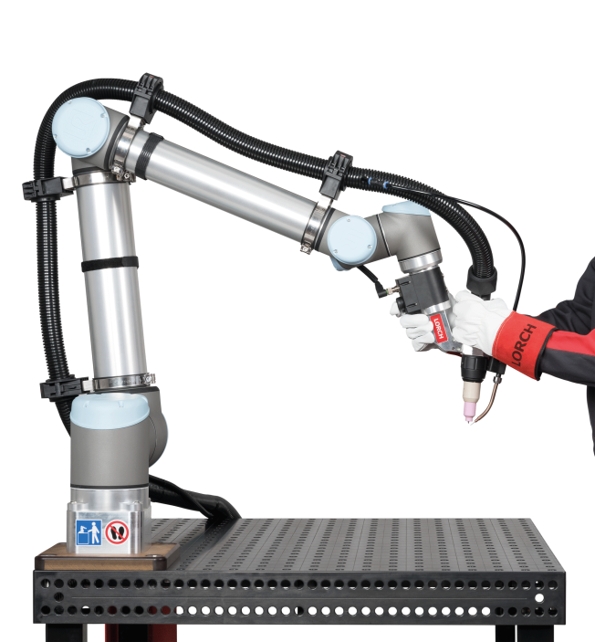

Fig.3: Required for “teaching”, the Free Drive function on the TIG solution is activated directly on the torch holder, where it is within easy reach for the welder.

PR contact:
Lorch Schweißtechnik GmbH
Lisa Michler
T +49 7191 503-0
F +49 7191 503-199
Im Anwänder 24–26
71549 Auenwald
Germany
Reprint free of charge. Specimen copy requested.

