Lorch Schweißtechnik adding on to their Auenwald headquarters

Breaking ground for a new hall

Lorch Schweißtechnik is expanding the capacity of their operations at the Auenwald headquarters in Germany. Attended by Auenwald mayor Karl Ostfalk, the official ground-breaking ceremony was held recently to kick off the construction of a new hall. The goal behind this enlargement is to both streamline the logistics process of the company and to establish a more direct link to the service centre next door, which the company moved into only a short while ago.
The expansion represents an investment by the company both in their base in Auenwald and in their renowned as a Made in Germany brand. “The benefit we reap from this new building is two-fold: not only are we gaining a significant amount of storage space, but we are also laying a vital cornerstone for our future growth in Germany“, explains Wolfgang Grüb, managing partner at Lorch Schweißtechnik GmbH. Karl Ostfalk, Mayor of the Auenwald Municipality, is exhilarated by this expansion project: “Lorch Schweißtechnik GmbH is one of the largest employers in our region. We are proud that a company of such esteemed standing believes in Auenwald as a business location and keeps investing in its future.”
The new hall is planned to be put into service on August 1, 2019. The added capacity will stretch the warehouse space of this steadily growing company to a total of 3,540 square metres. Established as a global player for years, the family-operated businesses epitomises state-of-the-art welding technology and currently employs a staff of around 280 world-wide, including 17 apprentices.

Lorch Schweißtechnik GmbH is a leading manufacturer of electric arc welding systems for industrial applications, metalworking, partially automated solutions and robot automation systems. For more than 60 years, Lorch's premium quality systems have been manufactured in Germany at one of the world's most cutting-edge manufacturing plants for welding equipment and exported to more than 60 countries. The welding equipment engineered by Lorch merges first-rate suitability for real-world applications with superior ease of use and outstanding efficiency, setting new technological standards in the marketplace.

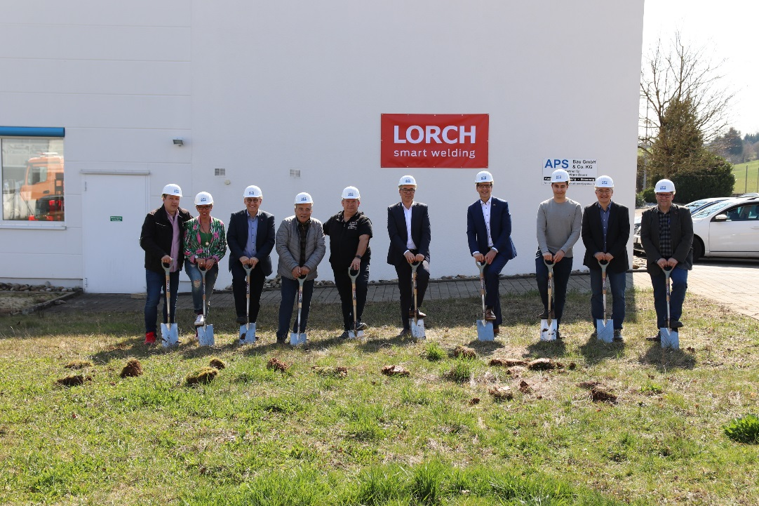Fig. 1: Construction of the new warehouse kicked off with the official ground-breaking ceremony, which was attended by Wolfgang Grüb, managing partner at Lorch Schweißtechnik GmbH, and Auenwald’s mayor, Karl Ostfalk (6th and 7th from the left).

For more information, log on to www.lorch.eu
PR contact:
Lorch Schweißtechnik GmbH
Lisa Michler
T +49 7191 503-0
F +49 7191 503-199
Im Anwänder 24-26
71549 Auenwald
Germany
Reprint free of charge. Specimen copy requested.

