Up to 30 per cent higher welding speed

Weld flux-cored wire efficiently with Lorch Speed processes

Lorch offers new, innovative flux-cored wire packages for the SpeedArc, SpeedArc XT and SpeedUp processes that accelerate welding with rutile and metal-cored wire and significantly improve efficiency. As a result the customer can weld up to 30 per cent more quickly in combination with a Lorch system.

Flux-cored wires are given priority when welding thick and heavy components that have to withstand very high dynamic loads. Typical areas of application are shipbuilding and the production of agricultural and construction machines. The new flux-cored wire packages for Lorch welding systems in combination with the Lorch Speed processes provide a significantly higher welding speed and expand the field of application of flux-cored wire welding.
With the focussed energy input and the high dynamics of the SpeedArc and Speed Arc XT arc, it is possible to weld flux-cored wire more quickly in forced positions and minimise the energy input. Is a result it is now possible to weld thin to medium-thickness sheets from four to eight millimetres with rutile flux-cored wires. The high arc pressure of the SpeedArc process also ensures optimal root penetration with thicker rutile flux-cored wire (e.g. 1.6 mm). As a result, the wire change between the welding of the root and fill layers can be eliminated and thus save significant time.
Use of the Lorch Speed processes also provides a clear improvement in efficiency when welding with metal-cored wire. With SpeedArc and SpeedArc XT, the tulip-shaped arc of the fluxed-core wire can be focussed so that it assumes the properties of a solid wire arc. Therefore, welding of the first layer in full-penetration welding is possible – which eliminates the extremely time-consuming and cost-intensive gap preparation. Additional benefits in practical use: Thanks to SpeedUp, vertical seams can now also be set quickly and easily with metal-cored wire, because the laborious weaving whilst welding the first layers of vertical pipe seams (HotPass) is eliminated. The perfect
regulation technology of SpeedUp also enables quicker welding of short vertical weld seams with metal-cored wire. A wire change to rutile flux-cored wire is no longer necessary and saves time and money.
Kim Angstmann, Product Manager of Lorch Schweißtechnik GmbH says, 'With the new Lorch flux-cored wire packages, we offer companies the possibility of mastering specific challenges in fluxed-core wire welding more easily. Moreover, cost-intensive and time-consuming measures, such as gap preparation and wire changes, are eliminated. Depending on the previously used welding system, the setting parameters and the application, the new combination of Lorch welding system, Speed processes and flux-cored package makes it possible for customers to weld up to 30 per cent faster.'
The Lorch flux-cored wire packages are designed for the most common rutile and metal-cored wire in the market and are available with the current Speed processes. They are offered for fluxed-core wires with a diameter of both 1.2 and 1.6 millimetres. The fluxed-core packages are available for the MicorMIG, MicorMIG Pulse and S-SpeedPulse XT series. Existing welding systems can be retrofitted at any time.

Lorch Schweißtechnik GmbH is one of the leading manufacturers of arc welding systems for industrial applications, the demanding metal working, as well as for use in automation with robots and collaborative robot systems. For more than 60 years, Lorch's premium quality systems have been manufactured in Germany at one of the world's most cutting-edge manufacturing plants for welding equipment and exported to more than 60 countries. The welding equipment engineered by Lorch merges first-rate suitability for real-world applications with superior ease of use and outstanding efficiency, setting new technological standards in the marketplace.

Fig.1: The combination of metal-cored wire and the SpeedArc and SpeedArc XT processes makes welding of the first layer in full penetration possible – which eliminates laborious gap preparation.

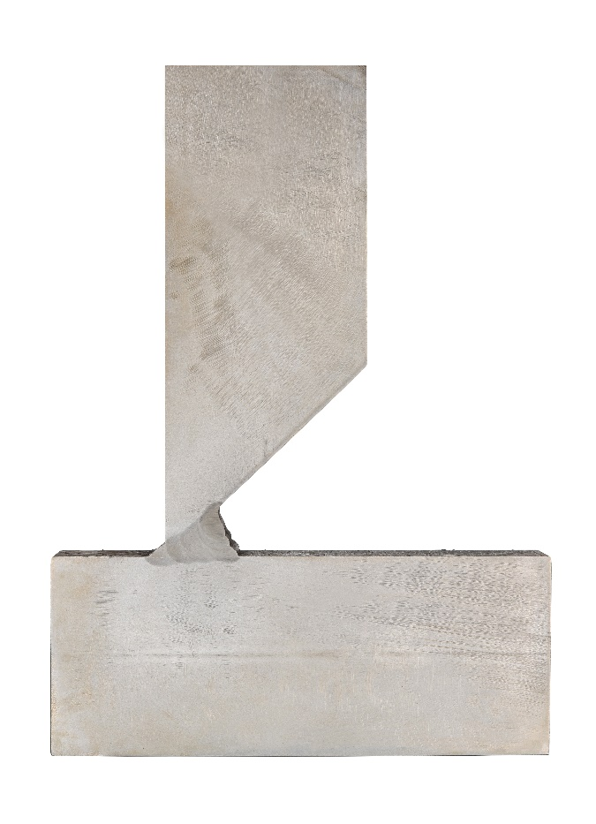
For more information, log on to www.lorch.eu
PR contact:
Lorch Schweißtechnik GmbH
Lisa Michler
T +49 7191 503-0
F +49 7191 503-199
Im Anwänder 24-26
71549 Auenwald
Germany
Reprint free of charge. Specimen copy requested.

