Efficient, safe and economical

Welding vertical seams with perfect precision and speed with Lorch's SpeedUp and welding tractors
Welding vertical seams poses a challenge of particular magnitude for every welder. However, thanks to Lorch's latest innovation SpeedUp vertical seam welding (PF) is now a breeze. When combined with Lorch's welding tractors, the process even makes completing extra long vertical seams as easy and efficient as can be.
Time and again, welders find in their daily work that the process of welding fillet welds in horizontal positions (PB) is difficult to control. One area that often proves to be particularly challenging are repairs, for instance on heavy-duty vehicles or stationary scaffolding, as they frequently force the welder to work in difficult positions. In the past, welders had to resort to the so-called Christmas tree welding technique to complete hard-to-control vertical seams. The downside of this technique is, however, that it consumes a great deal of time and requires welders of exceptional skill and experience.
Lorch’s ground-breaking process control variant SpeedUp has now nothing less than revolutionized the welding of vertical seams. Lorch scrapped the need to perform the demanding triangular movement required during Christmas tree welding and substituted it for a simple upward movement involving the cycling alternation of high and low-power process intervals. The process ensures that material and filler metal are, respectively, melted and introduced in a balanced way during the high-current phase. During the second phase, the low energy input provides for the cooling necessary to allow the melt to solidify, preventing molten material from leaking and trickling down. The result is an exactly dimensioned vertical seam combined with significantly faster and extra low-spatter welding as well as a perfect A-measurement and secure root coverage. The exceptional characteristics of Lorch's SpeedUp process guarantee a flawless and easy-to-control weld even when dealing with more complex vertical seams and, as an added advantage, makes the necessary work more efficient and economical. The SpeedUp welding process is suitable for steel, stainless steel and aluminium sheets with a thickness of up to 12 mm.
When used for production applications, the SpeedUp processes perfectly meshes with the automated welding tractors engineered by Lorch: Whether used to finish a long vertical seam or for other weld positions such as cross and overhead welds (PC/PE), SpeedUp is the perfect complement for jobs performed with the help of automated linear torch guidance. Ideally suited for long and continuous weld seams commonly found in tank and container construction, Lorch Tracs always produce a first-rate weld seam while affording you tremendous savings in time and energy at the same time. The tractors can, for instance, be attached quickly and effortlessly to any workpiece by means of a magnetic mount, while a high-performance motor delivers the accurate feed rate necessary to guarantee a constant welding speed. All that is left for the welder to do is adjust the torch and set the appropriate values. SpeedUp and Trac will take care of the rest, allowing the welder to produce weld seams of unparalleled quality.
Bernd Dalmer, Lorch’s area sales manager for Germany's southern region, sums up the benefits the two techniques have to offer as follows: “By marrying automated welding technology with the SpeedUp processes we have managed to both lessen the load on the welder and speed up their work process tremendously. Better still, the proficient duo also guarantees welding results or greater quality and reliability. Last, but not least: since they are perfectly attuned, the processes provide for a lasting reduction in the costs of material.”
Lorch Schweißtechnik GmbH is a leading manufacturer of electric arc welding systems for industrial applications, metalworking, partially automated solutions and robot automation systems. For 60 years, Lorch's premium quality systems have been manufactured in Germany at one of the world's most cutting-edge manufacturing plants for welding equipment and exported to more than 60 countries. The welding equipment engineered by Lorch merges first-rate suitability for real-world applications with superior ease of use and outstanding efficiency, setting new technological standards in the marketplace.
Fig. 1: The comparison clearly shows: SpeedUp (rgt) allows the welder to complete vertical seams much faster and more evenly in the same amount of time compared to the conventional “Christmas tree technique” (lft).
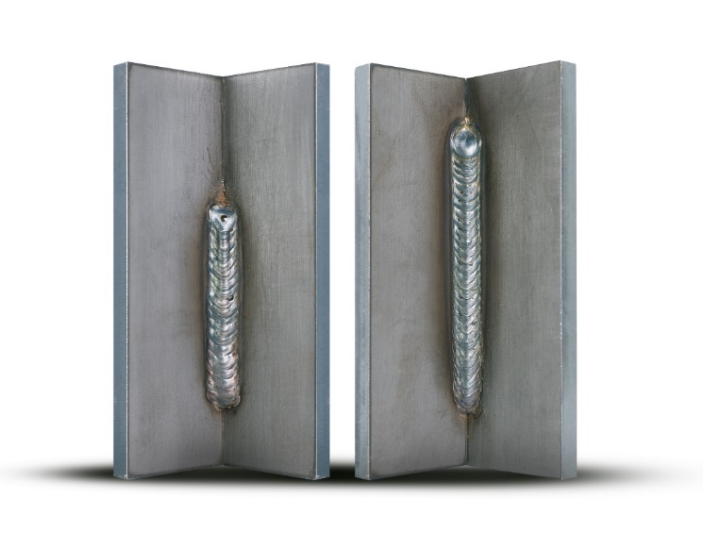
Fig. 2: A formidable team for long vertical, cross or overhead weld seams: SpeedUp and the automated welding tractors engineered by Lorch.

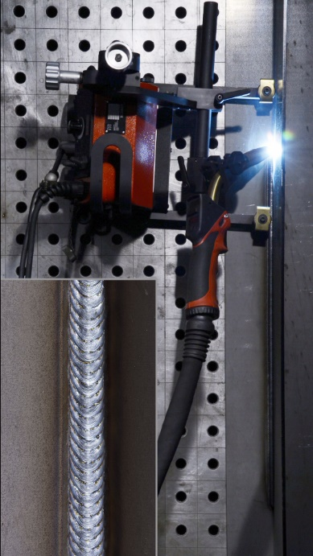

For more information, log on to www.lorch.eu
PR contact:
Lorch Schweißtechnik GmbH
Lisa Michler
T +49 7191 503-205
F +49 7191 503-199
Im Anwänder 24-26
71549 Auenwald
Germany
Reprint free of charge. Specimen copy requested.

